**Angular 2 Project**

**UTCN Automation and Computer Science**

**Group 30333**

**Big Laurentiu-Adrian**

1. **Getting Started**

* **What is Angular?**

Angular is a JavaScript Framework which allows you to create reactive Single-Page-Applications (SPAs).

* **Project setup and First app**

Firstly we will need to install Nodejs because it will be used behind the scenes by the CLI to bundle and optimize our project and will use NPM(node package manager) to manage different dependencies.(like the angular framework itself but also some other libraries).To get NodeJs go to **nodejs.org** and download it for your specific OS.

-To verify that node is installed correctly input in shell the following commands:

**node -v**  **npm -v**

-To install and create an Angular project we will need to input the following command in Shell:

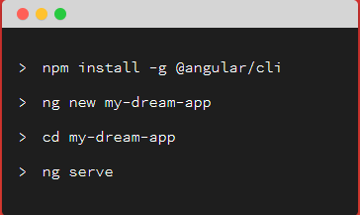

-For mac/linux add **sudo** first to run the command as admin

If all the commands worked as intended , Angular live development server should start

on localhost:4200/

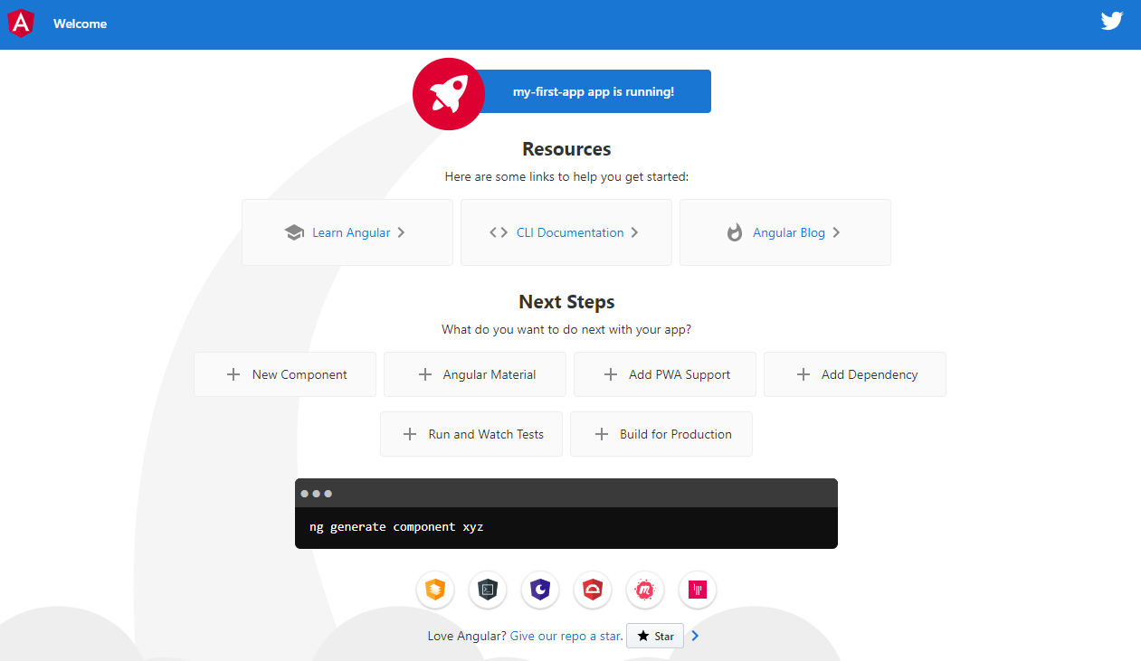

- (Optional)To use bootstrap we need to install it in our project with :

**npm install --save bootsrap@3**

And then add it in angular.json file(this file configures the CLI project) like so: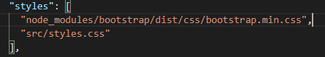

1. **The Basics**

* **How an Angular app gets loaded and started**

Angular gets started> **main.ts** file gets started, 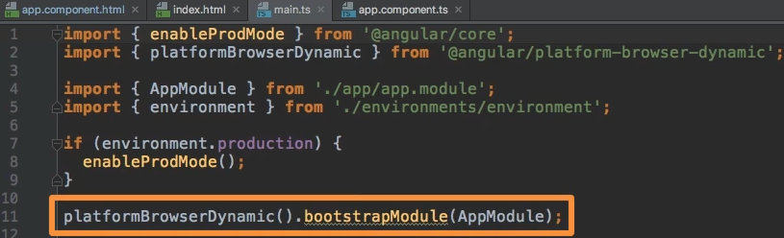

^^^ There we bootstrap an Angular application and we pass this AppModule as an argument.

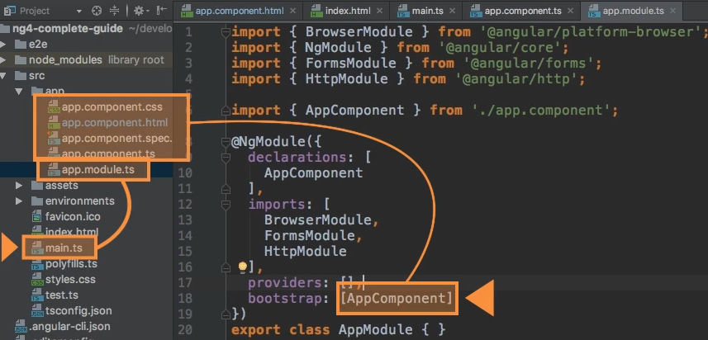

^^^In this module,we tell Angular that there is an app component which exists when it starts itself up.

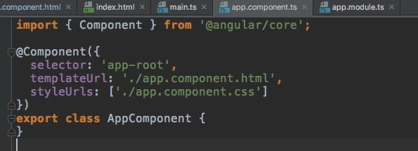

>analyzes the app component>reads the set up we pass here and therefore knows this **selector “app-root”** ^^^

And now Angular is able to handle app-root in **index.html** file

* **Components**

All the components we create won t be added in **index.html** but in **app.component.html** because this is the root component of our app right now.

* **create a custom component**

First of all, a component simply put is just a class( a TypeScript class), so that Angular is able to instantiate it to create object based on the blueprint we set up here.

-example:

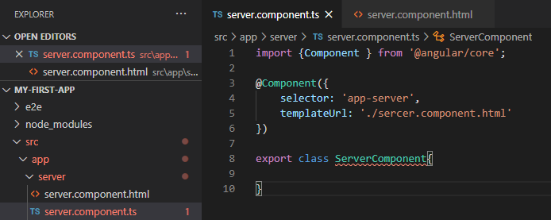

To tell Angular that **class ServerComponent** is not just a simple TypeScript class but instead something special, a component, we do this by adding a special **decorator**(

Decorators- are a TS feature which allow you to enhance your classes for example, enhance elements you use in your code). The component decorator and decorators are always attached by adding an “**@** “sign in front of them.

Now this component decorator is not something that TS knows from the start ,so we have to import it with **import {Component } from '@angular/core';**

Angular ships with a couple of packages where it basically groups its functionalities and the **core** package as the name implies gives us access to some of the core functionalities of Angular.

Now the **@Component** decorator is now know to TS, so when TS compiles this file is able to understand it.

Further we pass a Js object to this component decorator to configure it, because without any configuration is not that valuable to Angular.

Here we can setup some important information which will be stored as metadata for this class in the background which will tell Angular what to do with this class.

Configuration:

-”**selector:** “ : the HTML tag which you are able to use this component later in your other components templates.(usually denoted with the prefix “**app-**” and then a fitting name)

-”**template:** “ : here we reference another external file that will hold the template, the HTML file of the component

To be able to use this new component we need to change something about the **app.module (**this bundles the functionalities of our app and it basically gives Angular the information which features does my app have and use. **)**

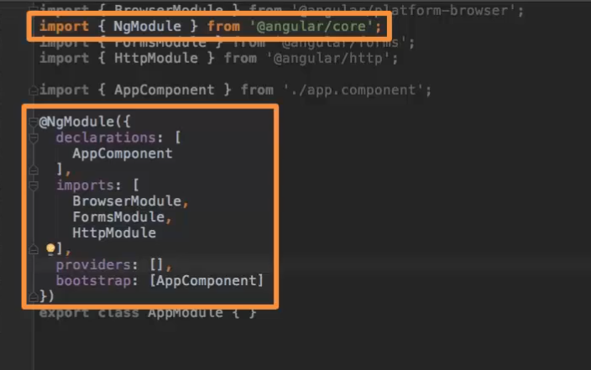

As with our component we transform it into something else by adding a decorator, here is the **@NgModel** decorator which is also imported form **@angular/core.**

Now in there we see 4 properties we set up on the object we passed to @NgModule: declarations, imports, providers, bootstrap( this is responsible for telling Angular which component should he be aware of at the point of time the whole application starts, so which component would be recognized in the index.html file).

Because Angular by default does not scan all our files we need to declare our new component in “**declarations:**” . But this is now enough because TS still does not know where this file is, so we need to add import at the top manually pointing to the file.

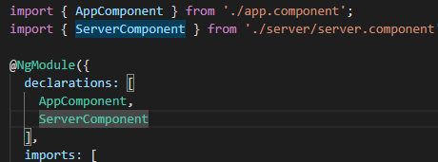

Finally to use the server component, we just add the **<app-server></app-server>** element to any template or component where we want to incorporate it.

* **CLI nesting components**

We can create a new component using the command line like so:

**ng generate component CompName**

Or

**ng g c CompName**

This will automatically create all we did on “create a custom component”.

* **Databinding**

Databinding = Communication, communication between your TS code of your component and the Template(html).

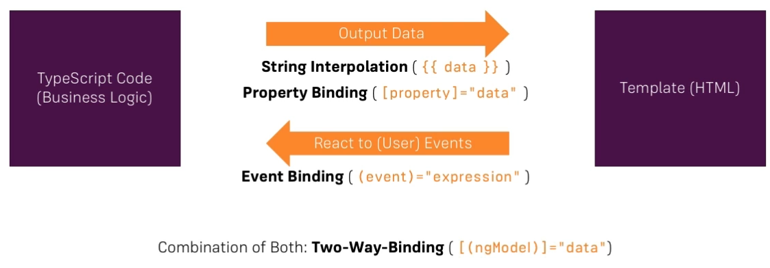

**-string interpolation:**text representing variables in components are placed in between double curly braces in the template. Angular finds the variable matching the text in the component and replaces the text with the value assigned to the variable.

Example:

server.component.ts

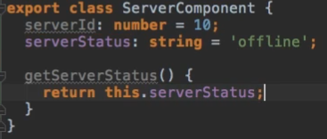

Server.component.html



Result:

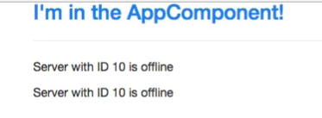

(it works with methods, numbers, strings, or anything that can be converted to a string)

**-property binding:** Property binding is a one-way mechanism that lets you set the property of a view element. It involves updating the value of a property in the component and binding it to an element in the view template. Property binding uses the [] syntax for data binding. An example is setting the disabled state of a button.

Example:

In **Servers.component.ts** we modify:

After 2 seconds allowNewServer = true;

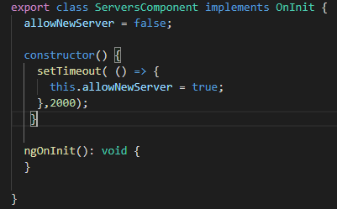

In **Servers.component.html** we modify:

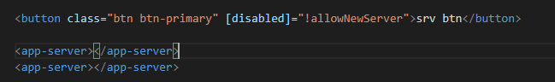

**-event binding:** This data binding type is when information flows from the view to the component when an event is triggered. The view sends the data from an event like the click of a button to be used to update the component. It is the exact opposite of property binding, where the data goes from the component to the view.

Example:

In **Servers.component.ts** we modify:

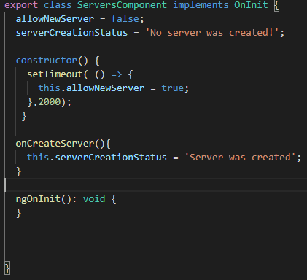

In **Servers.component.html** we modify:



Result of the code: on btn click the text will change to “server was created” from “no server was created”

**-two-way binding:** is a mechanism where data flows both ways from the component to the view and back. The component and view are always in sync, and changes made on either end are immediately updated both ways. Two-way binding is commonly used when dealing with forms where the user input is used to update the component’s state and vice versa.

Example:

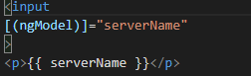

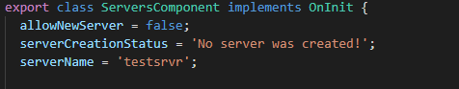

Result:

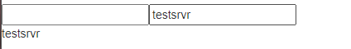

The input and the <p> tag will automatically update with the value of **serverName**

* **Directives**

At the core, a directive is a function that executes whenever the Angular compiler finds it in the DOM. Angular directives are used to extend the power of the HTML by giving it new syntax. Each directive has a name — either one from the Angular predefined like ng-repeat,ng-if,...., or a custom one which can be called anything.

1. **Project**

* **Planning**

My goal in this project is an online recipe book which will be split in two:

A recipe book and a shopping list.

We will be able to manage our recipes, view them in detail and also to manage our shopping list and even push ingredients from a recipe directly to the shopping list.

Component planning:

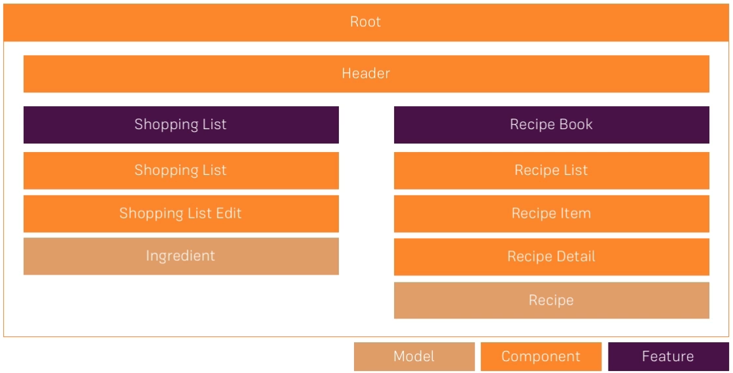

* **Creating Components**

The components I created so far are: header,shopping-list,shopping-edit,recipes,recipe-list,recipe-item,recipe-detail

with the methods presented in **The Basics** chapter.

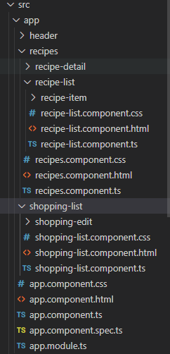

Result after nesting each component accordingly to the diagram shown previously

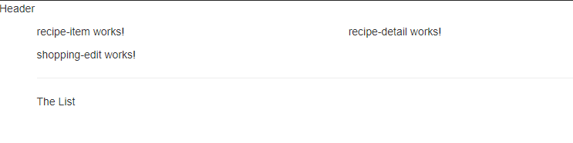

recipes>-recipe-list>recipe-item

-recipe-detail

shopping-list>shopping-edit

* **Creating a Recipe Model**

Create a new file **recipe.model.ts** in app/recipes

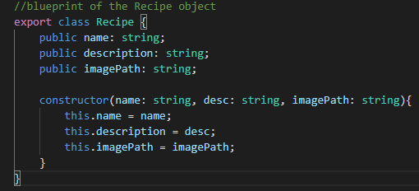

Now that we created a Recipe object we can use it to populate our recipes array from **recipe-list.component.ts**

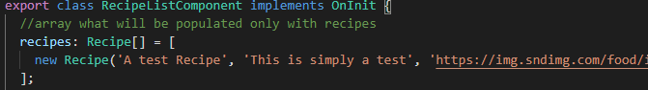

and display them in **recipe-list.component.html:**

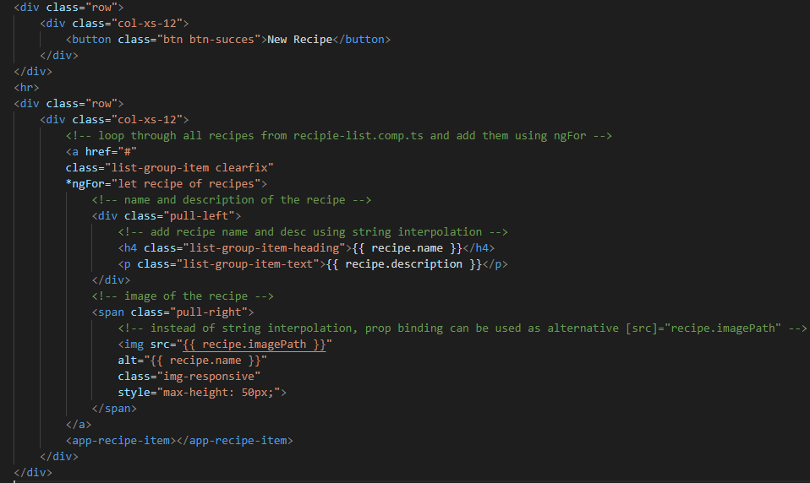

Output:

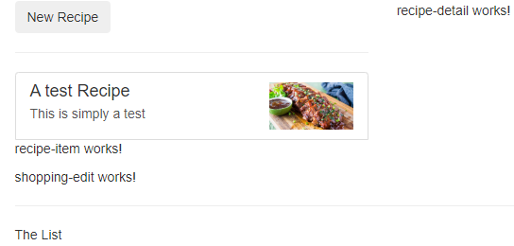

* **Displaying Recipe Details**(only html basic structure momentarily because we didn’t learn cross-component communication yet)

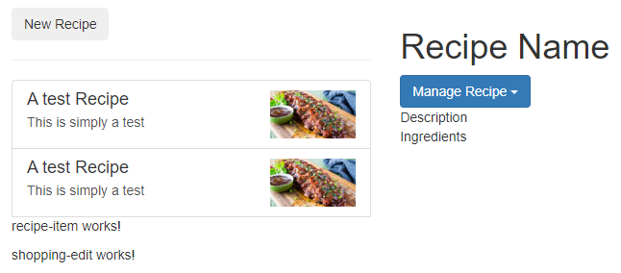

**recipe-detail.component.html:**

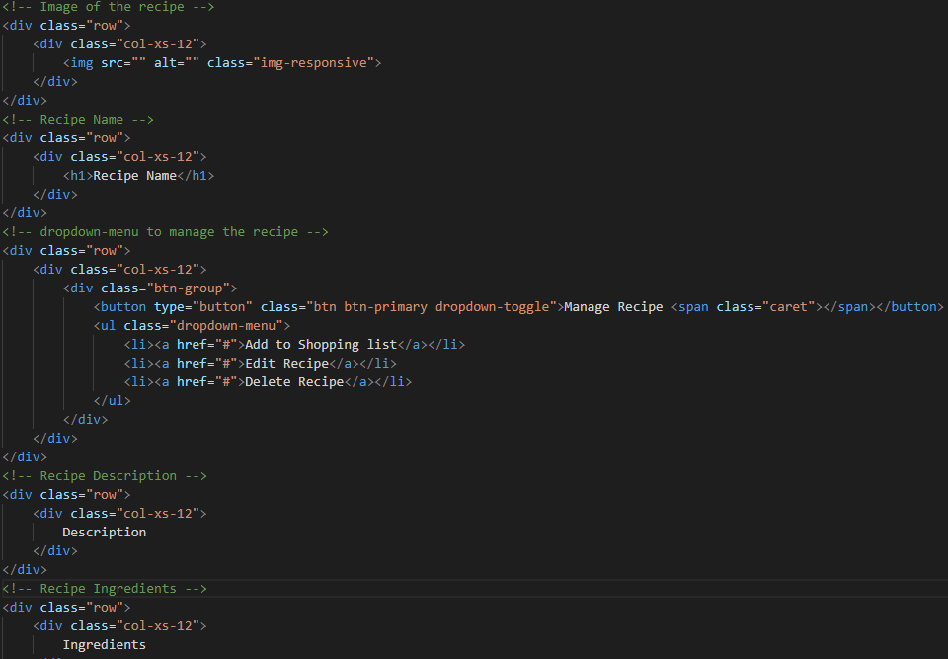

* **Creating an Ingredient Model**

We create a new **shared** folder in our app(root) folder because it will contain features or elements of our app which are shared across different features, like the ingredients which we’re going to use both in the shopping list and recipe section.

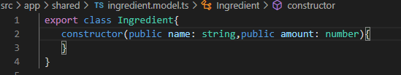

* **Creating and outputing the Shopping List**

Now that we created the Ingredient object we can use it to populate our ingredients array from **shopping-list.component.ts**

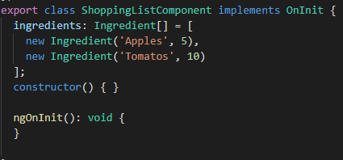

And display them in **shopping-list.component.html**:

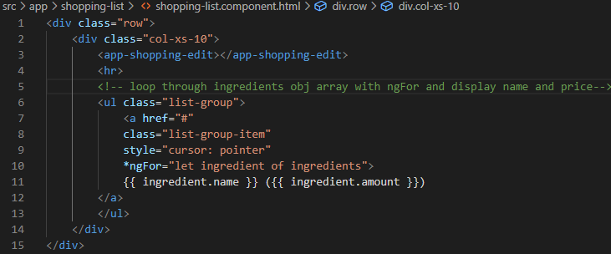

Output:

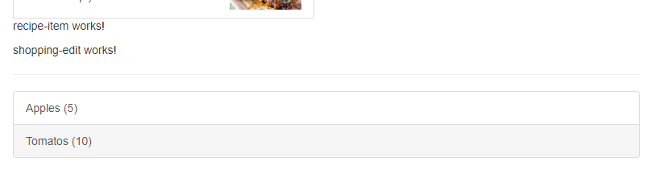

* **Adding Shopping List Edit**

Shopping-edit.component.html Output:

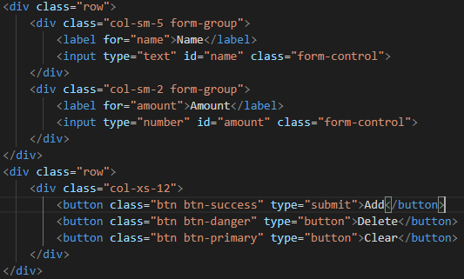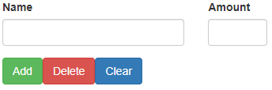

1. **DataBinding deep dive**

For this chapter we will start an example project to understand better databinding and then apply the methods learned in the course project.

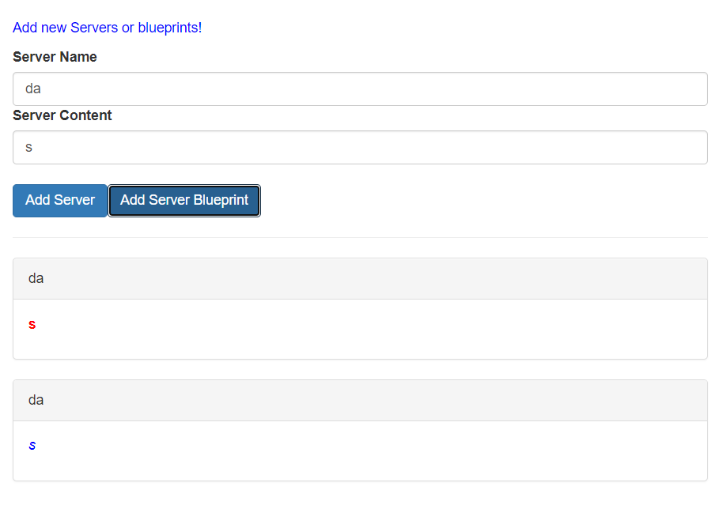

* **Splittin Apps into Components**

This whole app is written in a single component, the app component, so we will split it into cockpit and server-element component.

* **Binding to Custom Properties**

App.component.html server-element.html

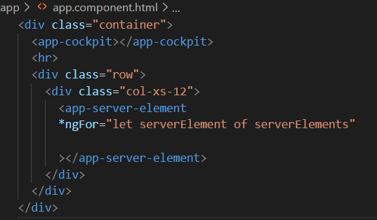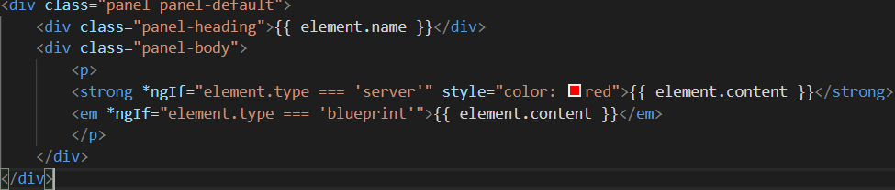

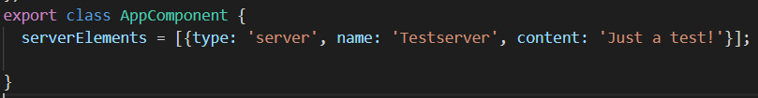

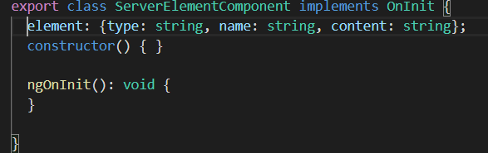

We got the **serverElement array** that we are looping though this array in **App.component.html** on the <app-server-element> .

On app-server-element we have our element property, now we want to access this component from outside( from app.component), it would be great if we could bind to it just simply using property binding but we would get the error : ‘’can’t bind to ‘element’ since it isn’t a known property of ‘app-server-element’ ‘

But that isn’t true. We even defined it as a property in ServerElementComponent, so why can’t we access it?

Because by default, all properties of components are only accessible inside these components, not from outside.So if you want to allow a parent components to be able to bind to this property you need to add **@Input()** decorator.

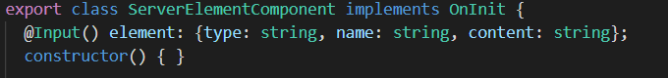

* **Assign an Alias to Custom Properties**

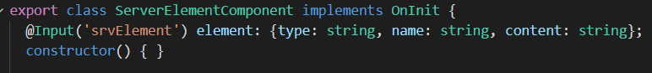

Now for all outside components that try to access the element property can only access it by the name srvElement.

* **Binding to custom Events**

We use @Output() decorator and instantiate it to a new EventEmitter instance in **cockpit.component.ts**



To rise the event we use **this.serverCreated.emit()** and pass data with **emit({serverName.this.newServerName});**  same for blueprintCreated :

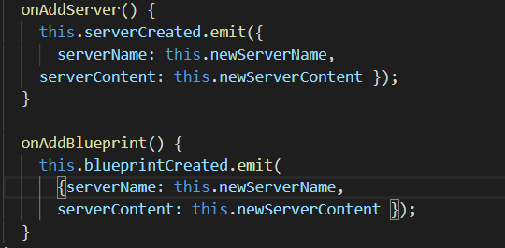

Then we catch it in the parent component, in our case app.component.html with

**(serverCreated) = “onServerAdded($event)”** and the same for blueprint:

: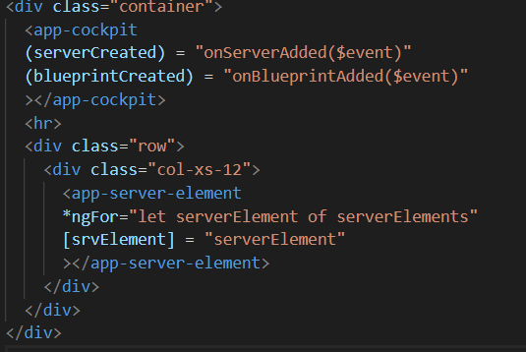

* **Assign an alias to a custom Event**

Now for all outside components that try to access the Event can only access it by the name bpCreated.



* **View Encapsulation**

Angular by default encapsulates your styles to override this we add the encapsulation property to the desired @Component

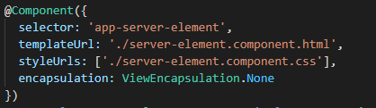

Now server-element.component.css applies to other components too.

* **Local reference in templates**

A local reference can be placed on any HTML element (but only on a template, not on a TS file).

Ex: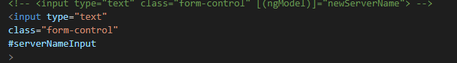

If we pass the reference **serverNameInput** to our **inAddServer** and console.log it will return the input element.To get the value we will use .value.

We can also use @ViewChild(‘serverNameInput’) to get an elementRef to use 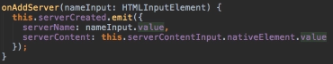

With these we get direct access to elements in our DOM, but I don't recommend this because Angular gives us a better way of accessing the DOM.

* **Protecting content into components with ng-content**

You use the **<ng-content></ng-content>** tag as a placeholder for that dynamic content, then when the template is parsed Angular will replace that placeholder tag with your content.

app.component.html

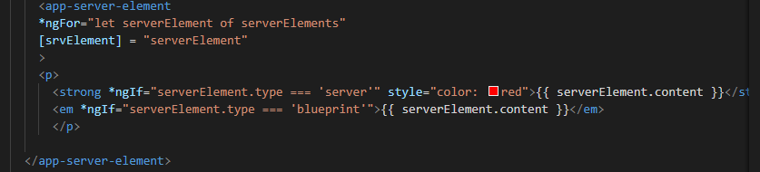

server-element.component.html

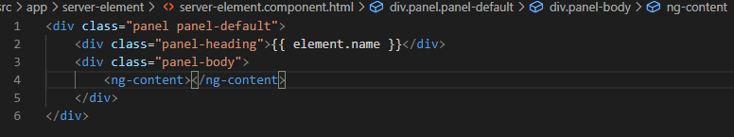

* **Component Lifecycle**

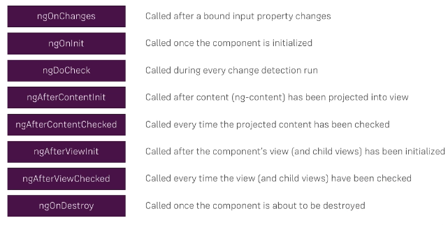

1. **Course Project - Components & Databinding**

* **Adding navigation with Event binding and ngif**

We will do this by emitting some event in the **header** (like we did on **binding to custom events**) which allows us to determine which component should be displayed in the **app component**.

**header.component.html**

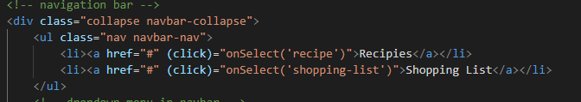

**Header.component.ts**

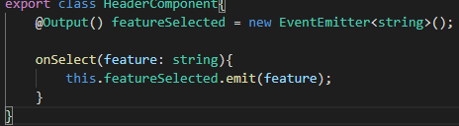

**App.component.html**



**App.component.ts**

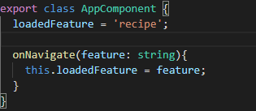

* **Passing Recipe Data with property binding**

Now we can cut the code for the recipe item from **recipe-list.component.html** to **recipe-item.component.html.**

First of all we will cut the ngFor here and go back to the recipe list component and add it to the **app-recipe-item selector** so that now the whole component is replicated for each recipe.

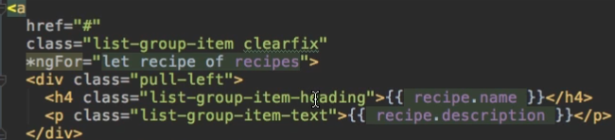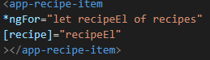

Further we input recipe 

To recipe item component and bind to our recipe, referring to the property in the single recipe item and bind to the recipe of the current loop iteration.

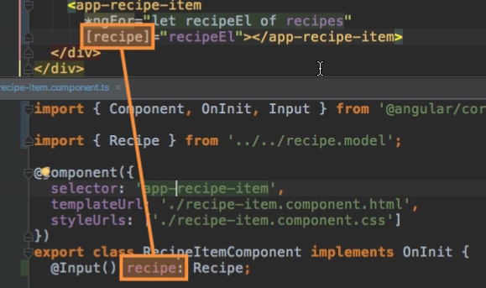

* **Passing Data with Event and Property Binding**

On recipe-item.component by adding a click listener **(click)=”onSelected()”** we emit an event informing our parent component(recipe-list component) that this recipe was selected. After which we implement onSelected() with an EventEmitter on the ts file.

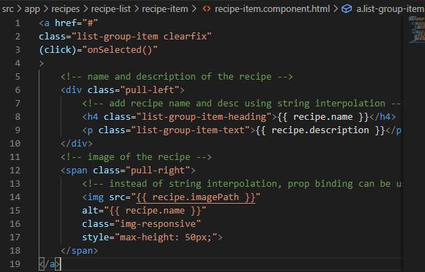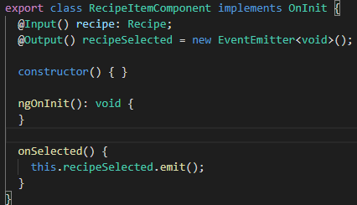

In recipe-list component we need to emit another event, so here we’ll execute **onRecipeSelected** and pass with it the recipeEl which we did select.That method has to be implemented on recipe-list.component.ts :

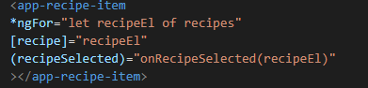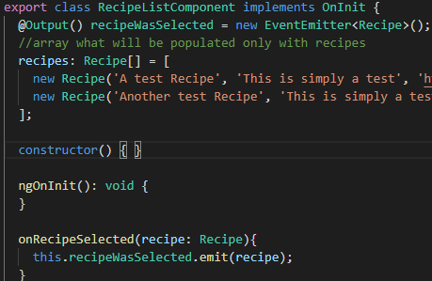

And now we want to emit another event **recipeWasSelected** and here I will pass a recipe which was selected.

Now with that, we can go to our recipe component, our main component for this feature area and on the list, we can listen to **recipeWasSelected**, the custom event we created above and here we will store this selected recipe in a **selectedRecipe** var.

Further we can pass this information to the recipe detail component and display it only if a recipe is set.

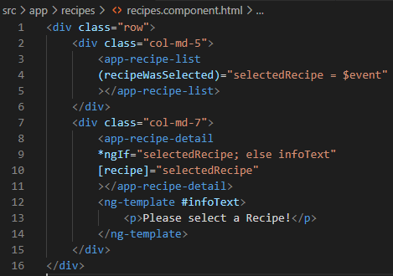

* **Allowing user to Add Ingredients to the Shopping List**

On shopping-edit component we add local references(#nameInput and #amountInput) on the name and amount inputs.

Further a click listener on the add button that calls the method onAddItem().

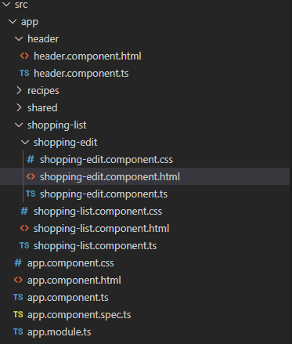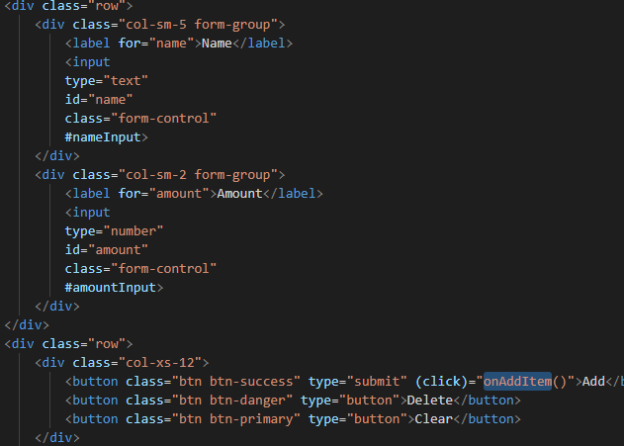

In the Ts file we will implement the method and add: 2 properties:name input reference of type elementRef and it will get a value by using @ViewChild, duplicate this for amount ref.

We will need a new eventemitter to pass the name and the amount of the ingredient with the function onAddItem().

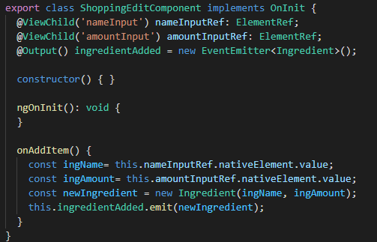

Next we catch the event in the shopping-list component and push it to the ingredients array: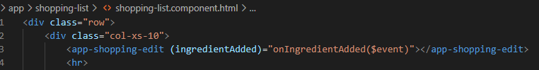

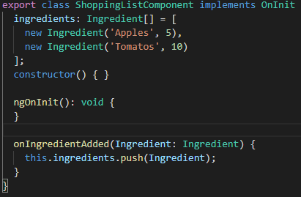

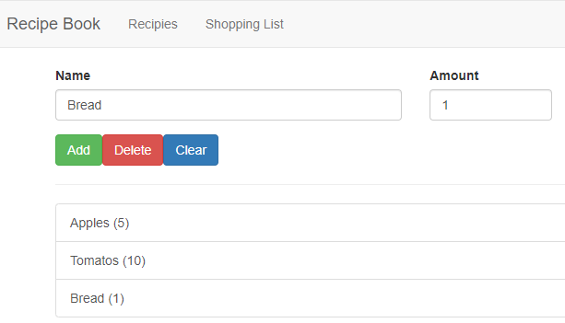

1. **Directives deep dive**

For this chapter we create a new dummy project to practice on directives

* **Creating a basic attribute directive**

We create a new file “**basic-highlights.directive.ts “**. Now in this file just like we added @component here we have to add @directive. In the directive config we add a unique selector with attribute style so this will be recognized whenever we add **appbasicHightlight**  without square brackets to an element. To verify this works we change the background color of the element where we attach this directive.For this we need to get access to the element the directive sits on and the cool thing is Angular gives us this access.We can inject the element the directive sits on into this directive.

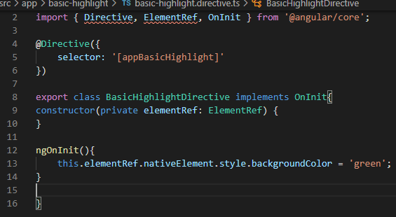

We add ngOnInit and in there, we access element ref,access the native element and there access the style and maybe the background color and set this equal to green.

Now to use this, first of all like for a component, we have to inform Angular that we have a new directive so we need to add it in our **app.module**

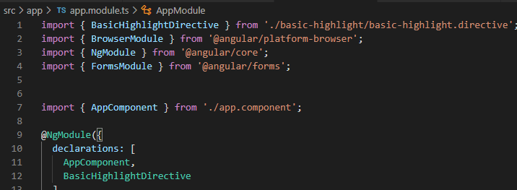

Result:

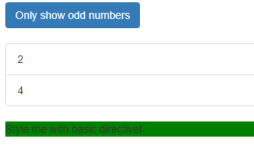

* **Using the Renderer to build a Better Attribute Directive**

For this we will generate another element( using the command **ng g d elem-name**) to demonstrate it.Now we inject the **renderer which is of type Renderer2** and now we can use the renderer by calling the property we created here (private renderer) and add which method to work with the DOM(in this example we use setStyle). To get the element for which we want to set the style,of course in Angular are a lot of ways to get the element but here we will inject the **element reference**

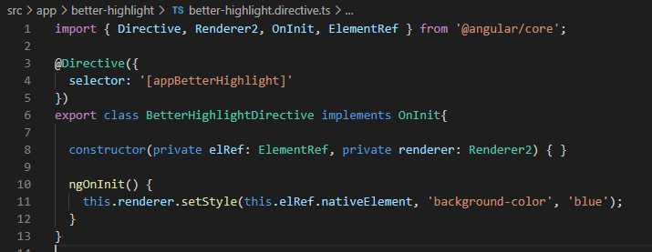

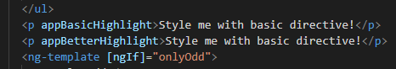

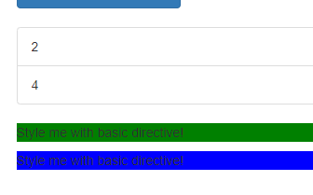

* **Using host listeners to Host events**

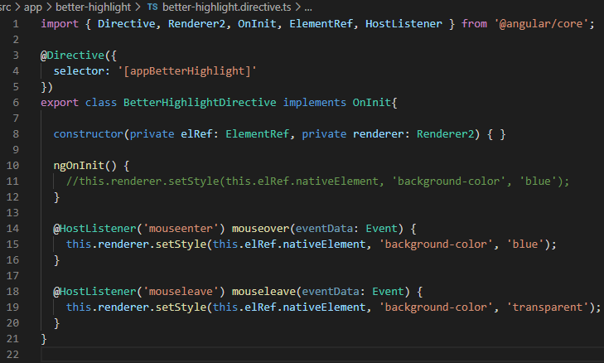

We use a new decorator: @HostListener and add it to a method we want to use, in our case mouseover and mouseleave. Now this methods can be triggered whenever some event occurs, that event is specified as an argument ( mouseenter, mouseleave).With that we listen to the mouseenter event, and when it's triggered we change the background color to blue and on leave back to transparent.

* **Using HostBind to bind to host properties**

This allows us to use even a simpler way of changing the background color that the method with the **renderer**  in a directive, the decorator @HostBinding .

Now in HostBinding we can pass a string defining to which property of the hosting element we want to bind.(style , background color ,...)

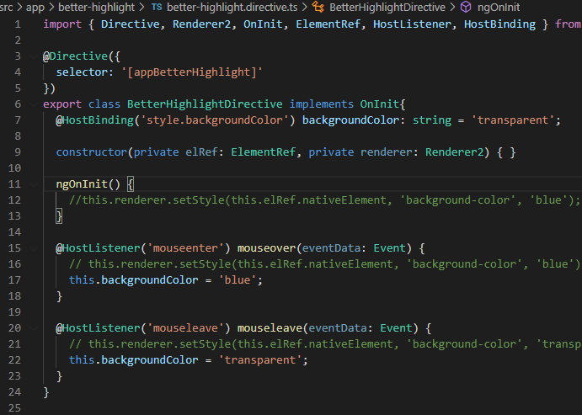

* **Binding to Directive Properties**

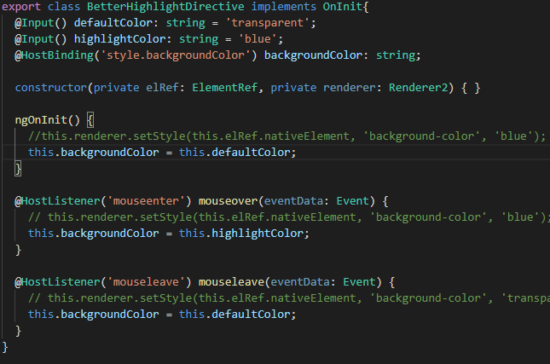

This should work the same as before but now we can bind it from outside.

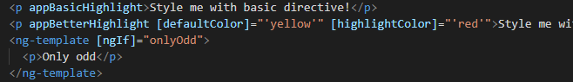

If you set an alias that is the same as the directive name to the input. You can change the property directly by using for example 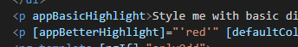

* **Building a structural directive**

For this we will create a new directive  and add an @Input. Here we want to bind to a property named **appUnless** (we need to make sure that the name matches the name of the directive selector because if we not we can’t bind to it) , which kind of simply put is the condition we get but whenever this condition changes we want to execute a method therefore we implement a setter with the **set** keyword. Now this turns into a method but it still is a property, it's just a setter of the property which is a method which gets executed whenever the property changes.Unless therefore needs to receive the value, the property we would normally get as an input

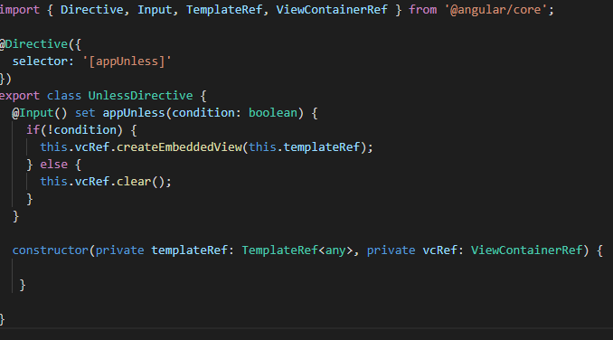

Here TemplateRef = template reference, vcRef= view container reference. (templateRef is the “what and vcRef is the “where”, what goes where)

So with these two tools available, we can use the vcRef whenever the condition changes, to call the createEmbeddedView method which does just what the name implies, it creates a view in this view container and the view simply is our template ref.

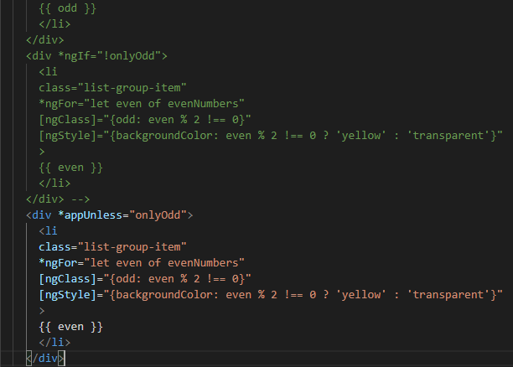

1. **Course Project - Directives**

We will create our own directive which will manipulate all the dropdowns in this chapter.

In our new directive appDropdown we will add a Hostlistener to listen to a click event and execute the method **toggleOpen().** Now to dynamically attach and detach a css file in our case the **.open** class to open the dropdown we use @HostBinding and bind the class property of the component .

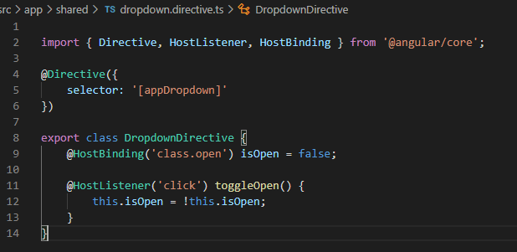

Now by adding the directive we ll have a working dropdown

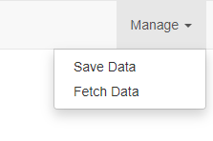

1. **Services & Dependency Injection**

* **Creating a logging service**

We create a new file in a test project named **logging.service.ts** . A service is like a normal TS file, we don’t need special decorators like we need for components or directives.

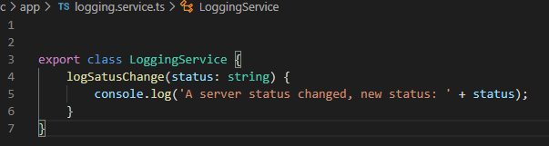

But it’s better if we don’t instantiate it ourselves, Angular offers some great tool which will give us access to our services => Angular **dependency injector**

* **Injecting the logging service into components**

What is a dependency injector?

Well a dependency is something a class of ours will depend on,for example the new account component depends on the loggingService because we want to call a method in that service and the dependency injector simply injects this dependency.

All we need to do is we need to inform Angular that we require such an instance.

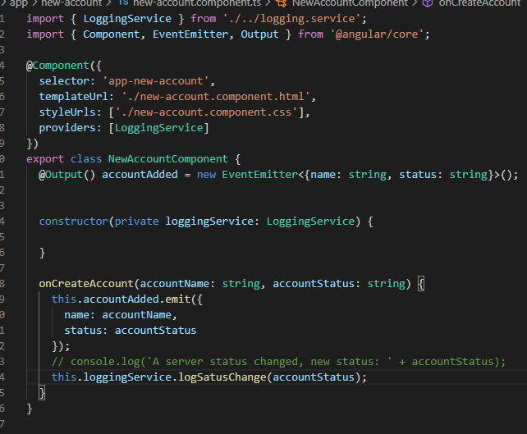

We define in the constructor that we require some argument, Angular will recognize this and tries to give us that argument, so he knows that we want a LoggingService type instance. Further we need to provide a service(to tell angular how to create it), we do this by adding the **providers** property, here we just have to specify the type of what we want to be able to get provided.

Now we can simply on our component, anywhere in this comp, access our loggingService property.

So now we don’t create this instance manually, now Angular creates it for us .

* **Creating a Data Service**

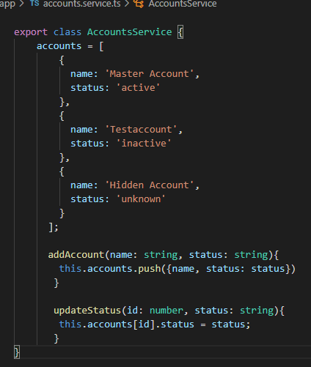

We store the **accounts**  in the app.component and then with the help of a chain of properties and event binding we get data to the app.component.

Let’s create a new service **accounts.service.ts** for that.Here we move the **accounts** from the app.component and we will add a method **addAccount()** where we get a name and a status, in this method we push the data into the accounts array.We add another method **updateStatus()** where we get the id and status, in this method we update the status of an account.

Next we should re-add the accounts in the app.component but this time it will be simply an array of accounts.Since we have our account service we should inject it here by adding AccountsService to providers and initialize it on the constructor.Further we populate our accounts array with accounts from the service.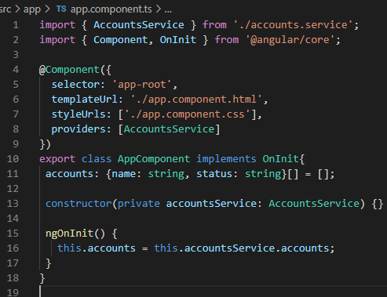

Now we want to update our new account and account component, let’ start with the new account:

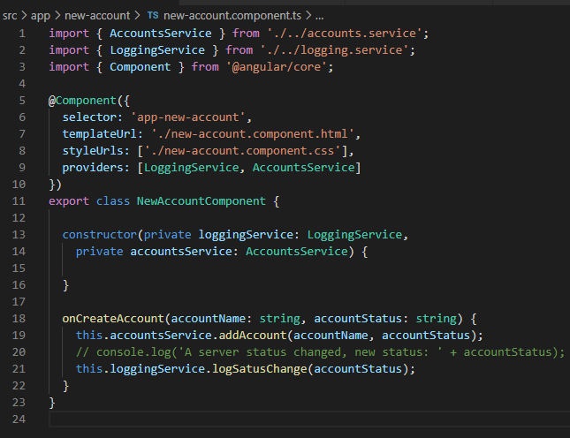

Here we no longer need the emit event that was on onCreateAccount, we get rid of the output and imports we don’t use anymore.Instead we should inject our service, our AccountsService .

Now with this injected we can call AccountsService => AddAccount and pass the account name and the status.

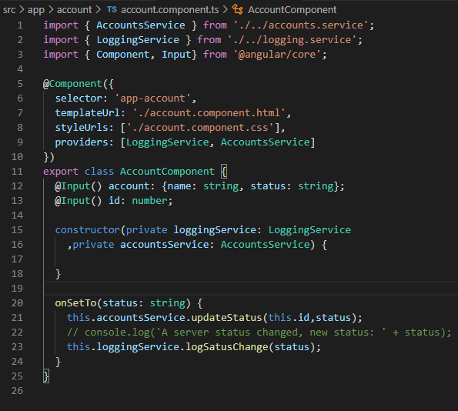

Next we go to our account component.Same as before we get rid of the output and the event emitter.Now we can inject AccountsService, with that we can call accountsService **updateStatus()** and pass the data.

* **Understanding the Hierarchical Injector**

In the last chapter we set up our account service and hooked it up on our app and still, our app seems broken if we click the buttons the status has not changed.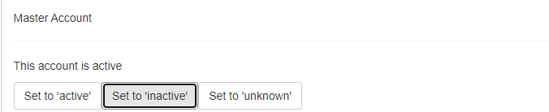

Actually is working correctly, we’re just using services wrong here, in this specific case, we’re not using the service in the app the way we should.

The Angular dependency injector actually is a hierarchical injector, that means that if we provide a service in some place of our app, let's say on one component, the Angular framework knows how to create an instance of that service for this component and all its child components and the child components of the child components will receive the same instance of the service.here are other places where we can provide a service too, the highest possible level is the app module:

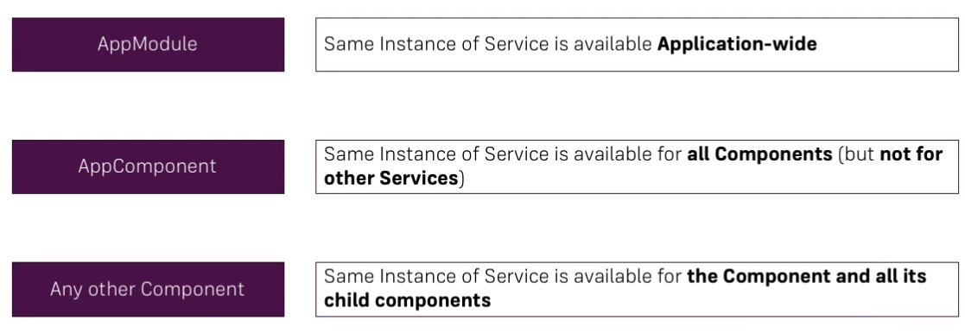

The lowest level therefore is a single component with no child components. If we provide a service there, this component will have its own instance of this service and doesn't have any child components, so this instance will only be available for this component and this will actually even overwrite if we were to provide the same service on a higher level and that's exactly what we're doing.

**To fix it** we just need to remove accountService from our providers in the new-account component but not the constructor because that tells Angular that we want an instance, the providers array basically tells which instance. And the same for the account component.

* **Injecting Services into Services**

Because the app component is not the highest possible level let’s remove accountService form the providers. Because the app module is the highest we can add AccountsService here in the providers array.Then with that little addition heater we're making sure that our whole application everything in our application receives the same instance of the service unless it overrides it as we did before.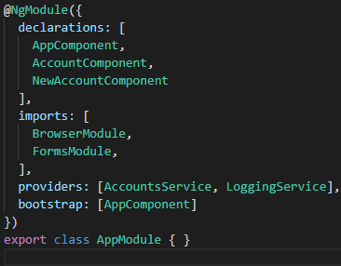

Now with that we can now even inject a service into another service because that's not possible by providing it on a component level, for that we need to provide it in the app module so let's say we want to log something if we call actually in the account service.So it would have to provide a logging service in my app module now and therefore I will comment the ones from the account component.

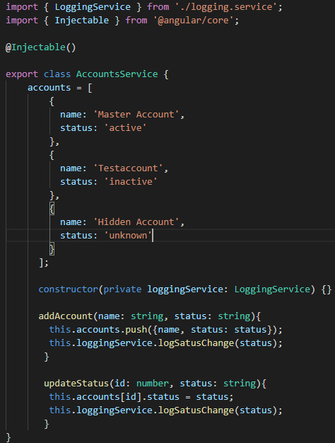

Now to use the **LoggingService** in our **AccountService** ,generally we start in the same way we add a constructor and we checked our logging service in this case. Now we use the loggingService in our **addAccount** and **updateStatus** methods to log the status.

But this will not work if we don’t attach a specific metadata that we should attach in this cases, it’s **@injectable()** . This tells angular that now this service is injectable or that something can be injected in there.

You don't add at injectable to the service you want to inject but to the service where you want to inject.

1. **Course Project - Services Dependency injection**

* **Setting up the services**

We place the services next to the future or in the folder holding the feature they belong to. So if we add a recipe service, the recipe folder is a good place for it.

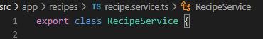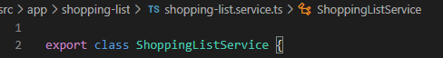

* **Managing Recipes in a Recipe Service**

The recipe service will be the place in our app where we manage our recipes.

Therefore we should take our recipes which we currently manage in our recipe list and manage it in the recipe service: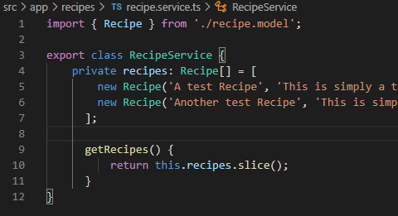

So we'll simply copy it for now and add it as a property in the recipe service.

I will actually make this private so that you can't directly access this array from outside and add a method **getRecipies()** which will return this array.

Well if we now change something on this array, we will change it on the array in this service.Therefore, we call **slice** with no arguments,this will simply return a new array which is an exact copy of the one in this service file.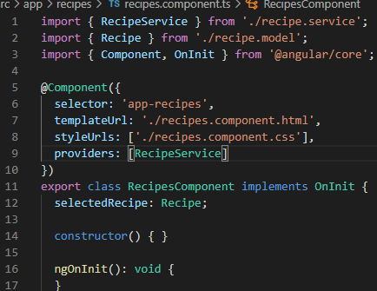

Now with that, we can and we have to add our service to a place in our app to provide them so that we can inject them.

I’ll add providers ,this array to the recipe component, therefore this component and all other recipe related components (since they are all child components) will share the same instance of this service but you won't be able to access the service or at least not the same instance in other components like the shopping list component.

* **Using a Service for Cross-Component communication**

To improve our app, remember, we have this long chain of inputs and outputs getting a selected item from the recipe item component => recipe list component => recipes component(listen for the event) => recipe detail. That is a super long way for just informing another component that we selected an item. So let’s change that here, the goal is that in the recipe item component where we have onSelected click, here we can directly inform the recipe detail component.

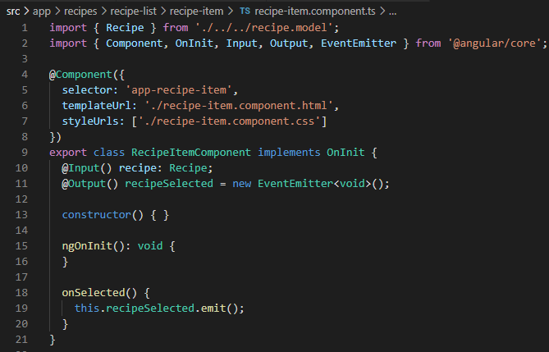

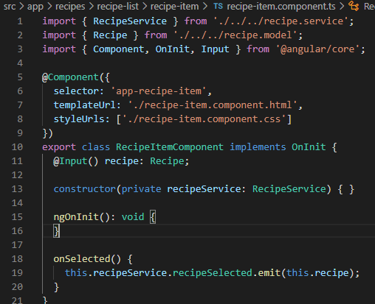

=>

In onClick here , I don’t want to emit an event, I want to call some method in my service which will then transfer this data for me. So in the recipe service, I'll add a new property, the public property which will name recipe selected it will be an object instantiated by using event emitter from @angular/core.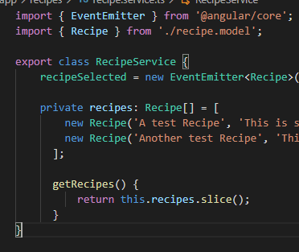

Now with this trick we can get rid of the listeners, RecipeSelected() and of the emitted event from **recipe list component.** We can also get rid of the event from recipes component html because we no longer use this chain of data to pass it around.

Next we will inject the service here in recipes component and on our ngOnInit()

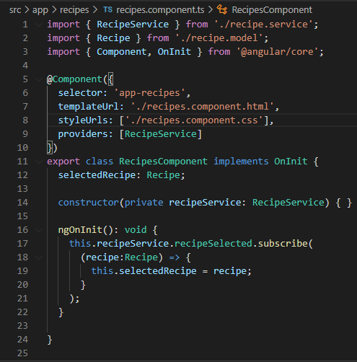

for example, we can set up the listener, so on the recipe selected, I can subscribe to it and get informed about myu changes. And now here we will receive some data which will be of type **Recipe** and in this arrow function we want to set this selectedRecipe = recipe (recipe that we got with the event).

And with that we should get the same behavior as before.

* **Adding the shopping list Service**

Here we use the same methodology as the one we used for the recipe service but with a few changes.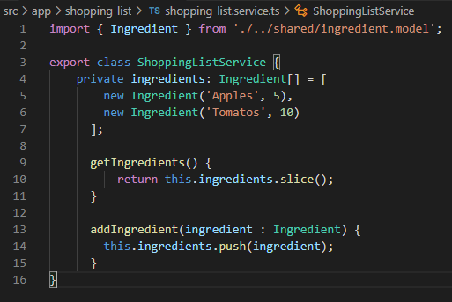

If we would inject our shopping-list service in our shopping-list component we shopping-edit could access it no problem but later on we want to access it from the recipe section so for this we’ll add it on our **app.module**:

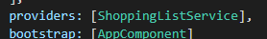

So now we’ll be able to use this service application wide.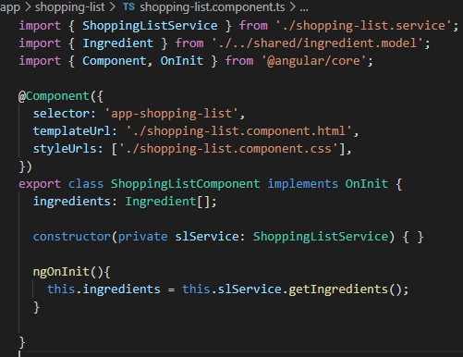

Next we’ll inject is to our shopping-list component and populate our ingredients array from the service.

Now we add the method for adding ingredients , **addIngredient()** but we’ll finish it in the next chapter,

* **Using services for Pushing Data from A to B**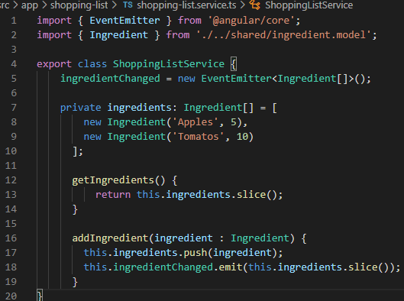

In this moment the add button doesn’t work because we are adding a new ingredient to the copy array but not to the original, that is not reflected in our components. Now to solve this we could remove **slice** or we need to inform our component that new data is available using a new event emitter ingredientsChanged. We emit this event whenever we change this array and pass a copy of our ingredients array.

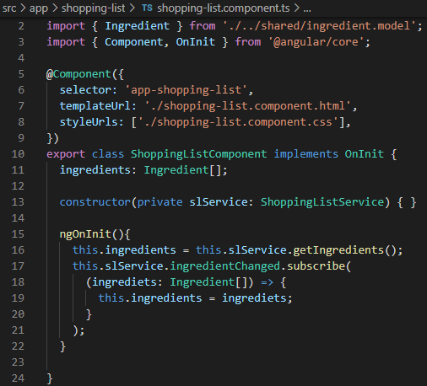

So now in the shopping-list component

, besides getting the ingredients when loading the app I also want to reach out to my shopping-list service and simply subscribe to that **ingredientsChanged** event.

Now whenever ingredients change, I know that I will get them. I can use them here in the body of the anonymous function I’m passing to subscribe and set this.ingredients= ingredients (set the ingredients from here with the ingredients we got from the event )

* **Adding Ingredients to Recipes**

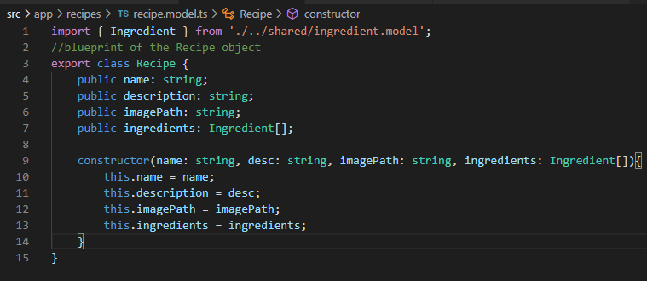

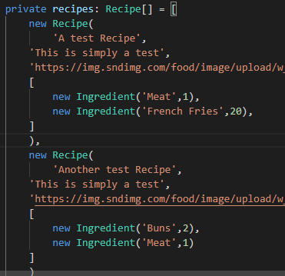

We start by adding Ingredients to our recipe model. Now in the recipe service we need to add some here, when we create our dummy recipes.

Now we cand output them in our recipe-detail component:

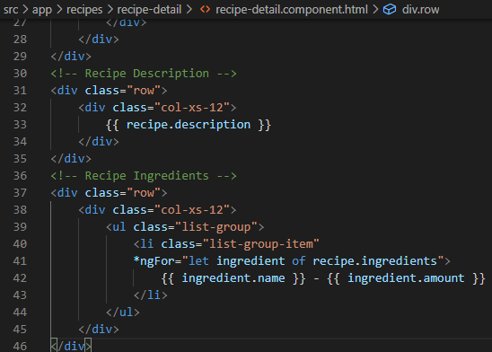

Here we loop through all the ingredients of recipe.ingredients because in the recipe detail component we have a recipe

and that has some ingredients.Next we output them with string interpolation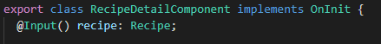

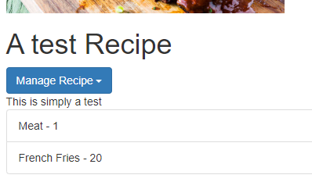

* **Passing Ingredients from Recipes to the Shopping-List (via Service)**

We start by adding a click event on **To shopping list** btn that calls the method onAddToShoppingList() .

We inject our **recipe service** in **recipe-detail component** and add the method onAddToShoppingList(). In this method we pass on the ingredients to the recipe service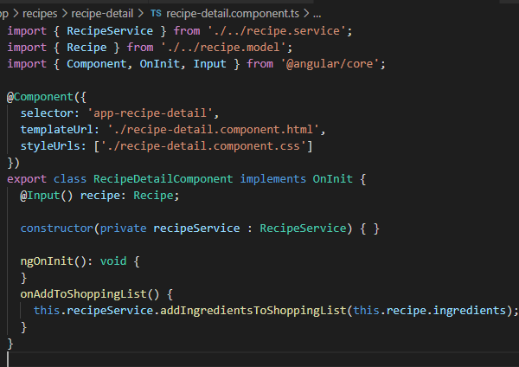

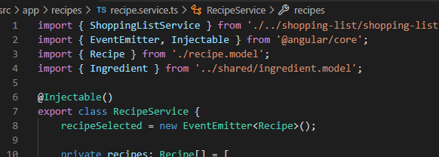

Here in the **recipe service** we need to access the **shopping-list service,** and for that we need to inject a service into a service with **@Injectable.**

Now we can inject our shopping list service and with that added we can reach out to it in our method **addIngredientToShoppingList()** by calling the method addIngredients and pass ingredients to that service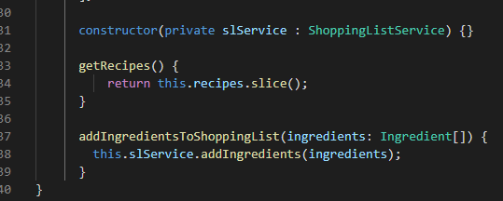

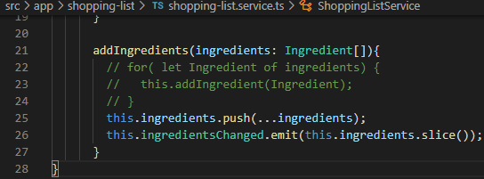

In our Shoppinglist service we receive our list ingredients.Now for the method to add them we can use the quick and easy for loop that is commented or we can add all our ingredients in one go and then emit our event.

So we call our ingredients here and call the **push** method and now we can use a **ES6** feature, **the spread operator ( … )** - which allows us to basically turn an array of elements into a list of elements ,because the push method here is able to handle multiple objects,however it is not able to handle an array(actually it can but it will push this array as a single object) . With this we can spread our ingredients into a list of single ingredients which are now pushed to our ingredients array.

Next we have to emit that our ingredients changed an pass a copy with **this.ingredients.slice().**

1. **Changing Pages with Routing**

In our dummy app, we got three sections:

* Home
* Servers
  + View and Edit Servers
  + A Service is used to load and update Servers
* Users
  + View Users

This app will be improved by adding routing.

* **Setting up and Loading Routes**

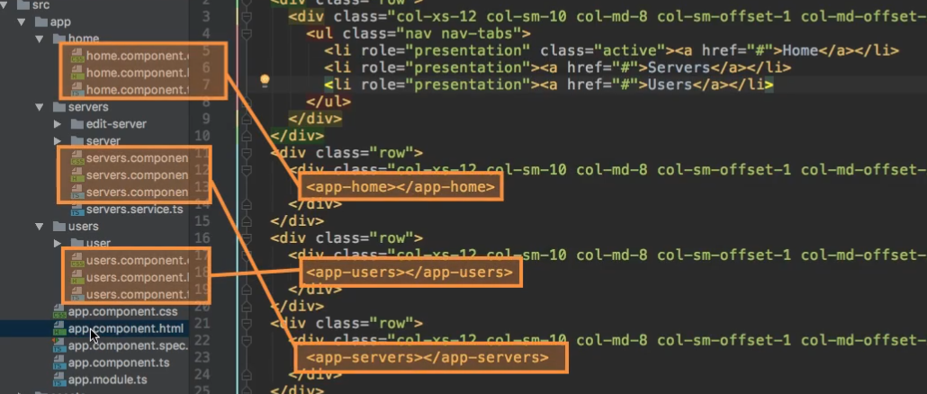

Here we got our 3 main components for our app. In the **app.component** we’re loading them all, so we want to display only one at a time by dynamically loading them by clicking on these links at the top and loading a different route in our app.

So since this is a core part of our app we will register it in the app.module

We start by adding a constant name **appRoutes**  of type **Routes,** this should be imported from **@angualar/router**. Now this constant holds an array of js objects with this structure: 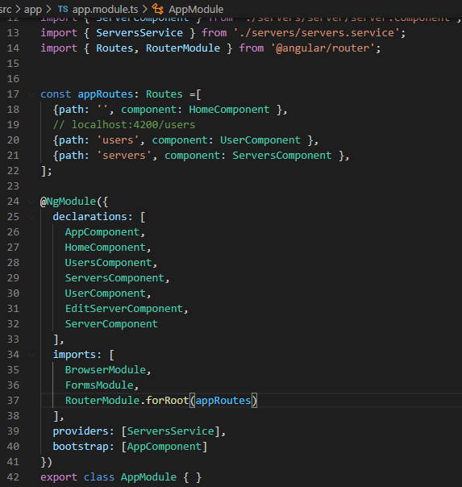

* Path: this is what gets entered in the URL after your domain
* Component: the action which you inform Angular that once this path is reached, a certain component should be loaded.

Next to register our routes in our app we should add **RouterModule** to our imports array, this routerModule has a special method that we can call, **forRoot**, which allows us to register some routes for our main application. ForRoot will receive our appRoutes constant as an argument , with that now our routes are registered in our Angular app on this RouterModule.

* **Navigating with Router Links**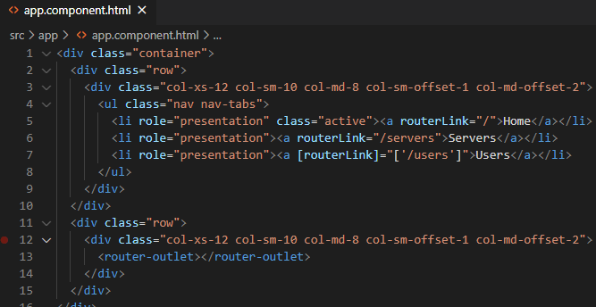

In our app component we remove all the component tags and add <router-outlet>.

Now to display the component we want in the router-outlet we could use the < href=”/users”> for example, this will work but it will **refresh** the page everytime we click on it and we don’t want that. Instead we use a special directive: **routerLink,** (we can also use routerLink with property binding, this can be used to pass even an array which gives you a more fine grained control over routerLink ) Now this doesn’t **reload** the page because **routerLink catches the click** on the element, prevents the default which would be to send a request and instead analyzes what we passed here to the routerLink directive.

* **Understanding navigation Paths**

**Relative path**, example:

If we put a 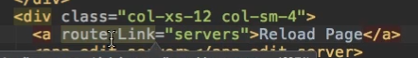 in our servers component to reload the page, this would give us an error because it doesn’t find a route that is **“localhost:4200/servers/servers “**

**Absolute path,** this error won’t occur if we use an absolute path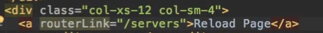

* **Styling active Router Links**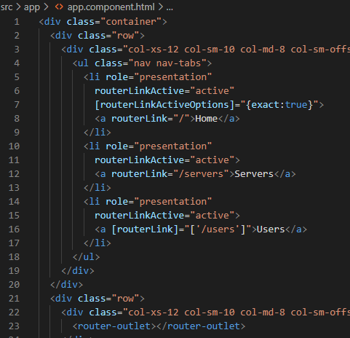

We dynamically add the active class when the RouterLink is active with a special directive : **routerLinkActive,**

Now all my links should receive this ‘active ‘CSS class once they are clicked, but for the Home link this won’t work because it has “/” (an empty link). And that is always the case, we always have ‘/’ at the beginning of each path( **‘/’**users, ‘**/’**servers), to fix this we can add on the same element **RouterLinkActiveOption.** This needs a property binding because we don’t pass a string here, instead we pass a JS object and that won’t work without our **[ ] ,** in our case **exact: true** (this will tell Angular that only on this routerLinkActive active CSS class , if only everything is just **/** and not if it is only part of the path).

* **Navigating Programmatically**

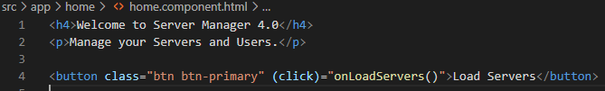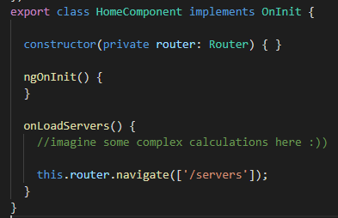

Firstly we inject the router, we bind it to a private property in our constructor

Next to redirect to another page,we use the method .**navigate** which takes as argument the path.

* **Using Relative Paths in Programmatic Navigation**

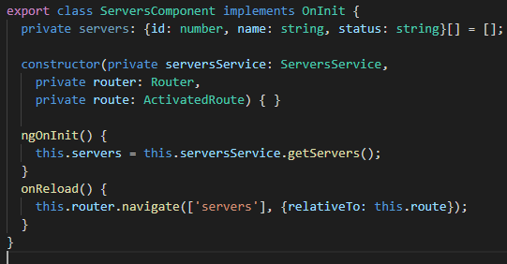

So back in our servers component, let's say we have again our reload page link but this time it's a button with a click listener, onReload.

On the navigate method we can add the **relativeTo** property, Here we define relative to which route this link should be loaded and by default, this is always the root domain, which is why we didn't get an error for this servers path. (if we let only .navigate([‘servers’])). Here we have to give a route though, so we don't pass a string here,instead we pass the **route**, We can get the currently active route by injecting **route** which is of type **ActivatedRoute.** Now ActivatedRoute like the name implies simply injects the currently active routes.

Next we can set this as a value, this injected route for the relativeTo property and now with that extra piece of information, Angular knows what our currently active route is.

* **Passing Parameters to Routes**

We can add parameters to our routes, dynamic segments in our paths. We do this by adding a **colon** and then any name you like, ex:

* **Fetching Route parameters**

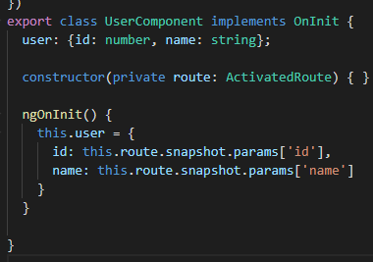

We can load our user by retrieving this parameter from our URL, so we assign this.user to a JS object with an ID and a name.

The value for the ID can be fetched from our route and there we have a **snapshot** property, and on this snapshot of our currently active route we have a **params** JS object (here we can get our ID)

* **Fetching route parameters Reactively**

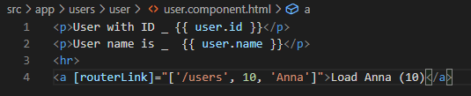

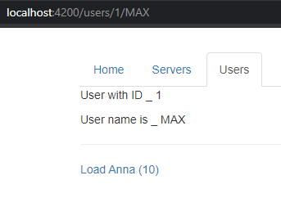

instead say routerLink and now I will actually use this syntax with the square brackets where I pass an array and I want to load /users, an absolute path to load the correct route. The second element will be the ID, and then the name. This will now construct a route which is /users/10/Anna.

We get a link on our currently loaded page with users 1 Max and if I click **Load Anaa**, you'll see that the URL was updated but the text wasn’t, this is the default behavior of Angular:

Now if we load a new route, what happens?

Angular has a look at our app module, finds the fitting route, loads the component, initializes the component and gives us the data by accessing the snapshot.

Now that only happens if we haven't been on this component before but if we click this link, which is on the user component, well then the URL still changes but we already are on the component which should get loaded.

So Angular doesn't really instantiate this component.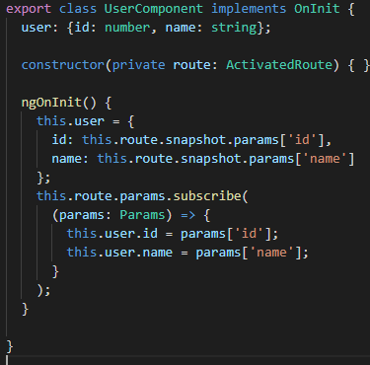

In our TypeScript code, in **ngOnInit** here, let's say after we assign this initial set up, we can use our route object and instead of using the snapshot here, we use the **params** property on this route object itself.

Now we didn't use that before, we had the snapshot in between, the **difference** is that **Params** here is an **observable** (observables are a feature added by other third-party packages, not by Angular but heavily used by Angular which allow you to easily work with asynchronous tasks).

So an **observable** is an easy way to subscribe to some event which might happen in the future, to then execute the code when it happens without having to wait for it and that is what **params** is. It is observable and as the name implies, we can observe it and we do so by **subscribing** to it.

**Subscribe** can take 3 functions you pass as arguments: The first one is the most important one here, it'll be fired whenever new data is sent through that observable.

When that happens the function gets executed and we update the ID and name .

* **Passing query parameters and fragments**

Firstly we add our new path to our app.module

Next when we click this a tag we create this new route **servers/5/edit .** To add the ? we can bind to **queryParams** property. QueryParams is not a new directive, is just another bindable property from routerLink. Here we have to pass a JS object and we can now define key-value pairs of the parameters we want to edit. 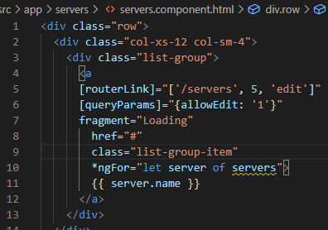

We also have the fragment property accessed with [fragment]

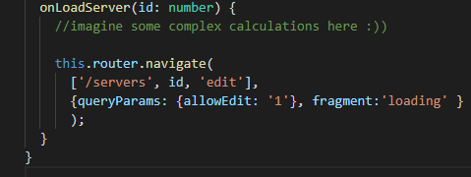

Another way of passing them.

* **Retrieving query parameters and fragments**

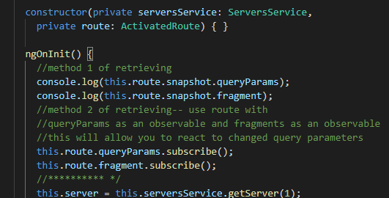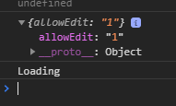

* **Setting up Child(nested) Routes**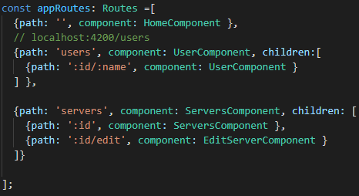

We do this by adding another property, **children:[] .** Children takes another array of routes, so now we can simply take the other servers routes and add them inside this array.

For this to work we need to have a <router-outlet> in our parent component, in our case ServersComponent and Usercomponent. If we would have it only on our app.component this won’t work because servers/:id is a child of servers.

* **Configuring the handling of query parameters**



To prevent our query parameters from disappearing whenever we navigate away from our single server component, to the edit server component for example. So we want to preserve them because we already set this information at the point of time we visit a single server.

To preserve that information, we get a simple way of doing so. In the server component where we navigate, we can pass the **queryParamsHandling** property.

Now **queryParamsHandling** takes a string as a value and this could be “**merge**”, to merge our old query params with any new we might add here. But we don't add any new ones, so we can simply choose “**preserve**” instead and preserve which will overwrite the default behavior which is to simply drop them, and make sure that the old ones are kept.

* **Redirecting and Wildcard Routes**

Firstly we create a new component named PageNotFound

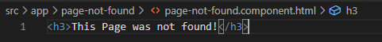

And add it to our appRoutes in app.module.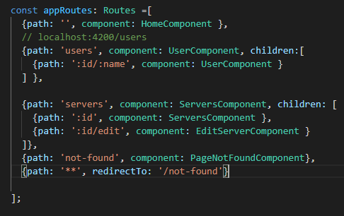

If you don’t want to specify a component to load you can use **redirectTo**  to specify a path.

The **\*\***  route is the wildcard route which means: catch all paths you don’t know. The order is very important here, make sure that the ** route is the last one specified in appRoutes array.

With this, everytime we access a path that doesn’t exist we will be redirected to page not found.

* **Outsourcing the Route Configuration**

We can create an app-routing.module.ts file to move all our routing configurations so we don’t add all of the in our app.module. We simply copy all our routing imports and routes array. But we need another extra step for this to work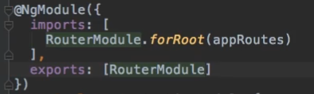

With this **exports** we tell Angular that if we add this module to the imports of another module, what would be accessible from it?

And the one thing we want to make accessible right now is our RouterModule.

* **Protecting Routes with canActivate**

I will add a new file in our root folder and I will name it auth-guard.service.ts because the code we run there is stored in such a service and now here, I will implement the canActivate interface.

This interface is provided by the @angular/router package,so you need to import it and it forces you to have a canActivate method in this class.

The **canActivate** method now will receive two arguments, the **ActivatedRouteSnapshot** and the state of the router: **RouterStateSnapshot**. canActivate also returns something, it either returns an **observable**,so make sure to import observable, from rxjs/Observable is the correct path.

In this case this observable will wrap a boolean, alternatively this route returns a promise, also returning the boolean in the end.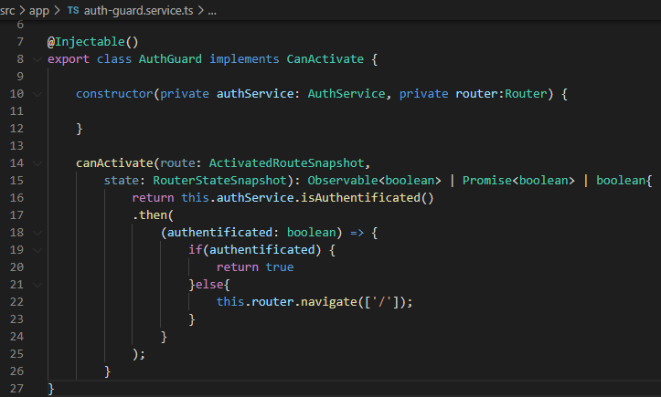

So canActivate can run both asynchronously, returning an observable or a promise or synchronously, because you might have some guards that execute code which runs completely on the client

Let's say we have another service, the auth service and this is just a fake service 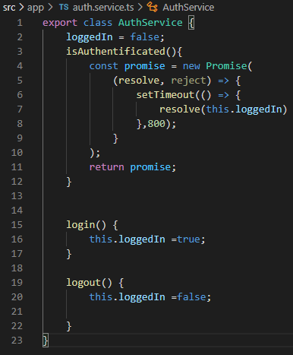

That might reach out to a server and allow us to login or logout and check our current authentication state.

We’ll add a fake login and logout method and I will have a method which allows us to check the state, authenticated and here I want to simulate that this takes some time to finish. In the end we’ll return a promise.

So with this auth service added, I now want to use it in my auth guard , we need to add @injectable to be able to reach out to the other service, to inject that service into this guard.

Now we’ll check the authenticated state, if it’s true return true and if it's false redirect to Home.

To use this guard we created we need to define which route or routes should be protected by this guard in our app.module with: 

and the new services we used in the providers array: **AuthService and AuthGuard.**

Now canActivate takes an array of all the code, all the guards, you want to apply to this route and it will automatically get applied to all the child routes.

* **Protecting child(nested) Routes with canActivateChild**

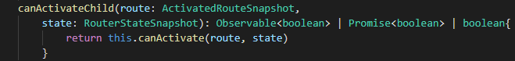

There is another guard we can use, it's pretty similar to canActivate, it's called CanActivateChild. This method in this class which basically takes the same form as the canActivate method, so it has the route and state and it returns an observable, promise or boolean.

Well and since this is exactly the same form and we want to run the same logic, we can simply return this.canActivate. So now we simply pass our route and state as arguments since canActivate expects these two arguments.

What is the advantage of adding this then?

Well since we added the CanActivateChild interface, we can now use a different hook here in our routes, instead of only using canActivate.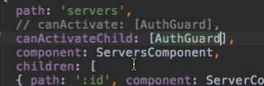

This CanActivateChild also takes an array of services which act as guards, which implement the right interfaces, and we can still add the auth guard because the auth guard now is able to do both, protect a single route since we have canActivate implemented or all child routes since we have CanActivateChild implemented.

* **Controlling navigation with canDeactivate**

Firstly we’ll add a new **changesSaved** property in our edit-server.component and which I want to update whenever I click on update Server, so we call changesSaved=true in our onUpdateServer(). After the changes were made I want to navigate away, for this we’ll use relativeTo configuration and want to navigate relative to the currently active route.

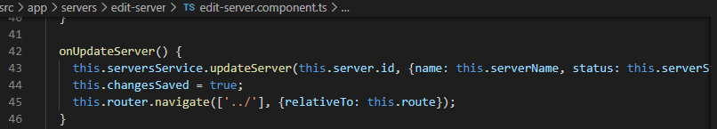

Now let's make sure that whenever the user tries to accidentally navigate away, that we prevent him from doing so or at least ask if he really wants to leave.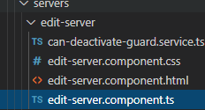

On our edit server folder here we’ll add a new file, named can-deactivate-guard. First of all I want to export an interface, an interface simply is a contract which can be imported by some other class let's say which forces this class to provide some logic.

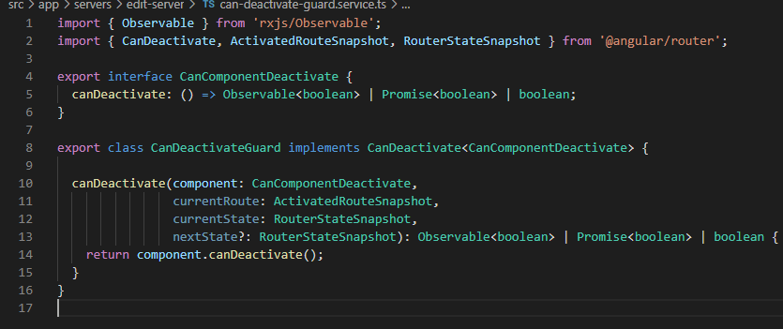

Now that we have the interface we also need the service itself, so we’ll name it **CanDeactivateGuard** an this guard will implement **CanDeactivate**, this is an interface provided by the Angular router, so we need to import it from there. This actually is a generic type and it will wrap our own interface.

This guard will also need to have a canDeactivate method, this is the canDeactivate method which will be called by the Angular router once we try to leave a route.

Therefore this will have the component on which we're currently on as an argument ,and this component needs to be of type **CanComponentDeactivate**, which means it needs to be a component which has this interface implemented(therefore a component which has a canDeactivate method). We also will receive the current route as an argument ( so that is an **activatedRouteSnapshot)**,It will have the **currentState** (so that's a **routerStateSnapshot)** and finally the **nextState (** so where do you want to go.)

Now I want to call **canDeactivate** on the component we're currently on,and this is why I need to implement this interface in this component ( the Angular router can execute canDeactivate in our service and can rely on the fact that the component we're currently on has the canDeactivate method too because this is what we will actually implement the logic checking whether we are allowed to leave or not because we need this connection between our guard and the component.)

With that set we can go to our **app-routing.module** and on edit page here we want to add this guard



For this to work we need to add our module to the providers array.

Finally for this to work we need a one last step, the interface now forces us to implement the canDeactivate method in our component which is important because we tried to call this method on our component here. So in the edit-server.component here, I will simply add a canDeactivate method

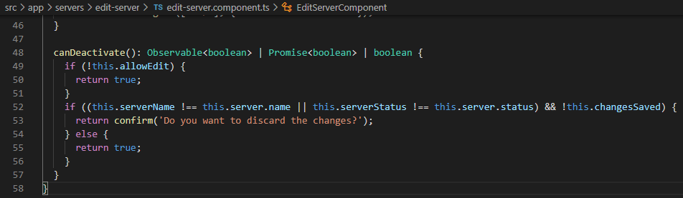

* **Resolving Dynamic Data with the resolve Guard**

Interface that classes can implement to be a data provider. A data provider class can be used with the router to resolve data during navigation. The interface defines a **resolve()** method that is invoked when the navigation starts. The router waits for the data to be resolved before the route is finally activated.

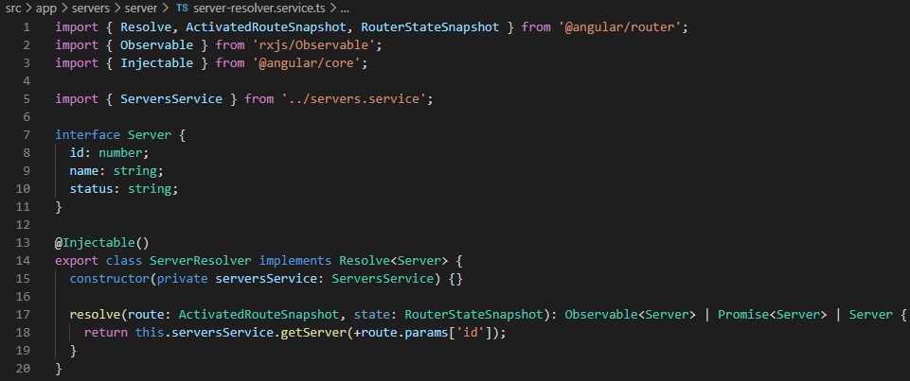

Resolve is a generic type and it should wrap whichever item or data field you will fetch here in the end, in our case we’ll fetch **server .** Now the resolve interface requires us to implement the resolve method and this resolve method takes two arguments, the route and the state.

This also has to return either an observable, a promise or just a server.

In this case we’ll need to import ServersService and with this the easiest way to use the resolve function is to reach out to our ServersService and call getServer and now we need to know the id of the server we need to fetch because that is what we do in the server component.

Now of course we have to add it, the first thing is in our app.module to our providers and to our routing module :



This is different to the other guards, there we use arrays but for resolve, a different approach is taken. This will now map the data this resolver gives us back and remember, it gives us back some data with this resolve method. The data it gives us back here the it will be stored in this server object 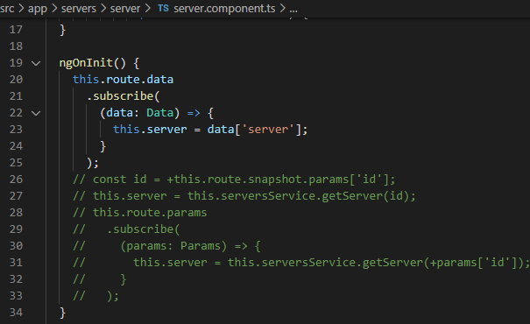

Next I will comment this out from the server component because now we use a resolver for this, so here we can easily get our server by binding the data observable.

1. **Course Project - Adding Routing**

This is the structure we’ll follow this chapter

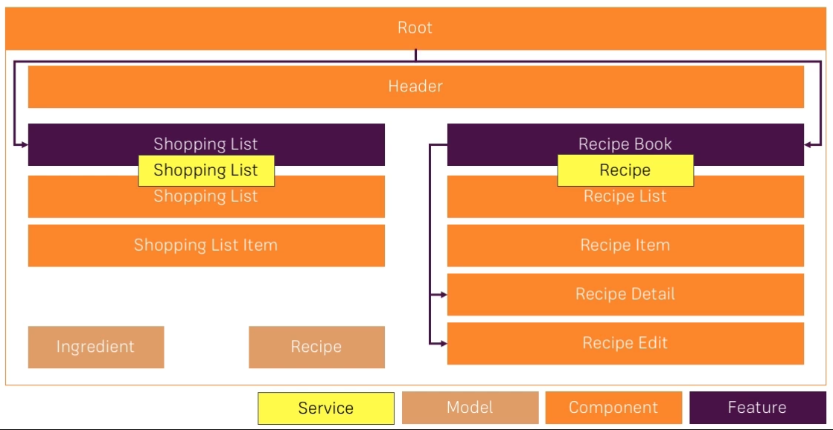

* **Setting up routes**

Now let's start with the root routes, with the routes for our overall application before we then dive into the child routes.

I will add an **AppRoutingModule** as shown in the routing section so let's add it in the app folder, the app-routing.module.ts file just like we did in the routing section.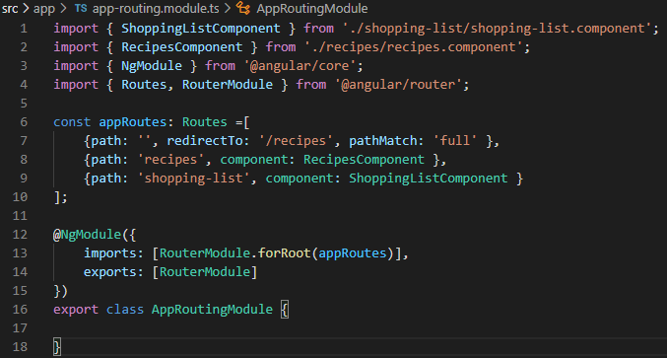

I'll add a constant named **appRoutes** which will hold our routes. Here we’ll add the **pathMatch** property (which overwrites the default and now says only redirect if the full path is empty) because we need to overwrite the default to it’s an empty path and an empty path is part of every path.

In my @NgModule we will import the **RouterModule** and call forRoot where we pass the appRoutes to configure this router module Angular ships with. With that our paths are configured and added to @angular/router but because we are in an extra module we want to get this into the main module, into our app module. I need to export this configured router.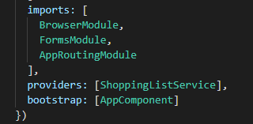

Next we need to import our AppRoutingModule into the app.module.

Now we just need a place for Angular to render our routes, so we add router-outlet in the app.component.

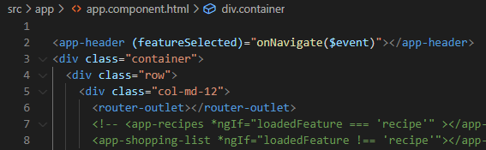

* **Adding navigation to the app**

We want to change the way we navigate in our header component, we no longer need our click listeners and the onSelect() method. These can be replaced with **routerLink**

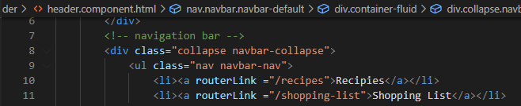

* **Marking the active route**

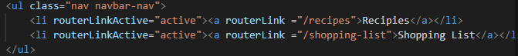

To dynamically add the “active” css class to the currently active route we can use the **routerLinkActive** directive(whenever the link on this element or nested inside of it, gets the active class)

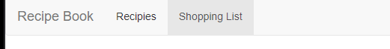

* **Fixing page reload issues**

To fix our refresh problem we need to remove the **href=”#”** from our a tags in:

Header, recipe-detail components. Now we shouldn't have any more reload problems when clicking the anchor tags on the header and recipe-detail

* **Adding child routing**

On our app routing module we add the **children** property to our recipes path, children takes an array of routes and each route is a Js object.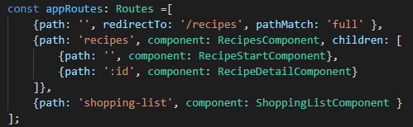

The first path is the empty path for which we create a new component **recipe-start component** where we output a <h3>Please select a recipe! </h3>

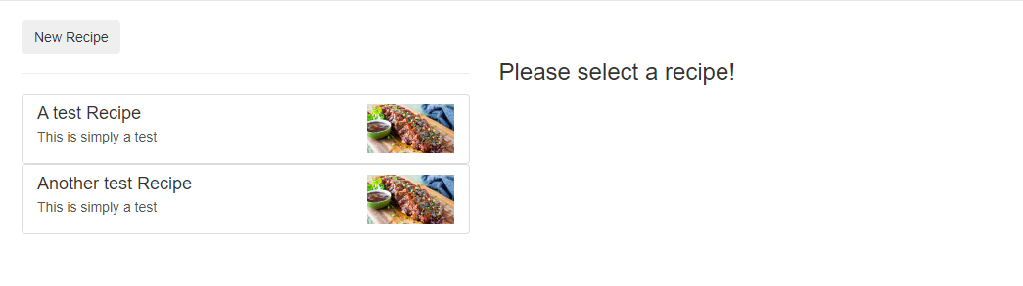

For the next path, in the Recipe Component , because this is the component where our child routes are registered so is in this components template that we need to provide a router outlet for the child routes to be rendered.

 We take the first step for restoring the functionality of our recipe select by adding this route which would allow us to load this component.

* **Configuring Route Parameters**

In the **recipe detail** component we can clearly remove @Input because that is not how we receive the value anymore, that means that we can remove the click listener and the onSelected method from the **recipe item** component.

So now in our **recipe-detail** component, we need to get our single recipe and we know that we will get the ID from the router.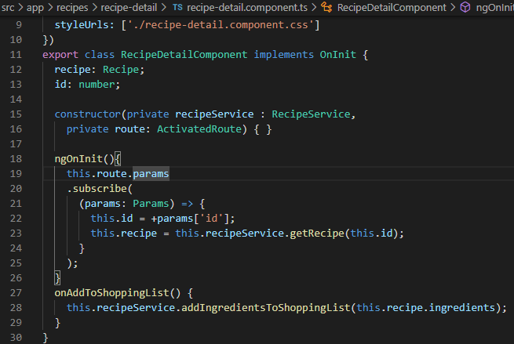

Let’s fetch this ID, for this we need to get access to the **ActivatedRoute** by injecting it.

Next we want to use the route, the params observable and subscribe to that observable, so now we can react to a new ID and store it into a property of our class **id: number.**

With this information we want to load our recipe form the recipe service and for that, we need to change our recipe service . In the recipe service we implement the method **getRecipe** which takes an Id of type number and then return the recipe at this index.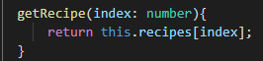

Now we can fetch our recipe using our recipe service whenever the ID changes



* **Passing Dynamic parameters to links**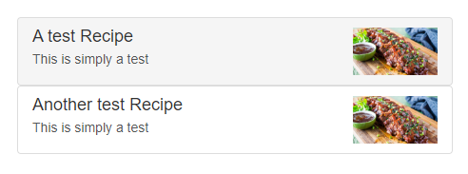

Here we’ll make these links to work again.

The place to make these links to work is our recipe list>recipe-item component.

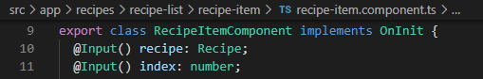

With this in our recipe-item we can now pass in the index of this item from outside, so we’ll do that from the **recipe-list component.**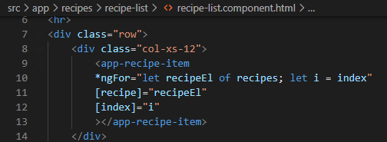

Here besides sending the recipe itself, I can also pass the index.

Now that we have the index property in the recipe-item we can complete our link.

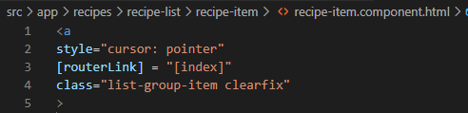

* **Styling Active Recipe items**

We use the property **routerLinkActive** the same as before

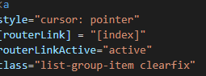

* **Adding Editing Routes**

For this we’ll need a new **recipe-edit** component, we’ll work on this later on in our forms chapter but we already want to load it.

To load this we need to go to our **AppRoutingModule** and add our paths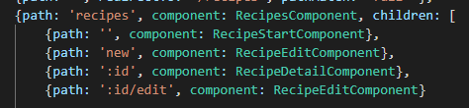

I will determine in the component whether we are in editMode or not.

(the new route comes before the route with the dynamic parameter, otherwise how would Angular know if whatever we pass right now is a new hardcoded path or a dynamic parameter)

* **Retrieving Route Parameters**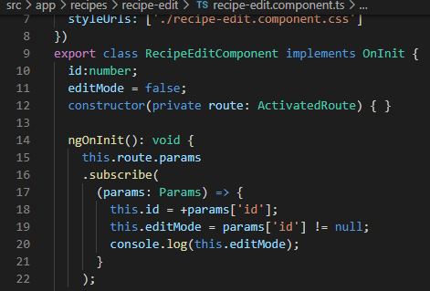

So we added our routes for the edit component,now let's go to that component and retrieve the ID and therefore determine whether we are in editMode or not.

We will inject the ActivatedRoute and in ngOnInit, we will retrieve the ID.

We will use the route and the params observable and subscribe to that, further we receive **params** which are of type **Params** and here I retrieve the ID that I’ll store un the property named id.

For our editMode we can initially assume that we are creating a new recipe, we are not in editMode. Now I will check this whenever the parameters change, then assign a new value to editMode. (we check if the id is null, if it is edit mode will be true)

* **Programming navigation to the edit page**

For that we’ll go to the **recipe-list component** which is where the **Edit Recipe button** is and add a click listener to it **OnNewRecipe()**

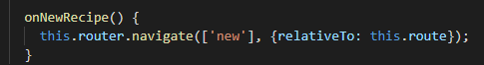

We need to inject the router to be able to navigate to this route and with that in onNewRecipe, we target the router to use the navigate method to target this path.

Because we already are on /recipes here, I can use a relative route and simply add new to it. Now to be able to use a relative route in the navigate method though, we also need to inform the router about our current route.(we do this with **ActivatedRoute**)

Next for the recipe **edit button** we add a new method **onEditRecipe()**

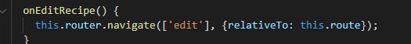

With the same principle as the new recipe button.

1. **Observables**

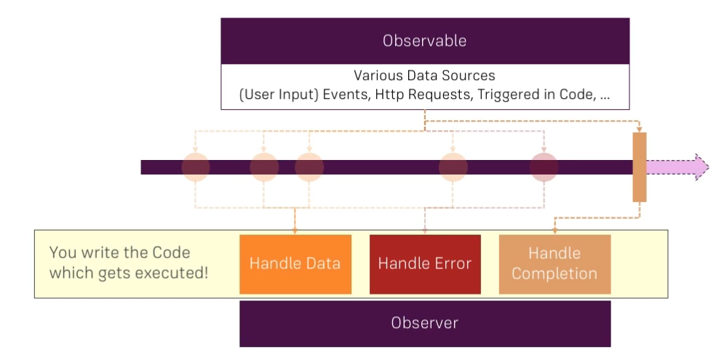

* **Create a custom observable**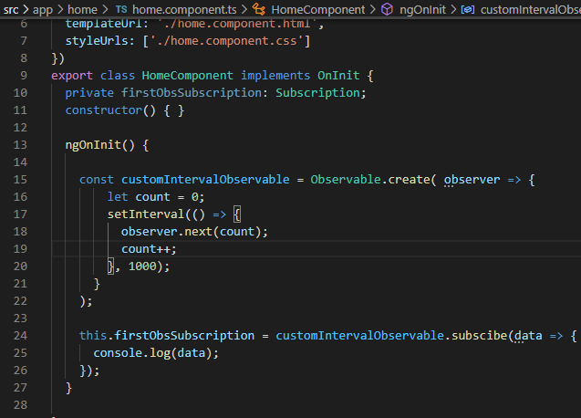

We’ll store our observable in a constant(in our case customInterval Observable), where we pass Observable.create.

The **create** method actually takes a function and I'll pass in an anonymous arrow function here, which will get an argument automatically, **RxJS** will pass in that argument for us and that argument is a so-called **observer.** (observer = is a part that is interested in being informed about new data, about errors or about the observable being completed.). Our job here is to tell the observer about new data , about an error or about the observable being completed, we're **not responsible for listening** because the observer is the listener (here we get that listening part as an argument and we need to tell it once we're done, once new data is there).l

So in this anonymous function, we can now use the regular set interval method and set an interval of one second, now this again receives an anonymous function. Here we call the observer with the method **next**() which emits a new value, and increment our count. With this,now, the count starts at zero, we increment it by 1 whenever the **set interval** fires and we let our **observer** know about that new data here.

Next we can also subscribe to our custom observable, and call subscribe and pass a function that simply accepts that **data** we're emitting then console.logging it.

Finally if I navigate away, then we got a problem here because I tried to call unsubscribe of undefined because I don't store my subscription so we’ll fix that by storing it into **firstObsSubscription.**

* **Error, Completion**

We'll use the **error method** to throw a new error here when count is greater than 3,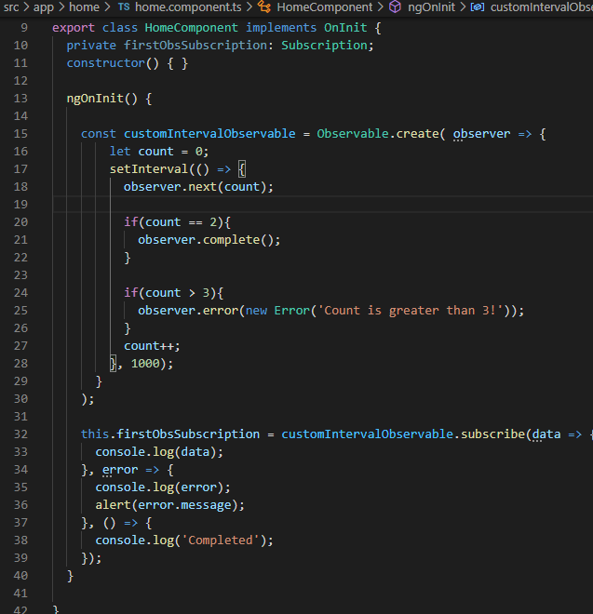

To **handle the error**, we passed the first argument which is this data function, the **second** argument would be our function that gets called when an error occurs and we'll get the error as an argument there.

Here we console.log that error and alert message it.

Now our interval by default doesn't complete, it will emit new values until the end of time, so we can complete it manually using the **complete() method** when count is equal to 2.

If you want to react to that completion, you can add a **third** arguments to the subscribe method and that is the **completion handler function**.

* **Operators**

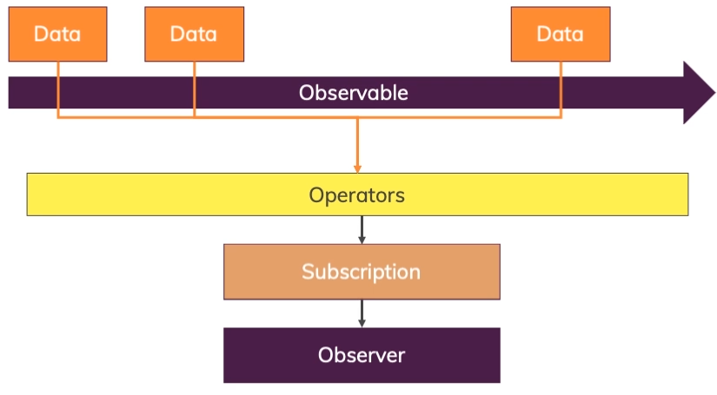

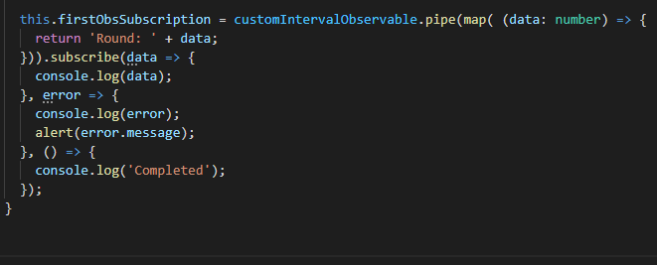

There are tons of built-in operators, like the **map** operator, which is one of the operators more often used.

So we have the **pipe method** and we're importing map.

Now we simply call map as a function inside of pipe here and map in turn takes a function as an argument, so an anonymous function. That anonymous function gets an argument and that is the data you would otherwise get here in your first subscribed callback. (It's the current data of your observable that's being emitted by that observable.) So we get that data here and in map, we now have to return new data.

* **Subject**

An RxJS Subject is a special type of Observable that allows values to be multicasted to many Observers. While plain Observables are unicast (each subscribed Observer owns an independent execution of the Observable), Subjects are multicast.

1. **Course Project- Observables**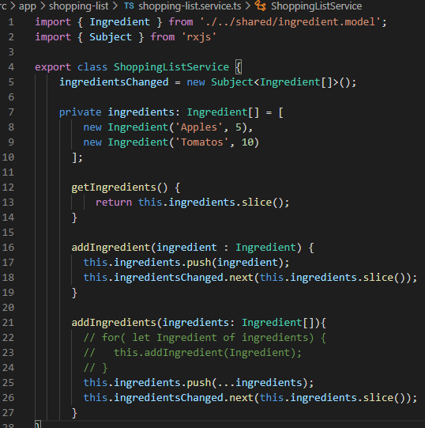

We replace in our shopping-list service the eventEmitter with **subject** and replace emit with **next.** Because subject use next to emit or send a new value

Here in the shopping list component, where we subscribe to the ingredients changed event emitter previously, we now subscribe to the subject, that has the same syntax.

However there is one thing we need to change, we don’t need to store that subscription in a property (**igChange**) and clean it up when we leave the component. (**onDestroy**)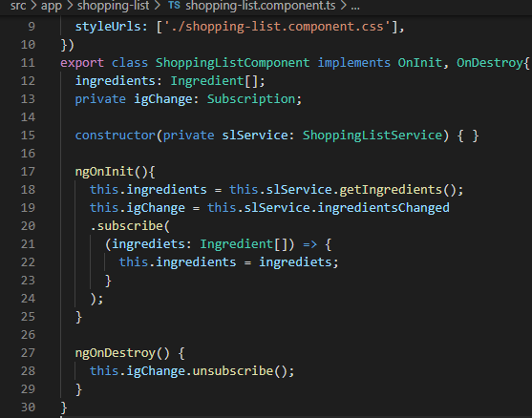

1. **Handling Forms**

Approaches:

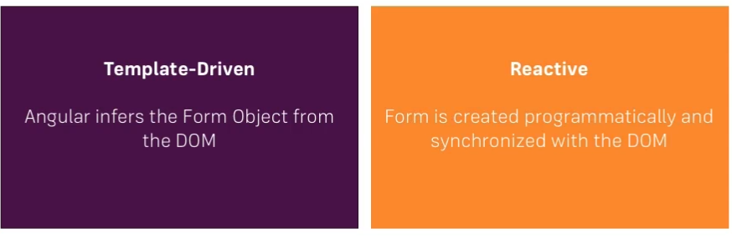

* **TD Submitting and using the form**

For this we create a dummy project with: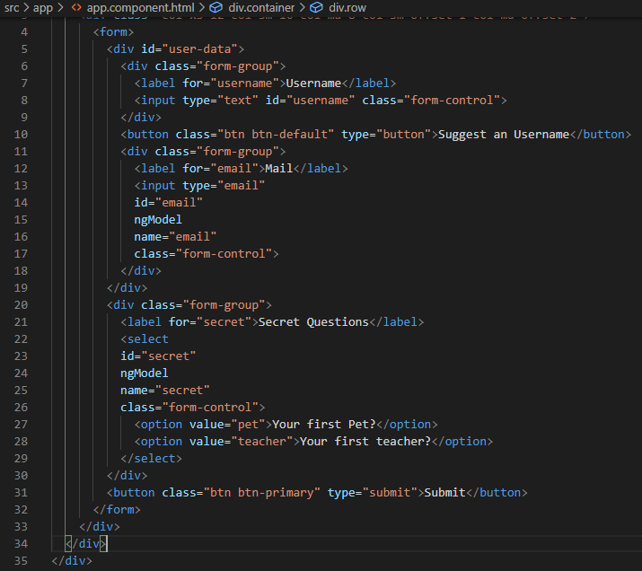

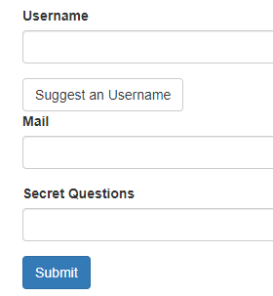

By adding  to our form element we use the **ngSubmit directive** that gets fired whenever this form is submitted, and here we call our method **onSubmit.** We add the reference #f to our form so we can access it in our method. To our #f we add **ngForm** which tells Angular to give access to this form that was created automatically by him. ( to the form Js object).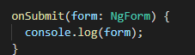

onSubmit will console.log our js form object.

* **TD accessing the form with ViewChild**

This is useful if you need to access the form, not just at the point of time when you submit it but also earlier.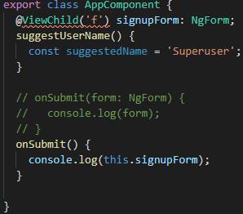



* **TD Adding Validation**

For example, we add required to our username input.**Required** is a default HTML attribute you can add to an input, here however Angular will detect it so it acts as a selector for a built-in directive shipping with Angular and it will automatically configure your form.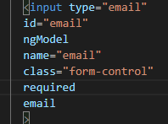

On the e-mail, we can for example therefore also add required and there also is an e-mail directive you can add. E-mail is not a built-in HTML attribute, but it still is a directive. ( e-mail is simply another directive made available by Angular which makes sure that this is actually a valid e-mail address.)

* **TD Using form states**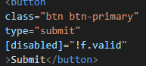

Here we add a disable property binding , so if the form is not valid then we disable the button.

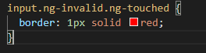

For the css we can also give our inputs a red border if they have the angular classes ng-invalid and ng-touched.

* **TD Outputting validation error messages**

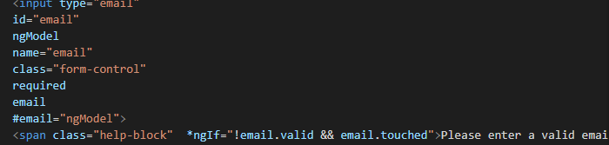

The ngModel here in the reference exposes some additional information about the control it creates for us in the overarching form by accessing ngModel. With this we display the span element if email is not valid and if it wasn’t touched.

* **TD set default values with ngModel**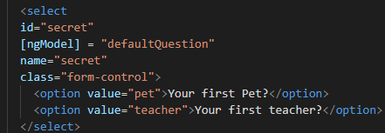

We add [] around ngModel so we can use property binding so this select here can now be bound to a default value and you could either hardcode a string or pass a value, defaultQuestion which has the value ‘pet’.

Now the default selected item is pet.

* **TD using ngModel with two-way binding**

For this question here we’ll add a new form group and a textarea. Now we could add ngModel to get access to whatever the user entered as a reply but we instantly want to repeat this reply.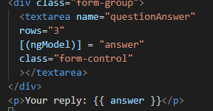

For this, we could still use two-way binding on ngModel here and bind it to the answer property which we initialized with an empty string in the ts file.

* **TD grouping form controls**

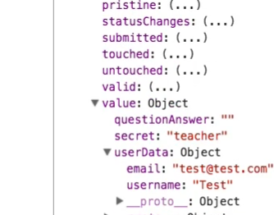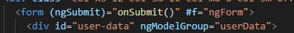

We already have a div that wraps the username and email so we can please a new directive **ngModelGroup** which will group this into a group of inputs in the POST.

* **Setting and patching form values**

You can do this with 2 way binding but this is an alternative solution:

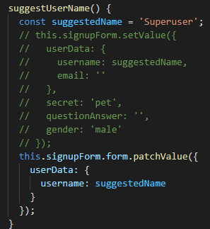

Remember that we do have access to this form here through @ViewChild.

For this, we get two different methods we can use:

The first one would be on our signupForm,the **setValue** method here.This allows you to set the value of the whole form.

However this approach does have one downside. If we already had some value we enter there and then want to click suggest username, it overwrites all our other content.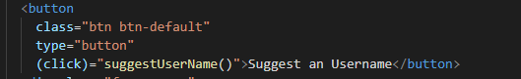

For the second one we have the **patchValue** method that is not available on the signupForm itself but on the FormGroup wrapped inside of it, here you can pass a Javascript object too, where you only overwrite specific certain controls. After setting it up, after I click the button now it only added super user and left all my other controls untouched.

* **TD Using form data**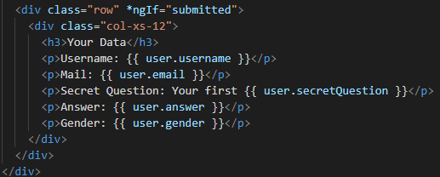

We only want to output this once the form has been submitted and then populate it with the data of my submitted form.

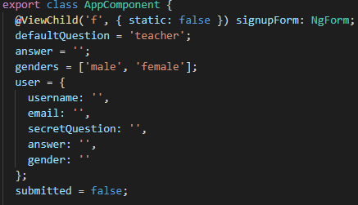

So in the app component here, I could add a new property named user, which is a Javascript object, which holds a username property,email,...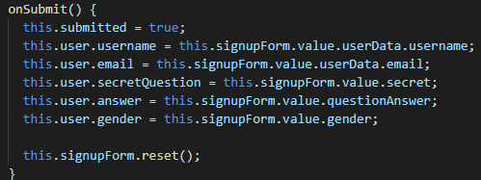

So that's the user object as created by default and when submitting the form, I want to update it.

Next in the onSubmit we update our **user** with the values from our **signupForm**

To **Reset** our form we can call signupForm.reset(), this will not only reset our inputs but will also reset our state like valid, touched and so on.

* **Reactive Creating a form**

I will initialize my form in the ngOnInit method, because we should initialize it before rendering the template of course, so make sure to use a lifecycle hook which is called before the template is rendered.

Here I will set up my **signupForm** and I will set it equal to a new **FormGroup** because signupForm is of type FormGroup.

Now we have almost a valid form, we need to pass a Javascript object here and add controls. **Controls** are basically just key-value pairs in this object we pass to the overall FormGroup.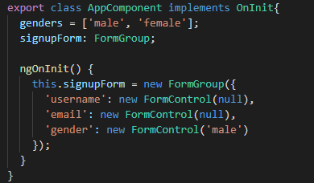

Because we have a username, email and gender field we will add them to the controls.

**FormControl**, another class made available by the reactive forms module or by this forms package.

Now this FormControl constructor, we can pass a couple of arguments: the **first** argument is the initial state, the **second** argument will be a single validator or an array of validators we want to apply to this control and The **third** argument will be potential asynchronous validators.

Now this basic form is initialized.

* **Reactive syncing HTML and Form**

Right now, Angular doesn't know which of our TypeScript controls here relates to which input in our template code, to fix this we add the **formGroup** directive here on the form itself and we pass via property binding our form as an argument, **signupForm** . Now this tells Angular, - use my formGroup that I defined not the default one.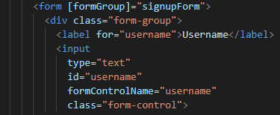

Next to tell Angular which controls should be connected to which inputs in the template code, for this we use another directive, the formControlName directive and here we pass the name of the control I want to connect this input to.

* **Reactive Submitting the Form**

The difference from the Template Driven approach is that we don’t have to get the form via a local reference because Angular doesn’t create the form for us anymore, we created it on our own in the ts file and we have access to it.

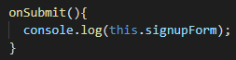

* **Reactive Adding Validation**

In the template driven approach, we would simply add required to the input. It doesn't work like this here in the reactive approach, because we’re not configuring the form in the template, you're only synchronizing it with the directives, formControlName and formGroup but you're not configuring it in the template , the TypeScript code, that's where you configure it. That is why FormControl takes more than one argument, the second argument allows you to specify some validators.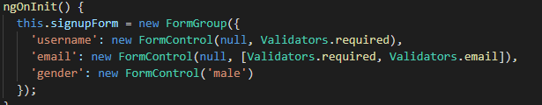

* **Reactive getting access to controls**

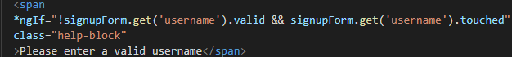

The get method allows us to get access to our controls easily, here you can either specify the control name or the path to the control.

* **Reactive Grouping Controls**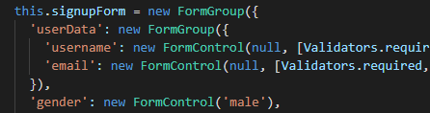

For this we use formGroup to nest our controls

Next we need to update our synchronization and we easily do this by wrapping our form controls here in another element like a div with the directive **formGroupName.** But with this addition we also need to change the path for out get, because now we have userData>username.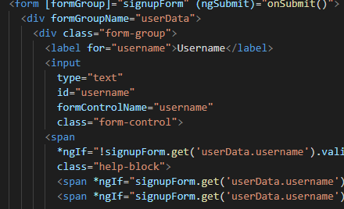

* **Reactive arrays of form controls**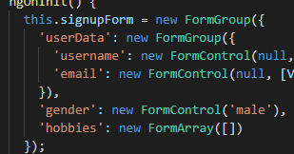

So the type here for the hobbies is not FormControl or FormGroup, instead it’s **FormArray.** Form array holds an array of controls, so you pass an array here to initialize it. In this array you could already initialize some form controls.

Next we make a method onAddHobby() that adds a new hobby to that array.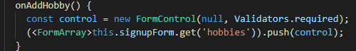

With this we are able to add controls but we won’t see it, we need to synchronize it with our HTML code.

So on this outer div , we’ll add a new directive , **formArrayName**. This tells Angular that somewhere in this div, our array will live.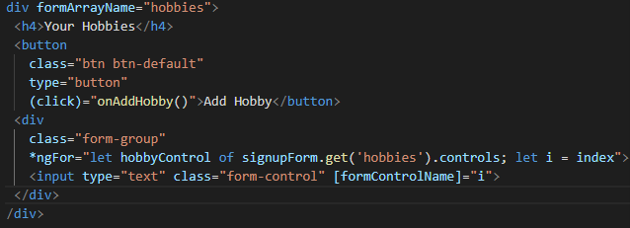

Next we’ll use this array with an input which allows the user to enter the actual hobby.

Now we loop through all the controls which are in this array with ngFor, and add an index to assign this input to one of these dynamically created controls

* **Reactive custom validators**

We want to create our own validator which checks whether the username the user entered is one of the users specified.



This method will be of type FormControl, a validator also needs to return something for Angular to be able to handle the return value correctly ---- a JS object that should have any key which can be interpreted as a string (so this function should return something like  this) 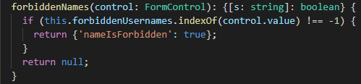

Next we check if the value of the control is part of this **forbiddenUsername** array, if this is the case we want to return an object which tells us the nameIsForbidden, if not we return null( if **validation is successful** we have to pass nothing or **null** ).

For this to work now we add a reference to the forbiddenNames function in our username . We use bind here because we need to make sure that this refers to what we want it to refer to.



Now if we enter a text in our username input it will stay invalid that is because right now we are checking if the control value is part of this array , this will return -1 if it’s not part. -1 is interpreted as true so we need to check if this is not equal to -1.

* **Reactive using error codes**

We want to say The ‘username is required’ if the field is empty and’ invalid username’ if forbiddenNames is true

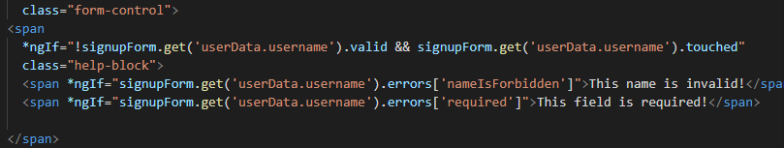

* **Reactive creating a custom async validator**

We create the forbiddenEmails method, this asynchronous validator also takes the **control** as an argument and returns a promise or an observable

So here we want to create a new promise which returns us anything and as all promises this receives a function with resolve and reject as arguments.

Next we add a timeout method to simulate the fact that we have an async task like reaching out to a server, and check if control value is equal to this email.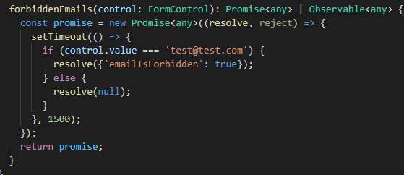

Next we add it to our email form control as the third argument



* **Reactive reacting to status or value changes**

There is a form state we can track in general, we’ll do this here on the ngOnInit, on my singupform and on each control of this form. You have 2 observables you can listen to **status changes** and **value changes.**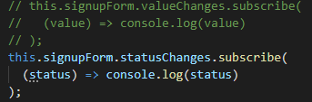

For value changes fires whenever we change something on the form, for example we change the input.

For status changes whenever we type something in the email input for example we get the status of the validation:

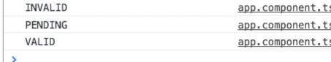

* **Reactive Setting and patching values**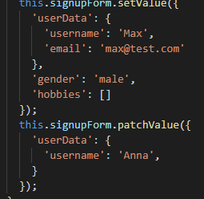

Setvalue prepopulates our form with the given values.

And as in the template driven approach you also have patchValue of course if you only want to update a part of the form

1. **Course Project - Forms**

* **Td adding the shopping-list form**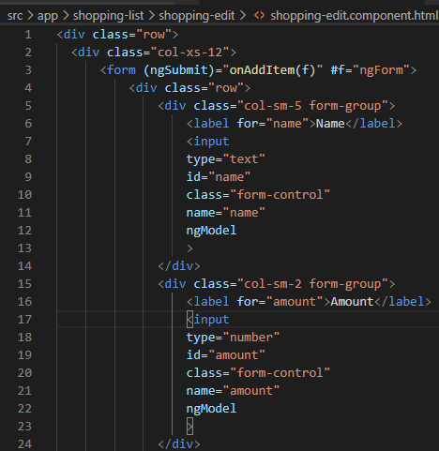

We use the template driven approach here where we get access to the form by placing a local reference to the form.

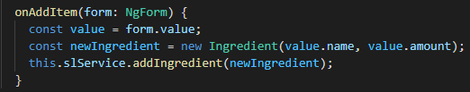

Here we access the values from the form passed down from our template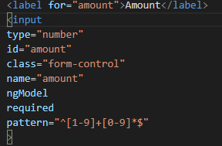

**Adding validation:**

For validation on the name input and amount input we added the **required** so we get some basic validation.

Next, an easy way of making sure that we may only enter numbers greater than zero is to use another build-in validator, the **pattern** validator , which will check the user input against a regular expression. (the expression we used will allow any number greater than zero). Finally we trigger the disabled property for our add btn if the form is valid or not.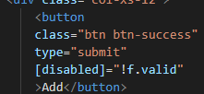

* **Adding the Selection items in the List**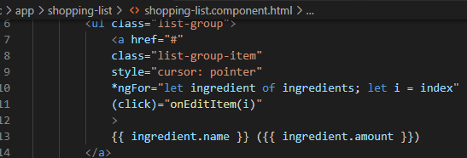

In our shopping-list component where we have our items I want to add a click listener to the item, so that we can click it and here we also pass an argument to the method the id of the ingredient. We need the id because later on we need to be able to replace the correct one in the array of ingredients which is managed in a service.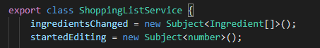

We’ll add a new subject in the shopping lists service and that I'll name startedEditing.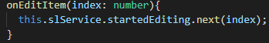

With this subject created in onEditItem, I can reach out to the shopping list service which we already inject and then use startedEditing and emit a new value , my index, which will make sure that now we pass on this index to our subject for now so that I can listen to it in other places like the shopping edit component.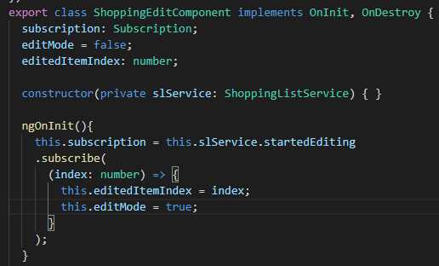

We store our subscription in this property **subscription** . Here we will receive the index and this will be triggered whenever we submit the startedEditing information.

So we store the index and if we are currently editing

Finally we implement OnDestroy to clear our subscribe just to be sure that you don’t create a memory leak.

* **Loading the Shopping List Items into the Form**

We already get the information about the item we’re about to edit.

I'll need a new method which simply gets the ingredient which expects to get the index a number and which will simply return the ingredient from our ingredients array.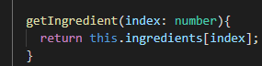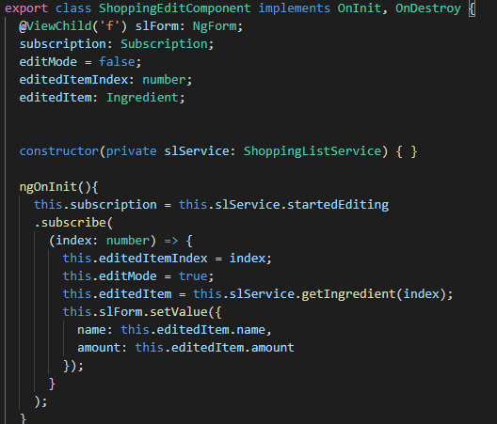

Now we can reach out to this new method in our **shopping-edit component** and store it in **editedItem** which is an ingredient, And we do this whenever we get a new information that we're in the edit mode. So here editedItem will reach out to the slService to the item we get from the getIngredient() method.

Next we want to reach out to our form and call **setValue** here, to assign a new value for the name and amount.

* **Update existing items**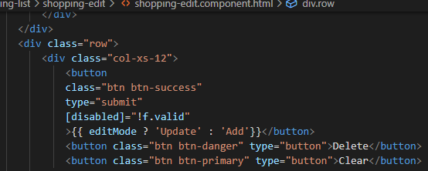

In the template, we set the button to only be add if only we are adding an item, if not we are updating a selected item.

In our slService we add a new method **updateIngredient**() , here we can reach out to my ingredients, get the one we are looking for and set it equal to the new one. Next I want to call ingredientsChanged and emit our updated ingredients.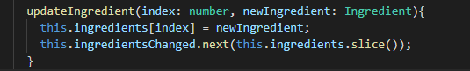

Now we need to call out this method if we are on editMode on our onaddItem method.

Here we can also reset the form by using form reset and setting editMode to false.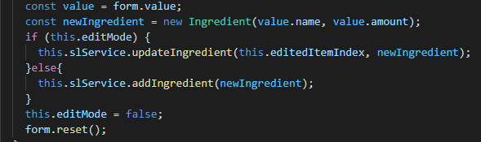

And use the same thing for out **Clear** button :



That has an onclicklistener and calls onClear() 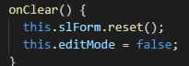

* **Allowing the Deletion of Shopping List Items**

We add an event listener an call the method onDelete() when we click the delete btn

On our shopping list service we add a method **deleteIngredients.** Here we can use the ingredients array and splice one of the elements and then call ingredientsChanged so we can refactor this.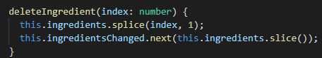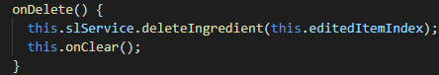

With that before we clear everything we call **deleteIngredient** and pass the editedItem **index.**

* **Creating the template for the(Reactive) recipe edit form**

We create the html structure for our recipe-edit component where we add name, image url, description, save, cancel and clear

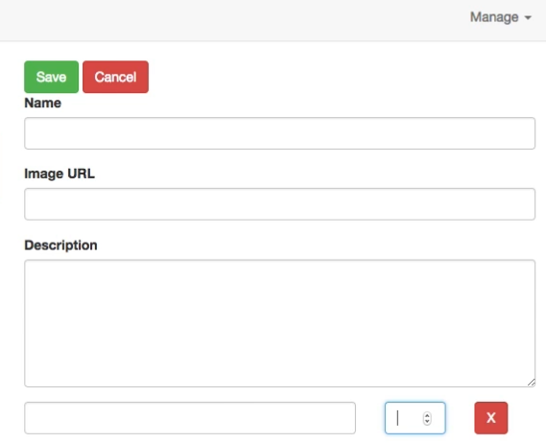

* **Creating the form for Editing Recipes**

So I will create a new private method in the recipe-edit.component which I'll name **initForm** because it is responsible for initializing our form. The form itself shall be a property here, so I will name it **recipeForm** and it will be of type FormGroup. I will reach out to **recipeForm** and assign a value and this value will be a new FormGroup to give us the outer shell of our form. **FormGroup** takes a Javascript object where we have key-value pairs for the control we want to register. 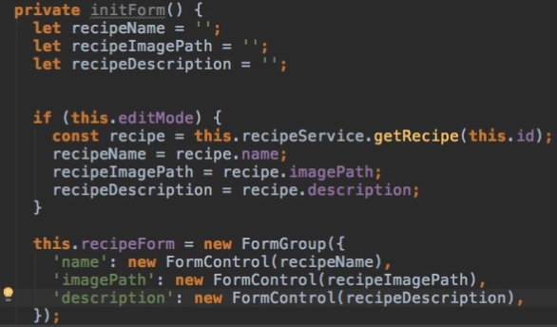

So the first control I do want to register here is the name of the recipe.

We create a variable at the top here which holds our recipe name and then let's add some logic which decides what the value should be if we are in edit mode.

We’ll do the same logic for the recipeImagePath and recipeDescription

We should call this method every time our route params change because that indicated that we reloaded the page 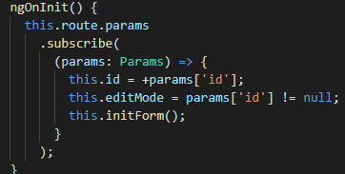

* **Syncing HTML with the Form**

First of all we need to add **the reactive forms module** in our app module otherwise synchronizing with our HTML code will fail because we don't have access to the directives we need.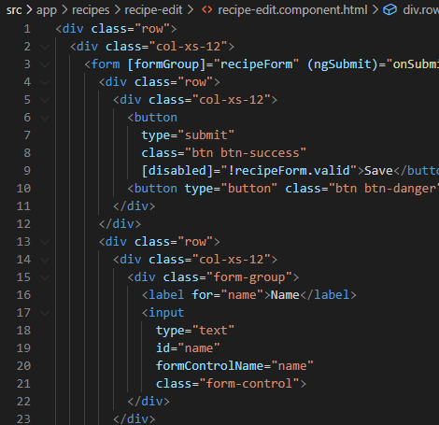

Now on our recipe-edit.component. Html file we want to connect to the form. We start by adding the FormGroup directive which we should use with square brackets because we need to pass some data to that directive via property binding and that data is our **recipeForm**. Now we're telling Angular that our overall form is managed by us and that Angular itself should not manage it, instead it should take our form.

With this, we can now assign our own controls, so we add **formControlName** to our name, imagePath, description input.

I'll also set up the **ngSubmit** listener and listen to **onSubmit()** method.

* **Adding Ingredient controls to a form array**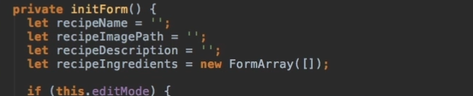

Let's work on our ingredients list,the base form is working but of course we got another control which we haven't added yet,this is this array of ingredients.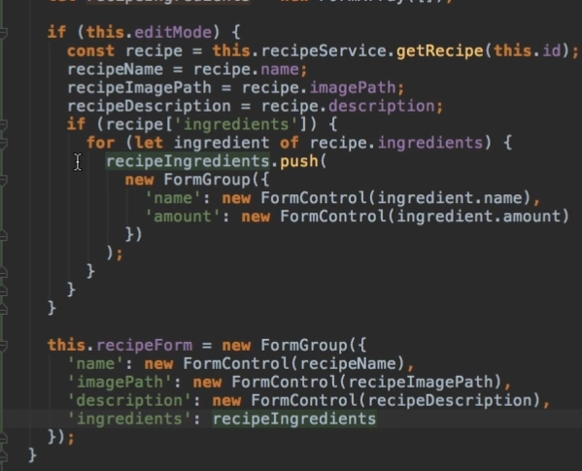

So when we initialize the form, we actually will have one other default value for the recipe ingredients, this will be a new **formArray.**

Here if we are in editMode we’ll check if we have any ingredients to begin with.

In this case, I want to use all the **ingredients** so I can simply loop through them with a for/of loop.

For a single ingredient of my ingredients, I can go through all of them and I can push them onto my recipe ingredients **formArray** which has a push method. ( I don't push the ingredient, I push a new FormGroup instead because I do have two controls which will control a single ingredient, the name and the amount.)

Next we need to synchronize our array with our HTML, so in the recipe edit component template .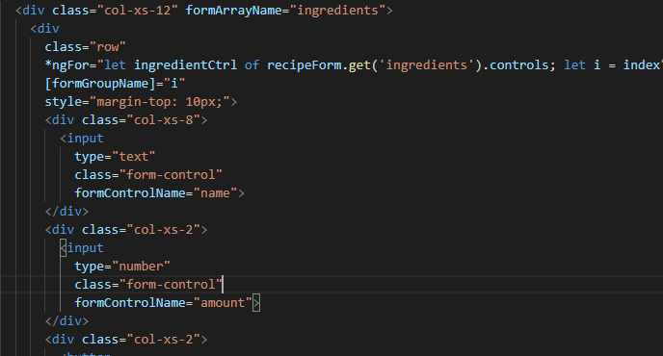

We add the formArrayName directive which will be bound to our **ingredients array (our form array).** Now each control of course is now going to be our row here, so on this row, I can place the **formGroupName** directive referring to the individual formGroupName **because** in our array, we will have form groups as each pair of name and amount control creates a FormGroup.

Now we add ngFor so we can loop through the ingredient control of my recipe form and there, get the ingredients control. **Get** is a method which gives us access to that and here.

So this gives us access to all the controls and the individual control is now saved in the ingredient control property or the variable we can use in the template and I can also extract the index of the current iteration which will be the name for my FormGroup.

Adding an add ingredient btn:

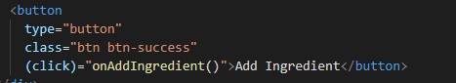

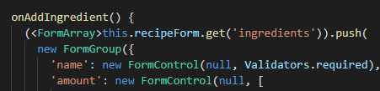

* **Validating user input**

We want to add the **required validator** to:

-our name, imagepath and description inputs, the same for when we create a new ingredient to the name and amount on the initForm()/

-in our onAddIngredient() to the name and amount

Don't execute it, don't add parentheses, you only want to pass a reference to this validator so that Angular is able to execute this method at the time it validates the input.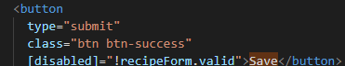

Now to use the validation we bind our save btn to disabled if the form is not valid.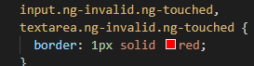

And also mark our invalid form inputs with some css styles.

* **Submitting the Recipe Edit Form**

I will need to change my recipe service, right now, it has no method which allows us to add or update recipes, so I'll add it, **addRecipe() and updateRecipe() .**

In the addRecipe case, I will simply take my recipes array and push a new item on it.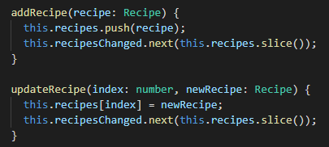

In the updateRecipe case, I will take my recipes array, take the element at the index I got here as an argument and set it equal to the new recipe.

Next on our onSubmit() in the recipe-edit component: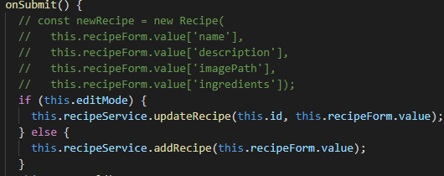

We can skip the first step (the one commented) of saving it in a new constant and just pass the **recipe form value** because the object stored here should have a valid format to fit one of our recipes.

**But for this to work** we need to fix a problem, We had this problem earlier in this course. It has something to do with our recipeService. We add an updateRecipes but when we get a list of recipes, we return a copy here with the slice method. Therefore this is not the same array we're using in our component as the one we're storing in this recipe service. We can simply use the same approach as in the shopping list service.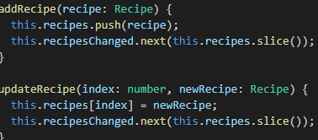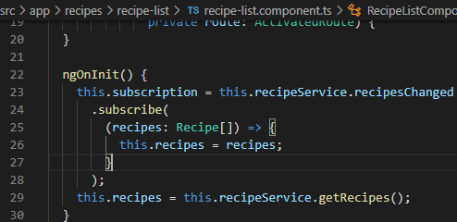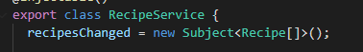

I'll have my **recipesChanged** event here, which is a new subject and now here where we call **addRecipe**, I use this **recipesChanged** event here to emit a new value, this new value is a new copy of my recipes.

So with this added now, we can go to our **recipe list component** which is in the end where we get our recipes and in ngOnInit,we want to listen to this event. I will subscribe to that event and if it did change I will receive a new array of recipes

* **Adding a Delete and Clear(Cancel) functionality**

We’ll start with the delete btn by creating the **deleteRecipe** method in our **recipe service**, where I will get the index of the recipe which should get deleted then I will use my recipes array, call the splice method and splice at the index one element to remove it. Thereafter I'll call **recipesChanged** and emit a copy of the updated recipes.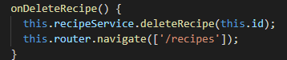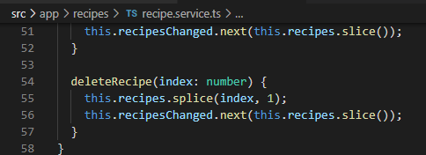

Next I’ll add a click listener on the delete btn from the **recipe-detail component** and implement the method **onDeleteRecipe().** Here onDeleteRecipe and I simply want to reach out to the recipe service, call deleteRecipe and pass the id and then navigate away.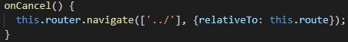

Next for the cancel btn from **recipe-edit component** we add an event listener that executes **onCancel()**. Here we’ll just navigate away.

* **Adding an image preview**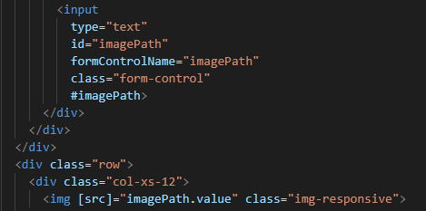

We bind the src to the imagepath reference value

1. **Using pipes to transform output**

To demonstrate the use of pipes we use a practice project

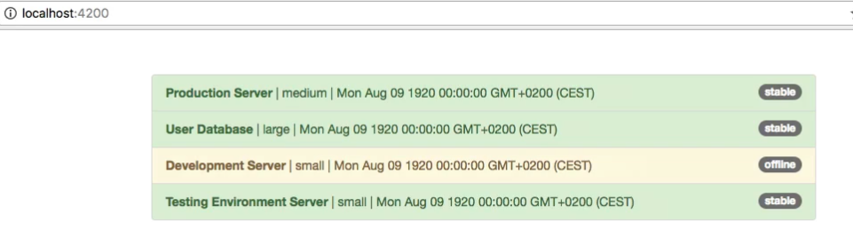

* **Using Pipes**

Here we used a pre build pipe like uppercase

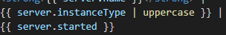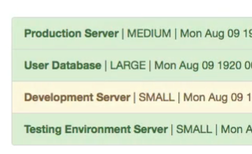

* **Parametrizing Pipes**

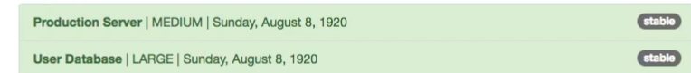

For example on the date here, we can add a parameter to configure the pipe by adding a **colon** . The date pipe can take a parameter and we simply add it after this colon.

You can find more about prebuild pipes on the angular cli documentation

* **Chaining Multiple Pipes**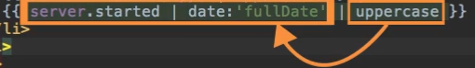

We simply add another pipe to chain them but the order is important , they will be parsed from left to right.

* **Creating a custom pipe**

To create a new pipe, we create a new file in your app folder, in our case we’ll create a pipe which shortens the words.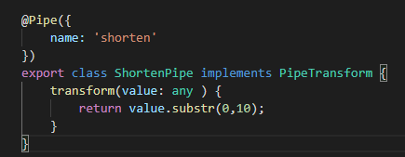

We’ll name our pipe ShortenPipe, this class needs to have one special method to be usable as a pipe and whilst not strictly necessary,it's a good practice to implement a certain interface which requires you to implement the method, the interface is called **PipeTransform.**

Now adding the transform method to receive the value which should get transformed.

Now to shorten this value, a quick and easy way to do this would be to return a string where we used the substring method which gives us the first 10 chars of the string.

We also need to add a special decorator, the **@Pipe** decorator which is also imported from @angular/core. In the @Pipe decorator, you can specify the name for the pipe by simply adding name and then for example, shorten.

Now that our pipe is created we need to import it in our app module declarations and use it in our template: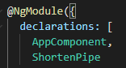



* **Parametrizing a custom pipe**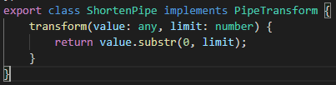

We receive a second argument in the transform, with this change you allow the user to pass a parameter to the pipe.

1. **Making HTTP Requests**

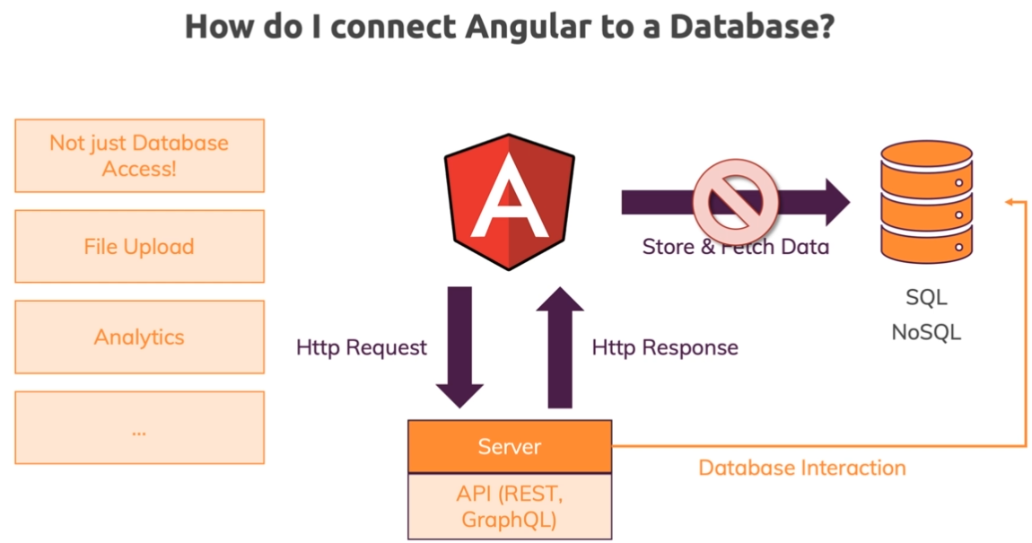

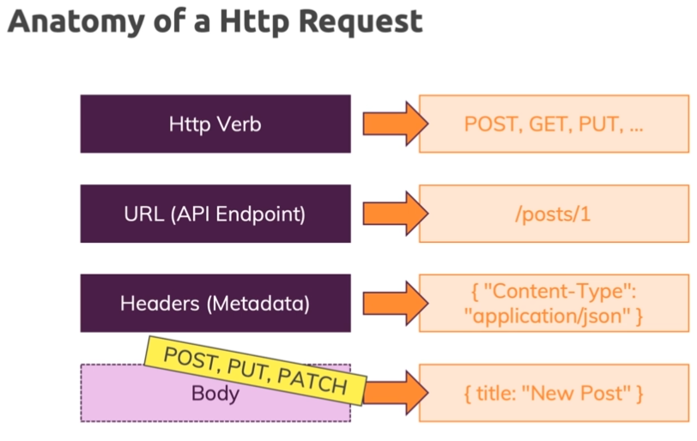

For our backend setup we’ll use **firebase** so we can get started for free.

* **Sending a POST request**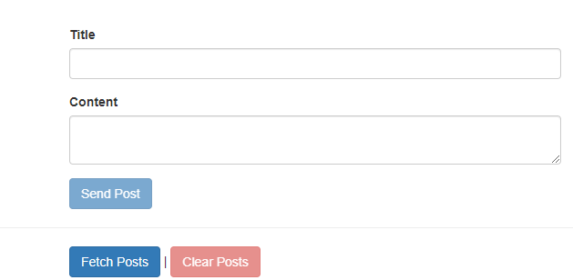

This is the practice app we’ll use for this chapter.

We start by adding the **HttpClientModule** in our app.module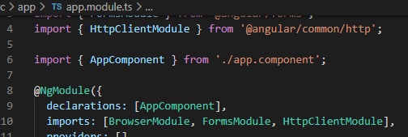

We can now start sending requests in our app componen. In there, we now just need to inject our **HttpClient** and import it 

Now let's say here in **onCreatePost** once we got that post data, we want to send it to Firebase. We can use that injected HTTP service and there, you have a couple of **HTTP verbs**(methods): **get, delete, post ….,** and that will allow you to send different kinds of requests.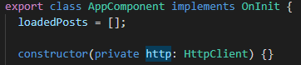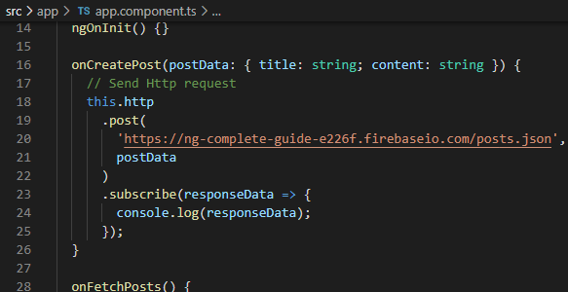

Now here since We want to store data, we'll start with a **post** request. Now you call this method and it takes a couple of arguments: **the first argument** is the **URL** you want to send this request to (and that is the URL we can find in our Firebase real-time database), **the second argument** being the request body. So we pass one additional argument here and that could be our post data, so the data we want to store.

Angular heavily uses **observable** as you already learned and HTTP requests are also managed via observable because they are a perfect scenario or a use case for observables. We can wrap them and we can then **subscribe** to them to get informed about the response and to handle errors and so on.

* **GETing Data**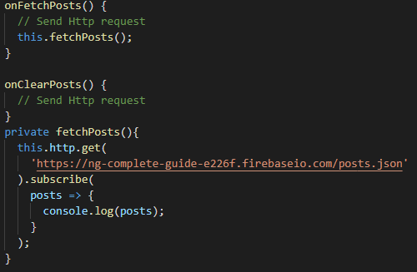

For this we’ll add a new **fetchPosts()** property and I want to use again the HttpClient with the **get** method and send a get request to that same URL we used for storing the data because is the URL from which we'll be able to get that data.

We also need to subscribe, no subscription=> no request.

With that we should get our posts here and console log them .

* **Using RxJS Operators to transform response data**

Here before we subscribe, we can now call **pipe** because pipe allows you to funnel your observable data through multiple operators before they reach the subscribe method.

The **map** operator allows us to get some data and return new data which is then automatically re-wrapped into an observable so that we can still subscribe to it. if it would not be wrapped into an observable again, we could not subscribe.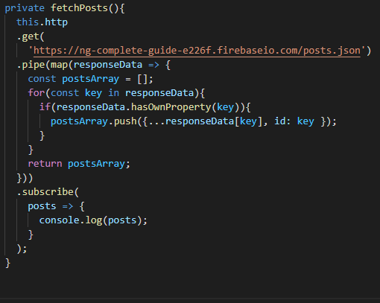

Map as an argument takes another function as input, a function which will **get our response data** and that should now **return the converted response data.**

Now to **convert** a Javascript object which we have here to an array, we have to manually loop through all the keys and create a new array.

In the for loop I will use **postsArray** and push response data key, so I'm accessing the key we're currently looking at in response data.

We want to push a new object so we will use the **{}** and the spread operator **…** ,This will pull out all the key-value pairs of that nested object we're accessing here.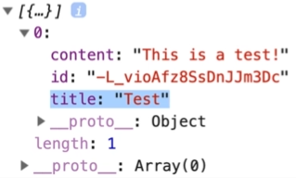

We’ll also add an **id** where we pass the key because it is a perfect ID and it is a unique generated by Firebase and wrap this into an **if** to check if the response data has a key.

* **Using types with the HttpClient**

We create a new file post.model.ts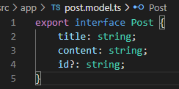 and import it into our app component where we can define the type with it like so:



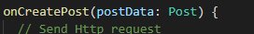

* **Outputting Posts**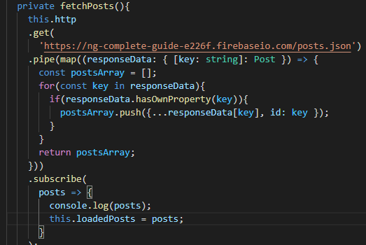

In our fetchPost method we load the received posts into an **loadedPosts array** and display them in our template by looping through them.

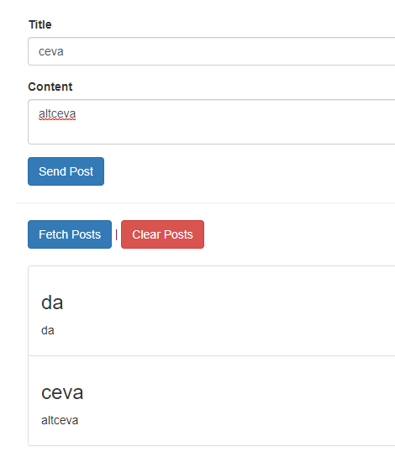

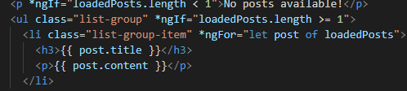

* **Showing a Loading indicator**

For this we create a new **isFetching** property and set it to true when we start to fetch and to false when we are done.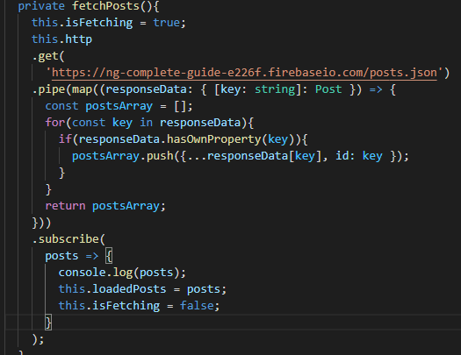

To display it in our template we can use an ngIf and a p tag or a nice css loading circle.



* **Using a service for Http requests**

We start by creating a new service , the **post.service.** Now we can use two approaches, we can use @injectable and there we can pass an object and set **providedIn = ‘root’** which is the more modern and recommended approach,but you could also provide it in the providers array of the app module and this also wouldn't be bad or a problem.

In this service, I want to have my HTTP request methods nd I only want to get the responses or the message whether we're done with the request in my front-end.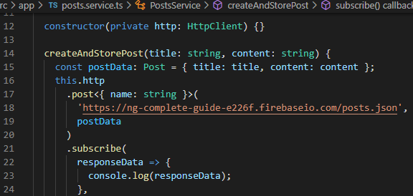

So therefore in this service I will add a new method, **createAndStorePost**, and here I want to send my HTTP request.

I also want to be able to fetch my post, so I'll add fetchPosts, and here I also want to send a request.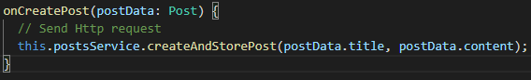

Now of course we move the code over and also inject the HTTP service into this **post service,** so let's add a constructor and with the help of that constructor, we inject the HttpClient and we store it in a property named HTTP.

Now onCreatePost we only need to call after we import our service, this.postService.createAndStorePost().

And we do the same for fetching post.

* **Sending a Delete request**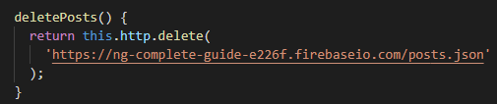

Because we want to be informed about that deletion process in the component we will **return** the observable here and I **will not subscribe** here in the service but instead in the app component.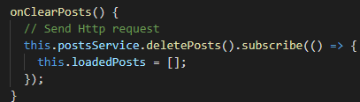

In the app component , in onCrearPosts I can reach out to the postService and call deletePosts and since this returns an observable we need to subscribe here.

We subscribe in the app component because we also want to clear our **loadedPosts** [] array

* **Handling Errors**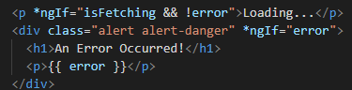

And now to set it up in our app component ,In the error handling function

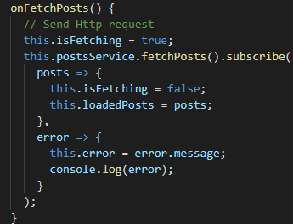

* **Using subjects for Error Handling**

This other way of handling errors could be interesting in cases like when you send a request and don't subscribe to it in your component. You could use a **subject** and that is especially useful if you have multiple places in the application that might be interested in your error.

So this error, we call next and we pass on error message and now the remaining step is that we subscribe to that subject in all the places we're interested in that error message.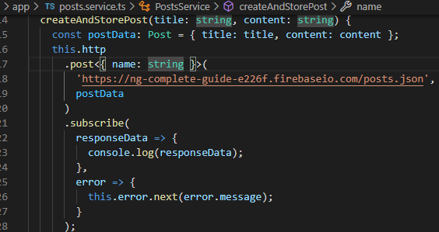

For example we cand subscribe to it here in the app component on ngOnInit and of course because it’s good practice we destroy errorSub after we are done with it.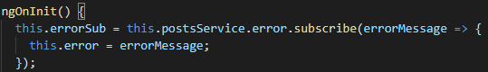

* **Using the catch error Operator**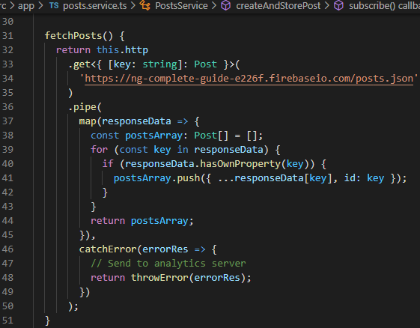

Let's say here when we fetch posts, where we already pipe some data, we got an error and we want to handle that. Now we can simply add the catch error operator here, we get our error response in here, so we get exactly the same data we would get in that second argument of the subscribe method.

here, we can now throw the error response or throw a new custom error which you generated.

Important, you need to return that observable which is created by throw error.

* **Setting Headers and query parameters**

So when configuring these HTTP requests, you set things like the URL you send the request to or in the case of a post request, you also set the data you want to attach to your request. Now of course, sometimes you also need to set some special headers, for example when you have a back-end that requires authorization and looks for an authorization header, if you want to set your own content type or you need to attach a custom header because your API you are sending the request to needs it.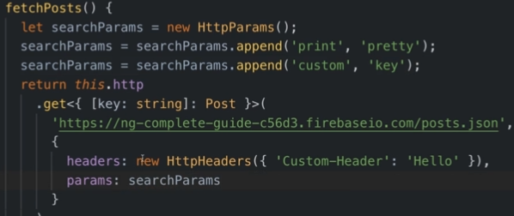

Now setting your own headers,**any HTTP request method**, no matter if it's post or **get** ,**delete**,**patch** or whatever has an **extra last argument**, (so in the case of get it's the second argument, in the case of post it would be the third argument) which is an object where you can configure that request and there, you can configure a lot more.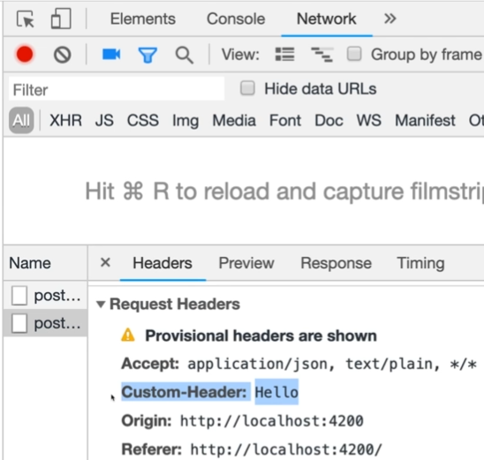

We add query params the same way as the header

We can pass multiple params by adding the key value pairs to an object.

* **Interceptors**

We start by creating a new file auth-interceptor.service and the class will implement the **HttpInterceptor**.This interface will forces us to add **intercept**() and that intercept method will actually get two argument: t**he first one** is a request object, which is of type HTTP request and the **second argument** that is typically called next,Next is of type HttpHandler

Now this intercept method now allows us to run code, and will run right before the request leaves our application.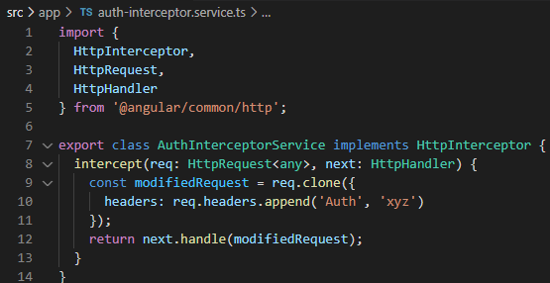

So for example here, we could for now just log request is on its way and thereafter we should return the result that next yields us. Next as I mentioned is a function or actually an object but an object with an important method that will allow us to let the request continue its journey, to be precise that's the handle method which you have to call to which you should pass that request object and by calling this, you let the request continue and you should actually return the result to really let it continue.

Now with that we have to provide this service in the app module. So let's go to the app module and in there, add a new element to the providers array and that should be a Javascript object now and not the name of that service where you have three keys - 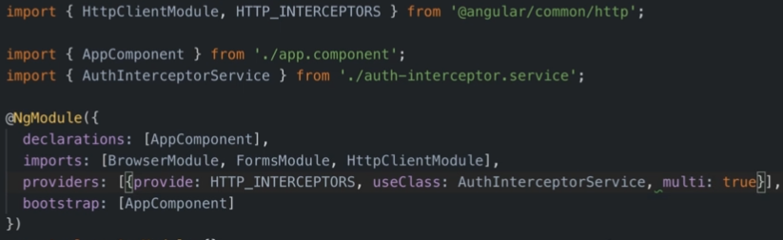

the first key is the provide key and there, you have to use HTTP_INTERCEPTORS, all capital cases.

The second key you pass to that object is the use class key where you now point at your interceptor class you want to add as an interceptor

And last but not least, you can have more than one interceptor and you inform Angular about that and that it should not replace the existing interceptors with this one by adding multi and setting this to true.

1. **Course Project - HTTP**

To start off we create a new firebase realtime database and configure it

* **Setting up the DataStorage Service**

We’ll create a new service for our data storage in the shared folder, we could also manage it in our recipe service but making a new service is cleaner.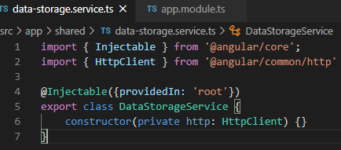

first of all, we will inject the Angular HTTP service and since we will inject a service into a service, we need to add @injectable.

For this to be usable we need to import the HttpClientModule in the app.module.

* **Storing Recipes**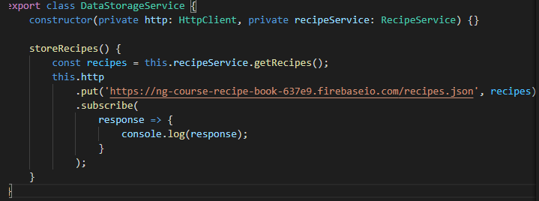

In our data storage service we make a new method **storeRecipes** where we retrieve our recipes from the recipe service and then post our data with put(with put we’ll overwrite anything that was there before, with post will just append) and subscribe to it.

Now to call it we add an listener in the header component to the save data btn and implement the triggered method



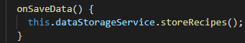

* **Fetching Recipes**

The same as for storing we add an click listener to our fetch data btn in the header and call a method. From that method we’ll call **fetchRecipes** from our data storage service. Here we’ll use the injected recipe service and call **setRecipes** to forward our recipes there, but for Ts to understand that the recipes we are getting here really are an array of recipes we need to add **<Recipe[]>** to make clear which format our extracted response body will have.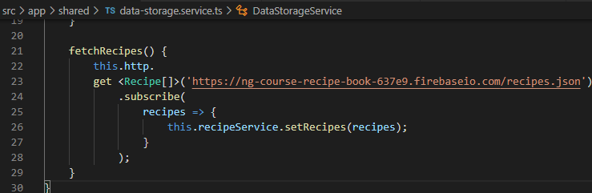

Next in the **recipe service** we need a new method to **overwrite** our array of recipes.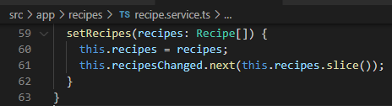

Here we overwrite the recipes we get with the recipes we have and then we call this.**recipesChanged** where we push a copy of our recipes so that we inform all our places in our app that we got new recipes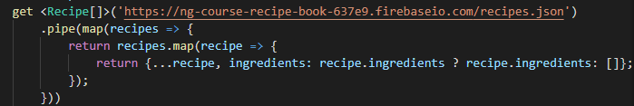

We also add this pipe to make sure that we always have ingredients even if there are none, even if it is an empty array. Because otherwise it would be undefined and if something would want to interact with ingredients we could get an error.(the first map is from the rxjs directive and allow you to transform the data into an observable chain, the second one is the normal Js method map which allows us to transform the data in our)

* **Resolving data before loading**

If we comment the static recipes and we want to receive them before loading we would need add an resolver because otherwise we would get an error.

We start by creating a new file **recipes-resolver.service.ts** in our recipe folder.

The class RecipeResolverService implements Resolve that is a generic interface which means we need to define which type of data it will resolve.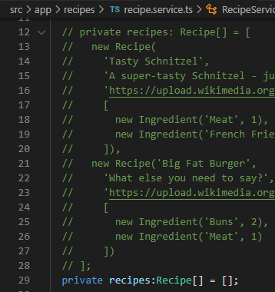

Next we inject our data storage service in the constructor because this is the service which will make the http request.

Now the resolve interface forces us to add a resolve method here which gets data about the route.

the goal is to return either an array of recipes which we can't because we need to load it first or an observable that will yield an array of recipes. For that, in our **fetch recipes** right now, we subscribe in here. I still want to set the recipes in the recipes service from inside fetch recipes but we can simply do this by adding another rxjs/operator, **the tap** **operator** and the tap operator, which allows us to execute some code here in place without altering the data that is funneled through that observable.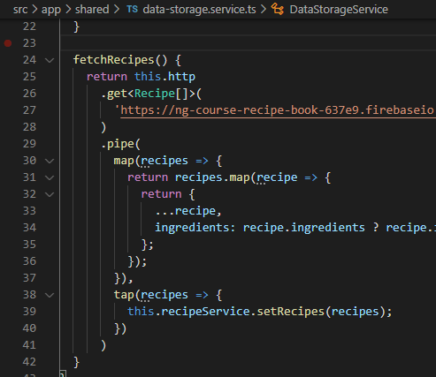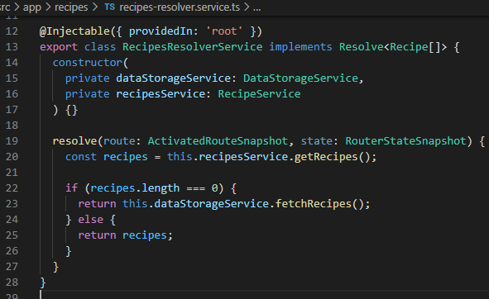

So now we’ll subscribe to our fetchRecipes in the header component.

Now with this change in the resolve method we can now return this data storage service fetchrecipes.(we don’t need to subscribe here because Angular will do it for us in the resolver) and we check whether we do have recipes and only fetch new ones if we don’t.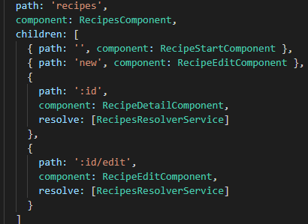

Now obviously to apply the resolver we go to the app routing module, where we have our two paths that rely on a recipe being loaded and on both these paths, we now have to add the resolve key which is an array of resolvers.

1. **Authentication, Route Protection**

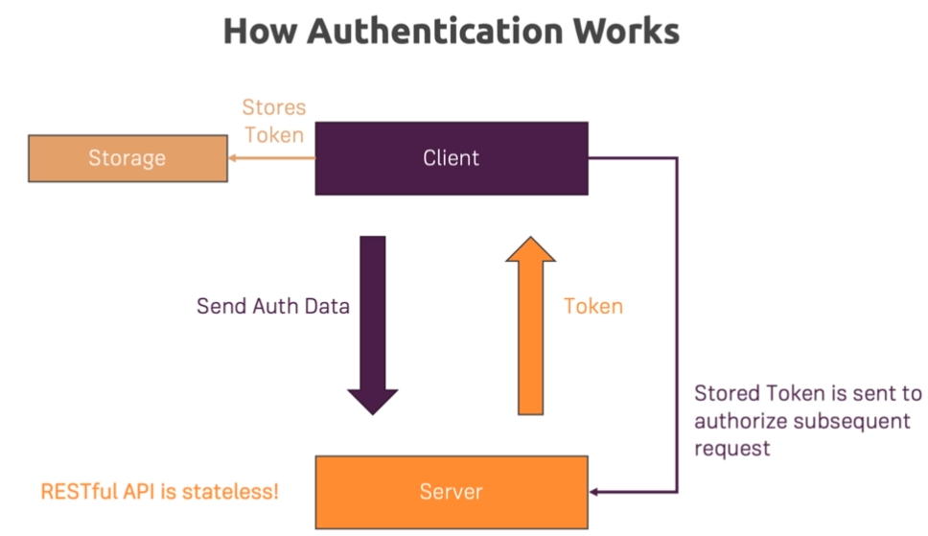

* **Adding the Auth Page**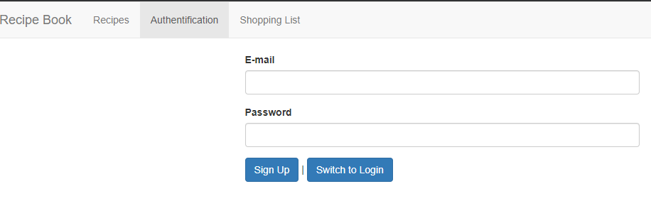

We start by creating a new component, the auth component, where we make a basic html structure like so.

Next we add our component to the routing module and add a new link in our header component that routes us to the auth component /auth

* **Switching between Auth Modes**

Here in this section we want to toggle between Login and SignUp modes, we start by creating on the auth component a new method which is called by an onclick listener and toggles the isLoginMode:

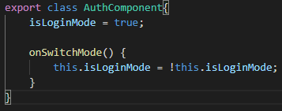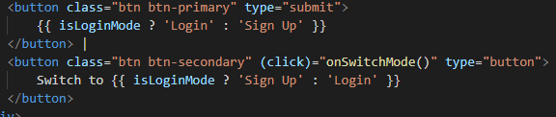

In the template we call the method and display the text accordingly to the value of isLoginMode.

* **Handling Form Input**

To handle this form we’ll use the template driven approach by adding a reference by which we can access the form and on submit we call the **onSubmit** method where we pass the form itself.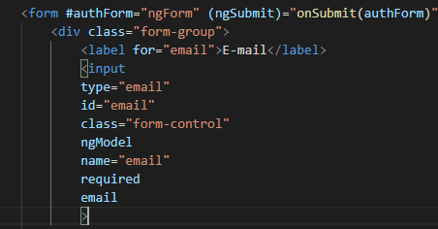

Further we add to our inputs ngModel and required properties.

Finally we disable the submit button if the form is not valid.

* **SetUp backend (firebase)**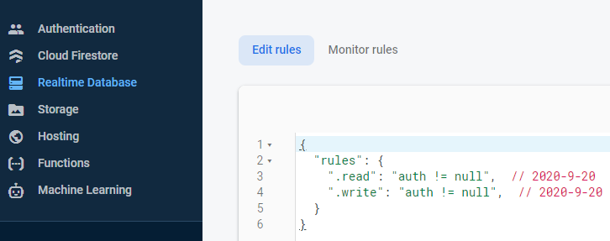

We start by setting this rules and adding authentication by email/password from the Authentication tab above

* **Preparing and sending the SignUp Request**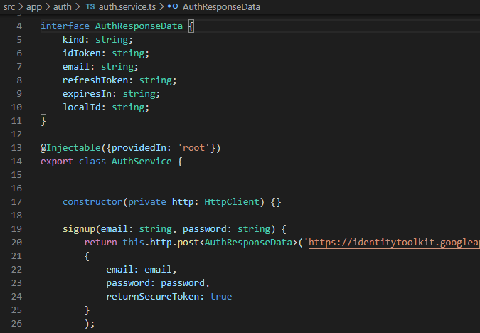

We start by creating an auth service where we implement a **signup** method where we should get as arguments the email and password, then return the post request.

We’ll search in the firebase API reference the structure of the post request for the signup/email and code it accordingly like so: <https://firebase.google.com/docs/reference/rest/auth#section-create-email-password>. Because this post also returns something, we define a new interface AuthResponseData where we define the type of data we are working with.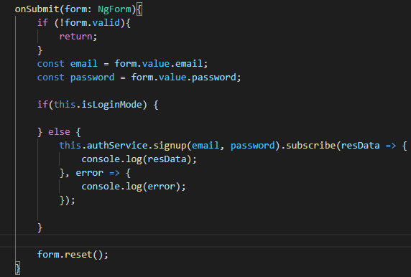

Next in our **auth component**  we’ll inject the auth service and call the signup method from the service in the onSubmit method.

Here we’ll also subscribe to signup because we return the http request in the service.

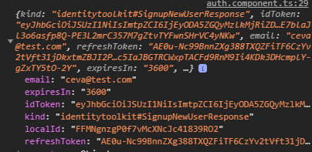

This is an example of how the response should look like:

* **Adding a Loading Spinner, error Handling Logic** 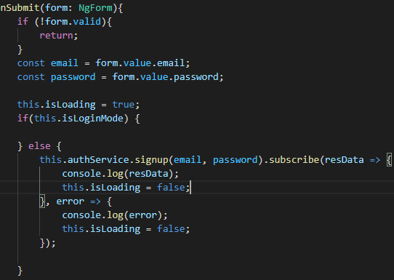

We create a new l**oading-spinner component** in the shared folder where we add the css style for the spinner in the component.css file (I got a spinner style from here <https://loading.io/css/> )

Now to use our new component we implement a loading logic similar to the isLoginMode in the auth component and display only the spinner if isLoading is true, if not we display the form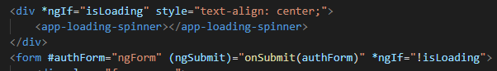

Finally for the error handling we create a new variable **error** which is initialized as null and we assign a new value to it if we have an error response.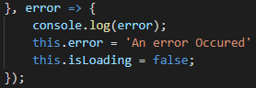

To display our error we add an alert and an ngIf the error exist in the template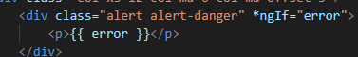

* **Improving Error Handling**

If we have a look at the Firebase Rest API documentation, you’ll see common error codes that are thrown by that endpoint, so we just have to check for this codes and output the message.

For this we can check with a switch in our error response from the auth component or use a pipe directly on the observable .

We start by adding a pipe on this observable and here we’ll use the **catch error operator**  and **throwError function** which will create a new observable that wraps an error.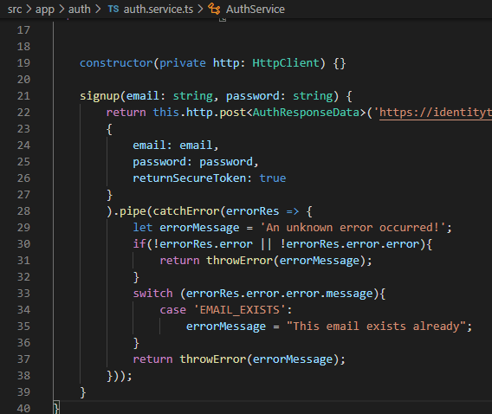

Here we check if the error key exists, if it doesn’t return the default, if it does exist we check in our switch case and assign the corresponding errorMessage and throw our error.

We receive our errorMessage in the auth component in the onSubmit method where we had the errorRes response, now we get the errorMessage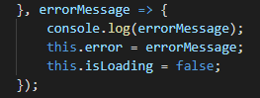

* **Sending Login Request**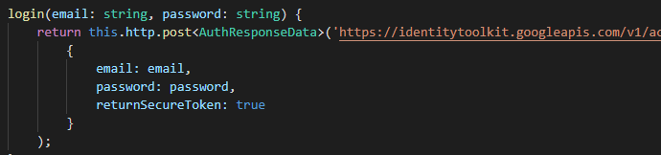

let's make sure we can send a request to login endpoint, for that in the auth service, start by adding a new login method. The data we send is the same as for signup and the data we receive is almost the same AuthResponseData but we’ll add  to it as an optional var so we don’t have to make a new interface for that.

Because our code repeats itself we can add a new variable named authObs which will be of type observable and that observable is a generic type which means we also have to identify which kind of data this will yield eventually and that data will of course be our auth response data. For that we need to export our AuthResponseData interface.

The idea is that after each **if** check at least one of the two observables will be stored in there or exactly one of the two so we subscribe to that observable after the if block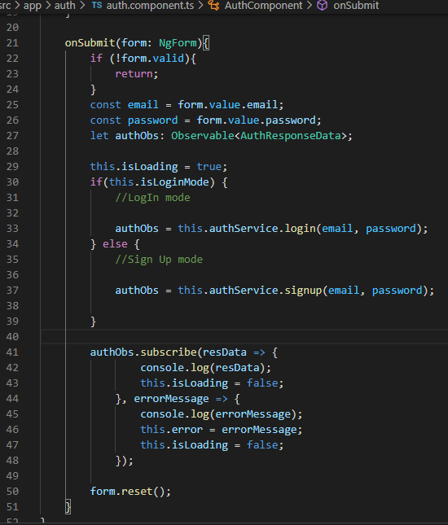

* **Login Error Handling**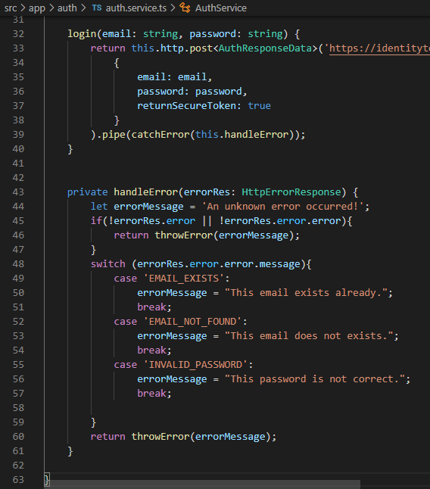

Like we did before with the observable we can share the error handling logic between both login and signup. We can create a new private method here in the auth service which we name handle error, here we copy the handling from signup and add some more cases to the switch block.

Now we can use that same pipe with catch error on our login observable and signup observable

* **Creating- Storing the user Data**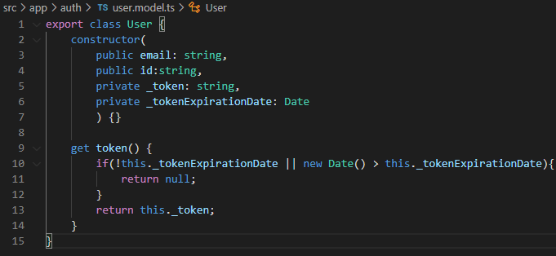

In the auth folder, I'll add a new user.model.ts file and, the idea here is that this model stores all the core data that makes up a user and even helps us with validating whether that token is still valid. (the token will expire after 1 hour). I'll use the TypeScript shortcut of automatically storing arguments of the constructor in properties of the class by adding an accessor in front of the argument name which will then also be used as the property name. Next we implement a getter for our token where we verify if the expiration date exists or if the current date is greater than the expiration date, if not we’ll return the token.

With that created, in the auth service, I want to store the authenticated user and I will actually store it as a subject. The idea of course is that we emit a new user whenever we have one we login or also when we logout, when we clear the user, when the user becomes invalid or the token expires.

**For signing up,** we know that when we succeed, if we don't have an error, we get the auth response data which contains that token we need for the user,also the email,expiry date,..

Therefore, I want to add a new operator to that pipe, the **tap operator.** The tap operator, allows us to perform an action without changing the response.

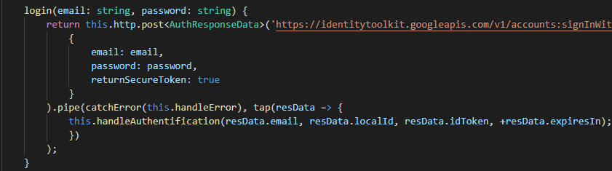

Here we pass the data to the **handleAuthentication** method( because we use the same method for signup and login we’ll implement this method so we don’t repeat code)

And here, I then want to create my new user. For that I'll create a new constant, user, where I call new user, here we pass the arguments we received at the call of the method.

Next for the **expirationDate**, we have to generate it because it’s not part of our response based on that **expiresIn** time we get back from Firebase. So therefore here, all we have to do is we have to get the current date and on that, we can call get time,(this is in milliseconds) and to that, we add resData expires in.(*1000 because expiresIn is in seconds)

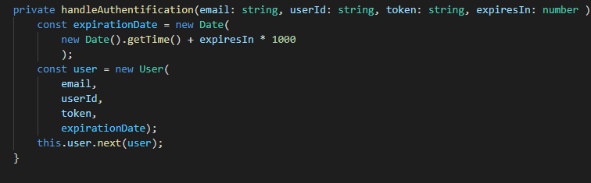

Finally that's creating the user, that's logging us in

* **Reflect the Auth State in the UI**

Firstly we add our logout btn in the header template



Next in the header component we inject the AuthService and here on the ngOnInit interface we subscribe to this.authService.user (such subscriptions should be managed by us so we store this one in a variable userSub and implement the interface onDestroy to clear that subscription), here we get an **user object** with which we’ll check if the user is authenticated and modify the **isAuthenticated** var accordingly.

Now we can change which links are visible in the header if the user is logged in or not (ex:)

, when authenticated: logout, recipes and when !isAuthentificated we display the authentication tab

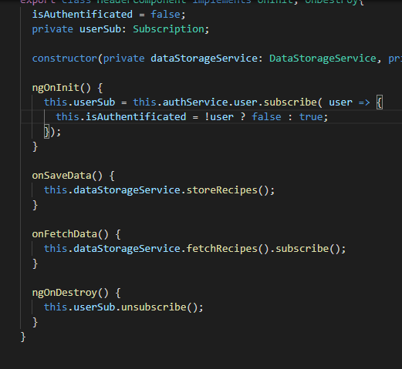

* **Adding the token to Outgoing Requests**

Just because we know that we are authenticated and that we have that token somewhere in our user object, Firebase doesn't know that, we're not attaching it to that outgoing request and therefore this is what we’ll do now.

We’ll start by injecting the auth service in the data storage service, now we need to get access to the user in **storeRecipes** and **FetchRecipes** because we need to get the token there. Hence in the auth service, we now should also store the token or the user in a way that we can access it through different means, we can do this by using **BehaviorSubject** . It behaves just like the other subject, which means we can call next, to emit a value and we can subscribe to it to be informed about new values. The difference is that behavior subject also gives subscribers immediate access to the previously emitted value even if they haven't subscribed at the point of time that value was emitted.(That means we can get access to be currently active user even if we only subscribe after that user has been emitted.)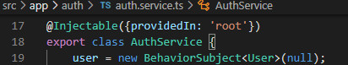

Now in the auth service we can reach out to the user in **fetchRecipes**(), to make sure I only get the user once we can manually immediately call **unsubscribe** or **take() pipe** In there we can then use this HTTP request observable and set it up in there and attach

our token which we get out of the user. The problem just is here, we're in subscribe of an observable and here, we create yet another observable. In the end, I want to return this observable here but returning from inside subscribe doesn't work, we have to return on the top level of this method. **The solution** is that we pipe these two observables, the **user** observable and the **HTTP** observable together into one big observable.

For this we’ll add another operator here to pipe for the user observable , **exhaustMap.** Which waits for the first observable, for the user observable to complete which will happen after we took the latest user. Thereafter, it gives us that user, so in exhaustMap we pass in a function, there we get the data from that previous observable and now we return a new observable in there. So in there, I will return this HTTP request where I get my recipes.This is now returned inside of exhaust map and therefore this entire observable chain now switches to this HTTP observable. Now regarding map and tap which we used before, we can cut that and since we already are in a pipe method call here and we added take and exhaustMap, we simply add the other two operators as next steps after the exhaustMap and then we return this overall observable.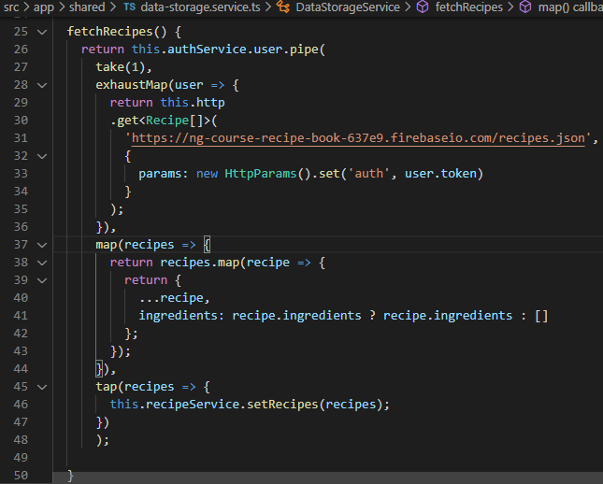

Now to add the token to this request we can do it manually  or we add a second argument to the get method which is an object where you can set the params.

* **Attaching the Token with an Interceptor**

Now we can use the same logic we used in fetched recipes in store recipes but since we're using the Angular HttpClient, we could also use another feature offered by that client because what we do here in the end is we manipulate all these outgoing requests in the same way so we could use **an interceptor.**

So let's add such an **interceptor** by creating a new auth-interceptor-service file in which we implement the HttpInterceptor, and that forces us to add the intercept method in which we pass the http req and handler.

Now in there we need to return next handle and pass in the request, However, not the request like this but actually, I want to edit the request and add my token.

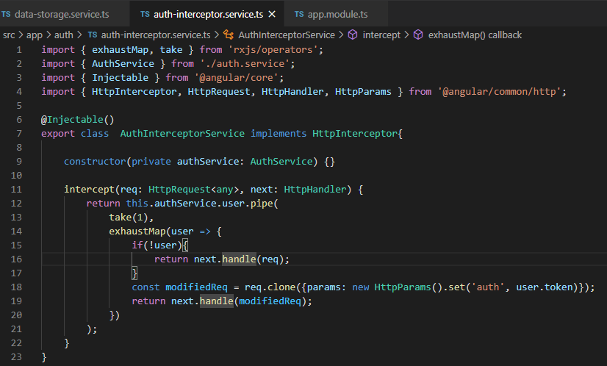

Therefore, let's add a constructor and inject the auth service, with that injected we can now reach out to the user which is a subject and therefore an observable and subscribe to it. Now we have the same problem as above, we need to return an observable, this also is an observable so we’ll solve it the same way with exhaustMap.

Now since we got the user in here, we can return next handle request, and we can edit the request based on the user to return this overall chain. Next we have to clone our request and update it, so the modified request is created by calling **request clone**  in which we call set and pass in the params.

Now we provide that token in the app module here under providers



Next we fix the fetchRecipes from user dataservice, we don't need to use the logic we had in there because we moved that into the interceptor,

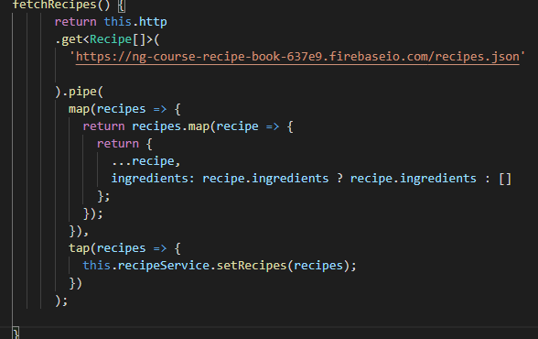

* **Adding Logout**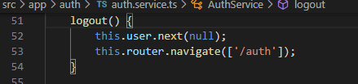



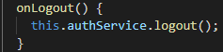

To logout we simply use our user subject and we call next where we pass null, to set the user to null.(the initial state)

* **Auto Login**

At the moment when we reload the page we lose all that status because when you reload the page, your Angular application restarts, the old one is basically dumped.This happens because the information is stored in the memory so if we want to store that token, we have to store it somewhere else and not in a Javascript variable or class property, we have to store it in a persistent storage that survives page reloads and browser restarts.

For this we’ll add in the handleAuthentification , Now there, I will give this a name of userData (this is basically the key by which you will be able to retrieve it later). Here I want to store the email, id , token and tokenExpirationDate so we can write the user to the local storage, though not as a Javascript object, instead we have to convert it to a string. We can do that with the JSON object and the stringify method, that is built into Javascript



Now and with all of that being stored in there, we can of course also retrieve it from there when our application restarts. For that we can add a new method which I will name auto login because it basically is a method that will try to automatically set the user to login when the application starts and it will do so by looking into the storage and checking whether there is an existing user snapshot stored.

So in auto login,the goal now will be to retrieve data from the local storage. For that we can access the local storage and get our user data item and that is a synchronous method which gives us our user data like that, so we can retrieve user data from local storage just like this.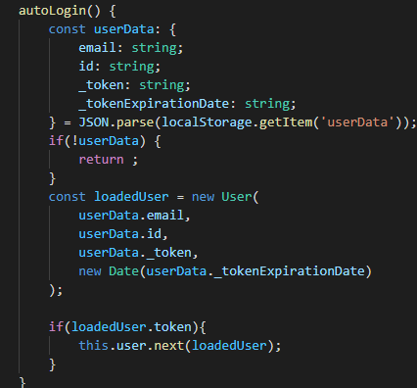

The first thing which I'll do then is I will check whether that exists, if we don't have user data, so if this is false, we can return because in this case,we can't log the user in.

Otherwise if we make it past this check, user data is set and there is some snapshot we were able to retrieve from that local storage.

Next only when we make it into this if check, we want to emit this loaded user as the currently active user.

* **Adding Auto Logout**

Our token will expire after 1 hour but when it does we won’t logout the user, because the snapshot won’t clear automatically. So first of all in the auth service, we should make sure that since we store a snapshot upon on logging in, we also clear that snapshot here in the logout function because if a user logs out.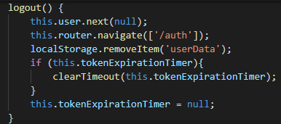

Next we set a timer to know when the token is stored or when we first get a token so that we know when to invalidate that token at a later point of time. And for this, I'll add yet another method here which I'll call **autoLogout**(),

To clear the token expiration timer we store it in a property which we can name token expiration timer where we store our timeout .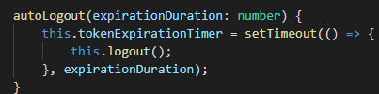

So in there, in logout, we should check if we do have an active timer because maybe we don't, maybe it expired anyways then we can't clear it but if we do have an active one then we should clear our timeout here and set this token expiration timer or pass this token expiration timer into clear timeout , and this will clear the token expiration timer and thereafter reset token expiration timer back to null manually.So now we cleared the timer when we logout and we also set it here,now of course we just have to make sure we do call auto logout because currently we aren't doing that.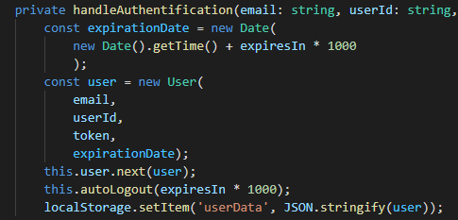

Now let's start with handle authentication, there we do emit our user. Now right after doing that or right before doing that, we should call auto logout and pass our current expiration time into that auto logout function.Now the current expiration time of course is our expires in value here which is in seconds times 1000 because we expect milliseconds.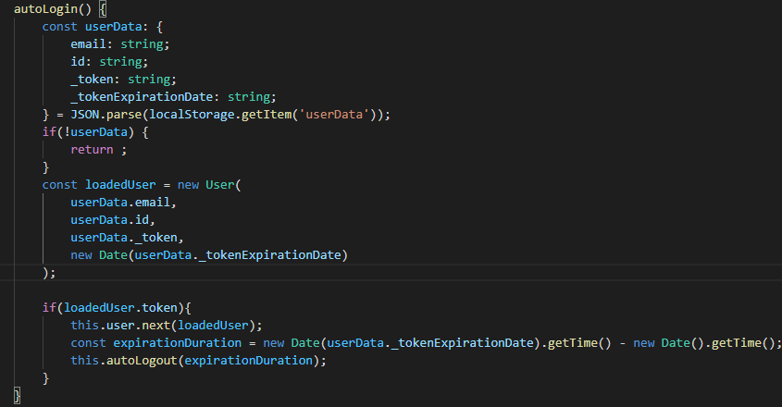

Now in **autologin** ,Here when we know that we do have a token and we therefore emit our user to the application, there we also want to call this auto logout but, we now have to calculate the remaining time.

After we calculate that we pass it to the auto logout function

Therefore now, this reloads and we're logged in, now if I call logout, we wipe the snapshot

* **Adding an Auth Guard**

We start by creating a new Auth.guard.ts where we add the AuthGuard class which implements CanActivate and since this technically is a service we need @injectable here and use providedIn root. The **canActivate** method has to be implemented in a certain way, it receives the currently active route which is of type activatedRouteSnapshot and routerStateSnapshot. We want to return the status as we can derive it from our auth service. So here, let's inject the auth service and the router with which we can find out whether the user is authenticated or not, by looking at that user behavior subject.

We don't subscribe to it here but return it instead because this already is an observable, however not an observable that returns a boolean (which we need for canActivate method) instead it is an observable that in the end returns a user object. To fix this we add a pipe with the map operator, and we get our user and want to return true or false.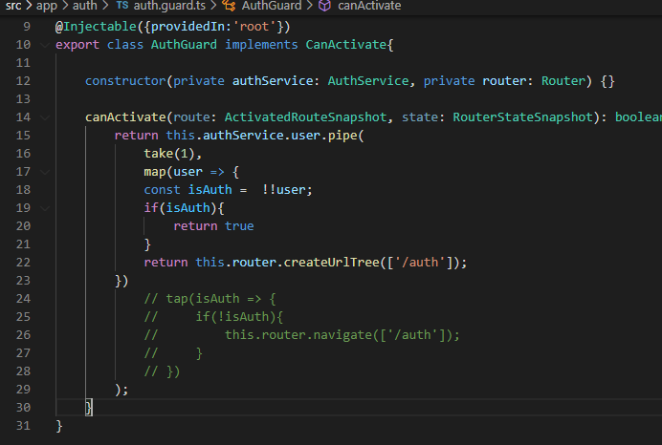

In this method we don’t return true or false here,but return true if you want to grant access and return **urlTree** otherwise. We’ll store the result of the conversion in the isAuth const then check if it’s true and return true. If not we return the UrlTree in which we simply pass the route segment we want to navigate to.

Now in our **app-routing module** we add the canActivate key which is an array of all the can activate guards we want.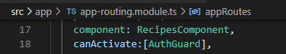

Now the guard works, What we should make sure though is that when we logout and we manually try to go to /recipes, that we actually redirect the user to a page where he can do something, like the authenticate page do that, we can go back to the guard, in there we are returning true or false.

1. **Dynamic Components**

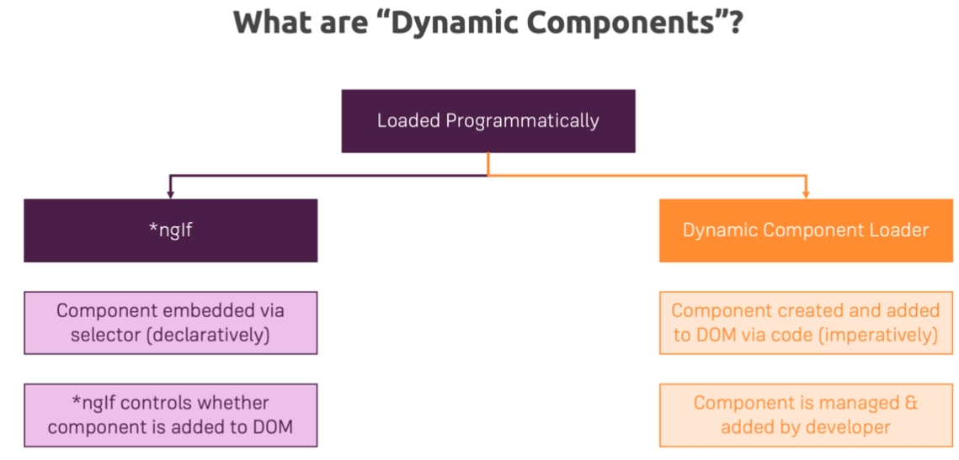

* **Adding an Alert Modal Component**

We start by creating a new alert component in the shared folder where we add a new property message and make it accessible from outside.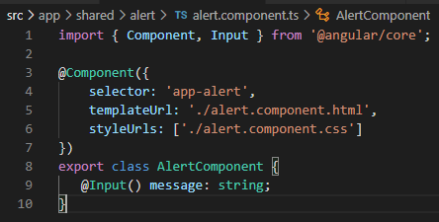

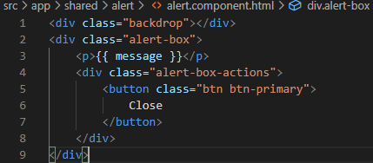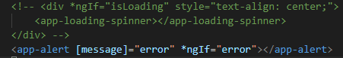

And we can use this component where we bind message with the error instead of the div with the ngif .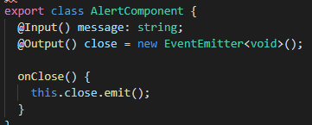

To close the modal we output an event emitter, the onClose method will trigger whenever the close btn is pressed or the backdrop

And on auth component we listen to close and call **onHandleError** which resets the error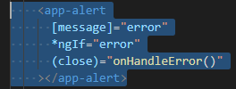

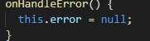

* **Programmatic Creation**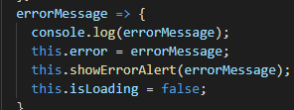

First of all we need a new method because now we have to write some code to show the error alert showErrorAllert() which should be called whenever we set the error.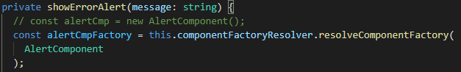

Now with the component **factory resolver** injected, in show error alert, you now use that resolver to get access to a **component factory**. Next to that factory, you have to pass the type of your component, which in our case here would be the alert component. ( you don't instantiate this, you just pass in the type so that Angular knows where to look for that component which it then should create for you.)

This method here will return a **component factory** , so this now is essentially an object that knows how to create alert components.

Now with that factory, we can use that factory to create a concrete component but for this, we also need a place where we can attach it in our DOM with a **viewContainer ref.** (which is essentially an object managed internally by Angular, which gives Angular a reference, a pointer to a place in the DOM , with which it can interact)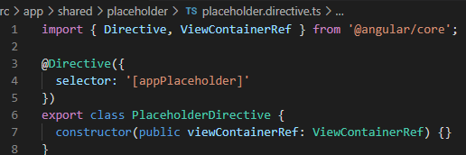

The official approach for getting access to it, is to create a **helper directive**. (we name is placeholder). So we have the placeholder directive and now this directive needs to do one important thing, it needs to inject the **view container ref** .

With the placeholder directive added, let's go back to the auth component and now we need to add a new element here, **ng-template**, This is a directive Angular ships with, which will not actually render anything to the DOM but still is accessible in the Angular templating language.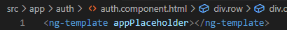

To ng-template we add the placeholder we created.

With this, now in the auth.component.ts file, we can now get access to that directive with the help of @ViewChild where we add the placeholderDirective. Then we can store this in a property of that component, like alert host of type placeholderDirective



Now that alert host can be used in showErrorAlert, so to get access to that iew container reference of our host. The next thing is that we clear anything that might have been rendered there before by simply calling **clear** on this view container reference.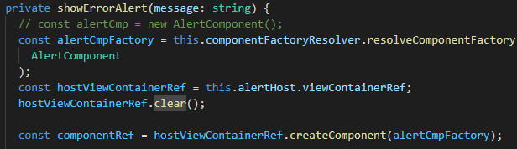

Now we can use our component factory to create a new alert component in that host view container reference and this is done by using our host view container reference and calling **createComponent**  where we pass the factory we created earlier.

(in Angular9 > this is not supported, so to announce Angular to prepare to create this component we need to add in our app.module 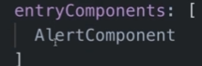)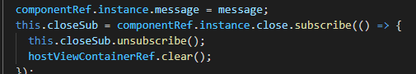

So how can we now pass data into that component or listen to an event or remove that? Well, we simply have to store the component that is created here in some constant or a variable with which we can work thereafter. We can use our component ref here and this has an instance property which gives us access to the concrete instance of this component. Now this instance should have the properties we added to our component.

Now for closing, we manually have to listen to our close event here

1. **Angular modules**

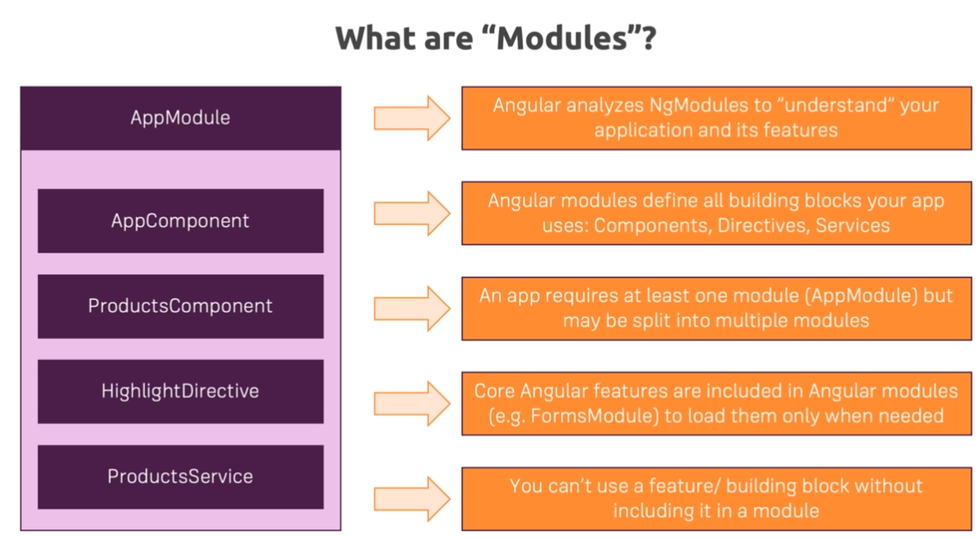

* **Getting started with Feature model**

We can work with multiple modules. Instead of having one big app module, we could split that into two separate new modules, so-called feature modules.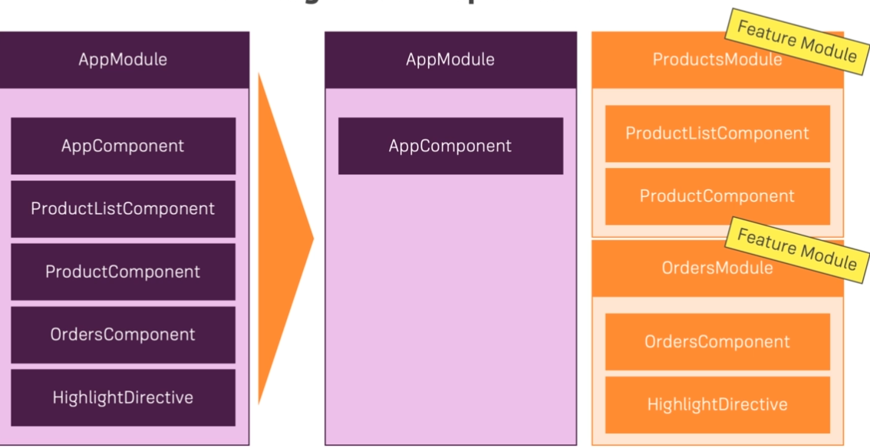

A **feature model** is a model that groups together components, directivers, pipes, that are used in a certain feature area of your application

We’ll start by creating a module for our recipes, for this in the recipes folder we create a new Ts file recipes.module

In which we add the @**NgModel** decorator and transfer all the recipe related declarations from the app.module.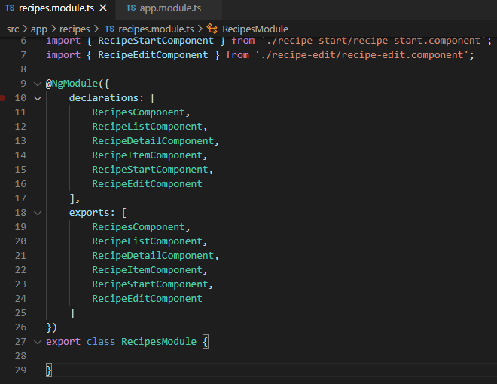

Now to receive the recipe module we need to import it in the app.module 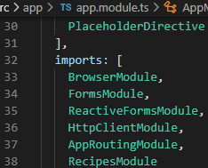

By exporting all the components in the recipe module.

**Note**: everything in a module works standalone, You can export something to then be able to import it into another module as I'm doing it here with all these components. but that alone does not mean that in this module you can use features that are made available in the app module.

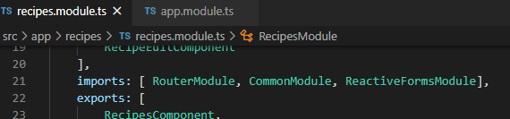

**To fix** the problem in the **note**, we simply import the router module, the CommonModule to get access to ngFor and ngIf(instead of the Browser module that is only declared in the app module because it instantiate more things at the start of the app) and ReactivesForms module to get access to the forms.

* **Adding Routes to Feature Modules**

We can move the recipes related route configuration away from the app routing module into our recipes module.

For this we create a new module recipeRouting module in which we move all the recipe routes from the **app-routing-module** to an array named routes.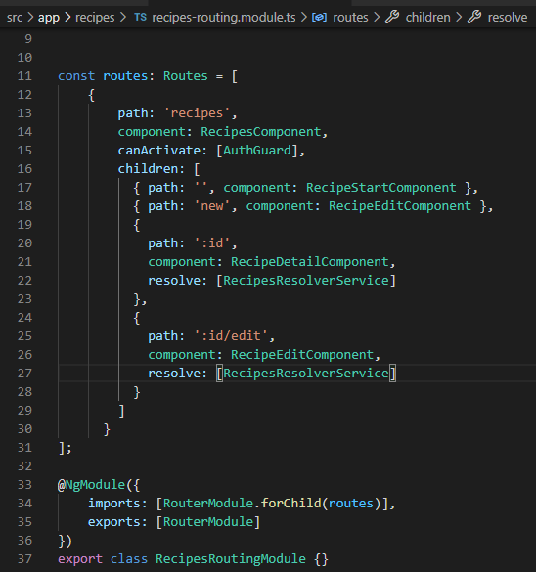

We’ll pass this array into the imported router module with the forchild method so we can pass all the routes. Then we’ll export the router module.

Finally we import this module to the recipe module .

* **The ShoppingList Feature Module**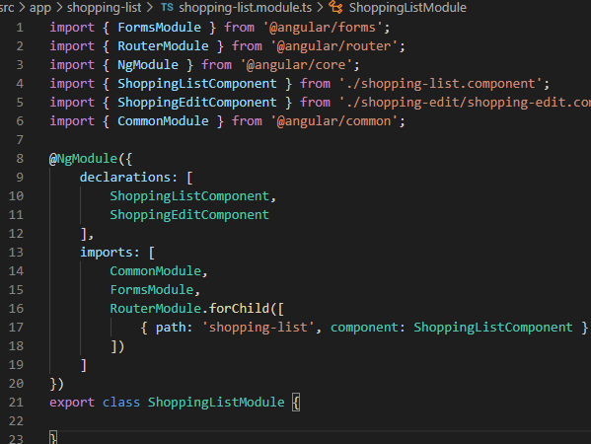

For this we make a new shopping list module and follow the same steps as in the recipe module.

But for this one we won’t make another separate routing module because we only have 1 route so there is no point.

* **Shared Modules**

Creating shared modules allows you to organize and streamline your code. You can put commonly used directives, pipes, and components into one module and then import just that module wherever you need it in other parts of your app.

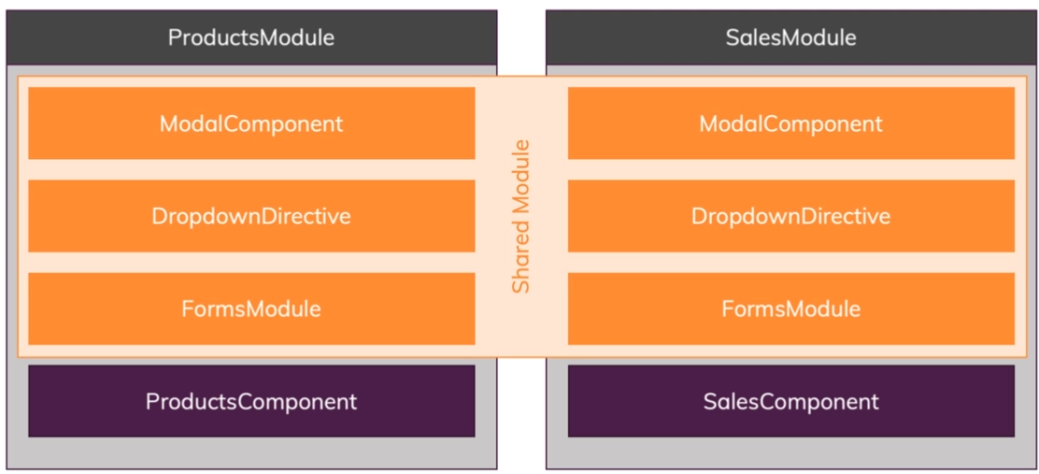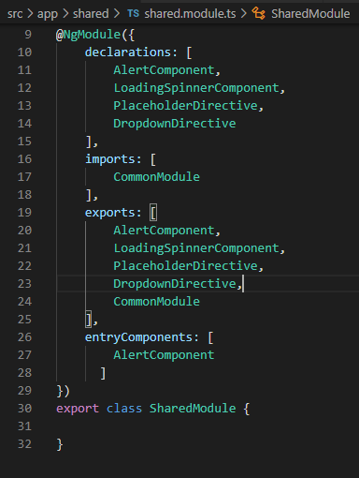

We start by creating a new module in the shared folder named shared.module

In which we declare and export all the shared components.

To make use of this module we can delete the alert component, loading spinner, … from the app.module and replace them with the shared module, thus freeing up space.

* **Core modules**

The Core Module is a module we create to define common services. The services defined in the Core Module are instantiated once.

This type of module is imported only from the main module, as it contains singleton services that any element in the application can use. We do not want to import it in each module, as this will create additional instances.

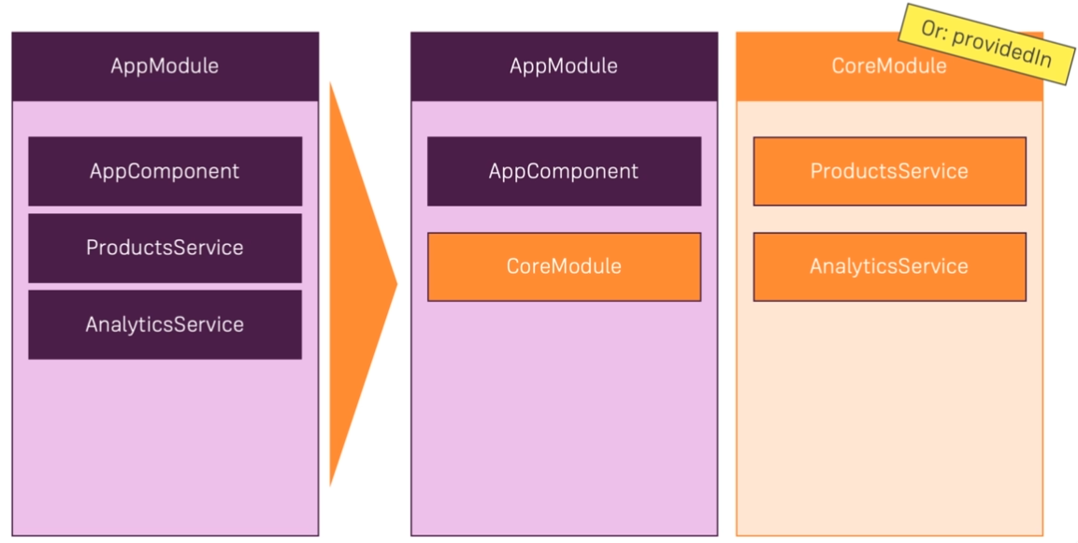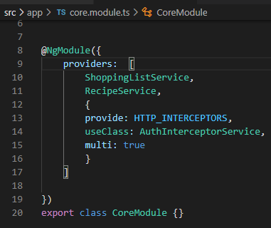

We start by creating a new module named core module where we move all the providers from the app.module. Now simply import the core module into the app.module to use this services again.

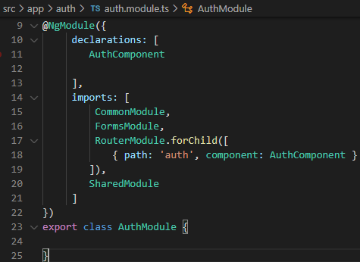

* **Adding an Auth Feature Module**

We create a new module in the auth folder named auth.module in which we import the modules we use here and add the route path to the imports also.

We also need the Shared module because we use the loading spinner in the auth component.

* **Lazy loading**

By default, NgModules are eagerly loaded, which means that as soon as the app loads, so do all the NgModules, whether or not they are immediately necessary. For large apps with lots of routes, consider lazy loading—a design pattern that loads NgModules as needed. Lazy loading helps keep initial bundle sizes smaller, which in turn helps decrease load times.

-Implementing lazy loading:

We’ll start with the recipe module because when we are not authenticated there is no need to load the recipes because we don’t even have a way to access them.

Now having the routes registered in a separate recipe routes module is an important starting point for lazy loading to work, your feature module needs to bring its own route config and need to bring that with forChild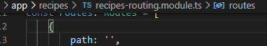

We’ll change this path to empty in the recipes routing module because now we need to add a path to our app routing module for lazy loading to work.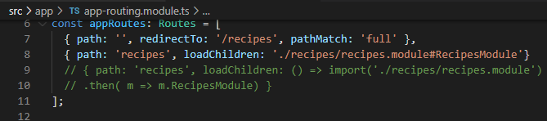

We add this path to the app-routing.module where now I don't add a component which I want to load but instead you add load children. That's a special property in a root config which angular understands as police only load the code content or the module I'm going to point when the user visits this path here. ( here we have 2 methods, first one which is an older one and the commented one which is the more modern approach)

And we need to remove the **recipesModule** from **app.module** because otherwise we are importing it both eagerly and lazily at the same time and that will cause an error.

* More lazy loading:

We’ll add lazy loading for shopping list and auth using the same principle as above

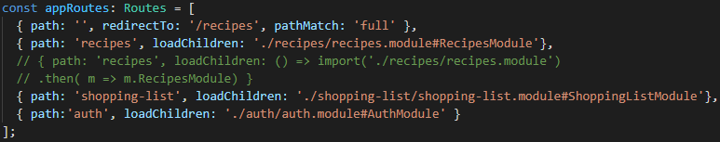

* **Preloading lazy-loaded code**

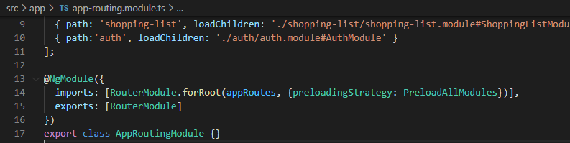

For this, we simply go to our root router module, so here we reconfigure our root routes and you can pass a second argument to that. This is an object where you can configure that root router and you can set up a preloading strategy, we set this strategy to PreloadAllModules. (The default is no preloading, you don't need to set)

With preload all modules imported and set here as a preloading strategy, you're telling Angular generally we're using lazy loading, so it will not put all that code into one bundle, it will split it but also it will preload the bundles as soon as possible.

The advantage is that the initial download bundles still is kept small because that code is not included and therefore the initial loading phase is fast. But then when the user is browsing the page and we have some idle time, then we preload these additional code bundles to make sure that subsequent navigation requests are faster, so we're getting the best of both worlds, a fast initial load and thereafter, fast subsequent loads.

* **Module Services**

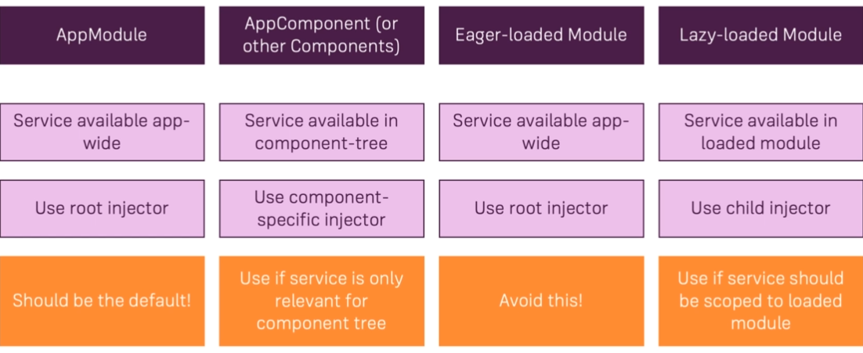

* **Ahead Of time Compilation**

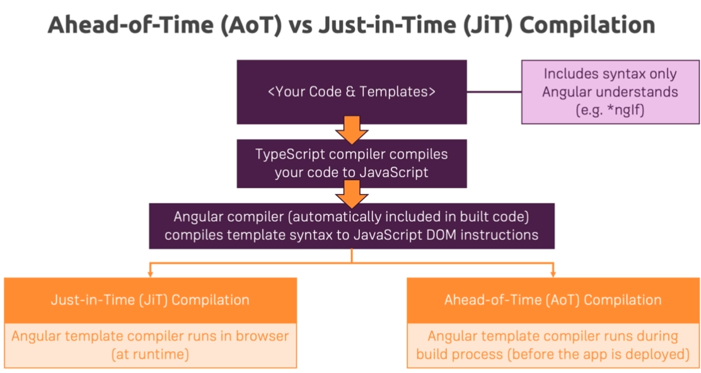

As soon we are preparing ourselves for production and upload it to a server we want to optimize our code as much as possible and shrink it to a small bundle.

We do that with the command , this command takes your Angular application and builds it into a few files which you can deploy.

We do get an error because JiT compiler is more forgiving than the AoT compiler( this does a couple of extra checks an found some code that didn’ t understand)

In the recipe detail component this part works with JiT compiler, the solution to this error  is to remove that code from the template to the TS file and add a new getter which we call instead it.

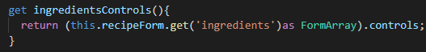



* **Deploying our Angular App**

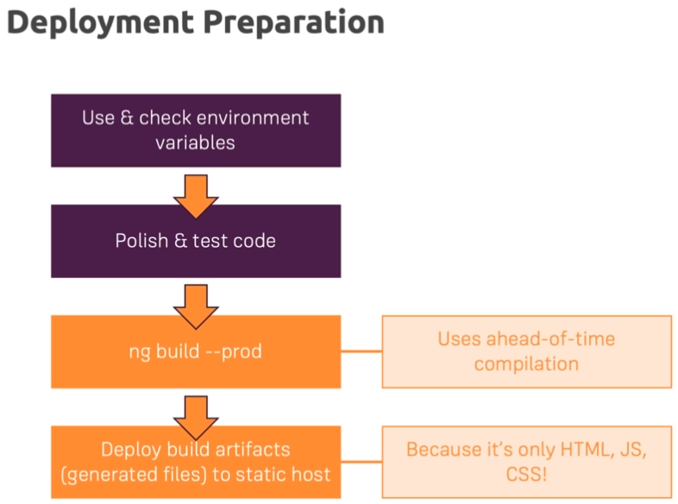

* **Using Environment Variables**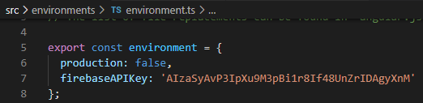

In our app folder we have an environments folder in which we have 2 files: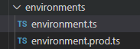

Now we're not using these files but what you could do here, you see you have an exported constant where we can add a key-value pairs in the environment.ts and in the environment.prod.ts file(it's the same constant with the same name).

The Angular CLI will automatically swap these two files when you are building for production. So during development, this environment.ts file and the value you have in here will be used and during production the other constant.

We’ll use this for our API key, now after we added it we need to import the environment const and replace the API key with the constant. (with this the variable will switch automatically without any extra code depending on the environment we are in)





* **Deployment Firebase Hosting**

After we’ve build our project for prod with **ng build --prod** we need to install firebase CLI with npm install -g firebase-tools .

With that done we need to run : **firebase login** to log into the firebase account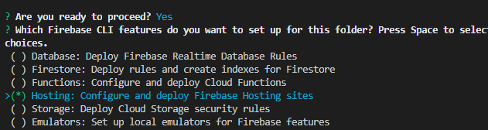

The next command we need is **firebase init** with which we connect to our firebase projects.

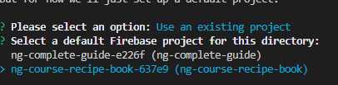

Then select the project we want to use.

On the next step we are asked about public directories and we should not use the default but the public directory which contains all the files we want to deploy. This usually is in the dist folder in our app







And with this we are done, but finally we want to run **firebase deploy**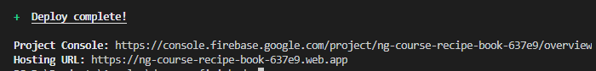

From now we can access the hosting URL where we can find our app

1. **Animations**

* **Triggers and State**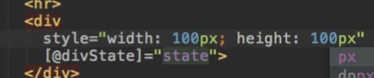

Each animation has a trigger so we need to add one (which we import from angular core). Next as the first argument we pass a name (divState in our case ) which we also add in the template to the element we want to use the trigger , as the second argument defines the animation this trigger should toggle which is simply an array. With that set up we add a state with which we can change the animation between 2 states, normal and highlighted 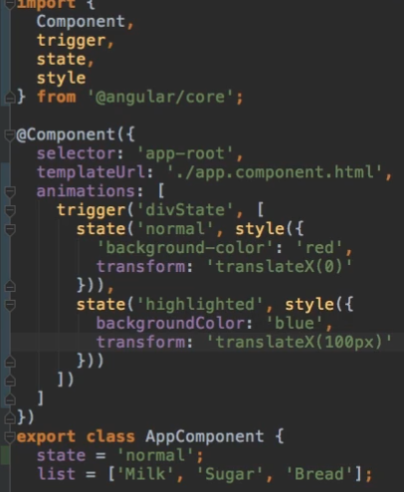

To change the state we use an onclick event 



Next to add a smooth transition so it actually looks like an animation we add the transition method where as the first argument expects the starting state then the final state, as second argument we specify what to do. 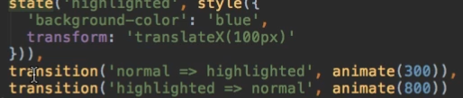

* **Advanced transitions**

We ll add a new trigger Wildstate which works at the same time and way as the divState but adds the shrunken state.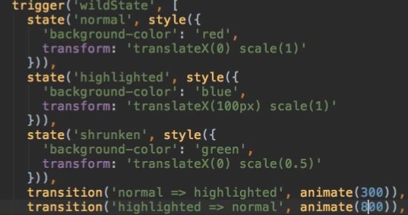

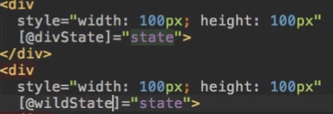

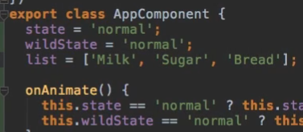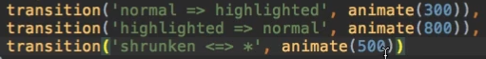

* **Transition Phases**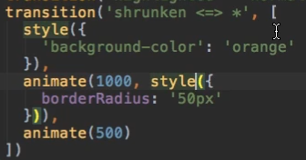

As the second argument for the transition method we can also pass an array where we can chain the style and animation changes to get a smoother transition.

* **Keyframes**

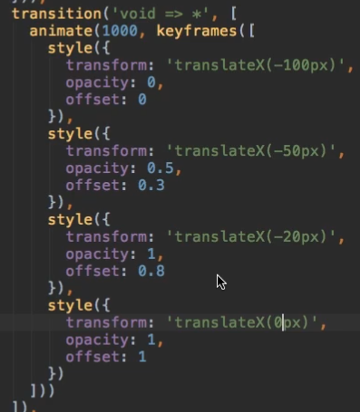

Keyframes is a more advanced transition phase which allows us to know which part of multiple styles will occur at which timing. To use keyframes we add it as a second argument to the animate method and by using the offset argument we can choose at which time we execute the style from the overall animation time ( in our case we have an animation of 1 second, so offset 0.3 will be after 300 ms passed)

* **Grouping transitions**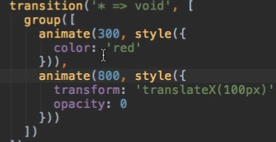

In this group method here as an argument we pass an array of animations we want to perform synchronously

* **Animation Callbacks**

This method will get triggered when the animation starts and the other one when it ended.

1. **Adding Offline Capabilities with Service Workers**

* **Adding Service Workers**

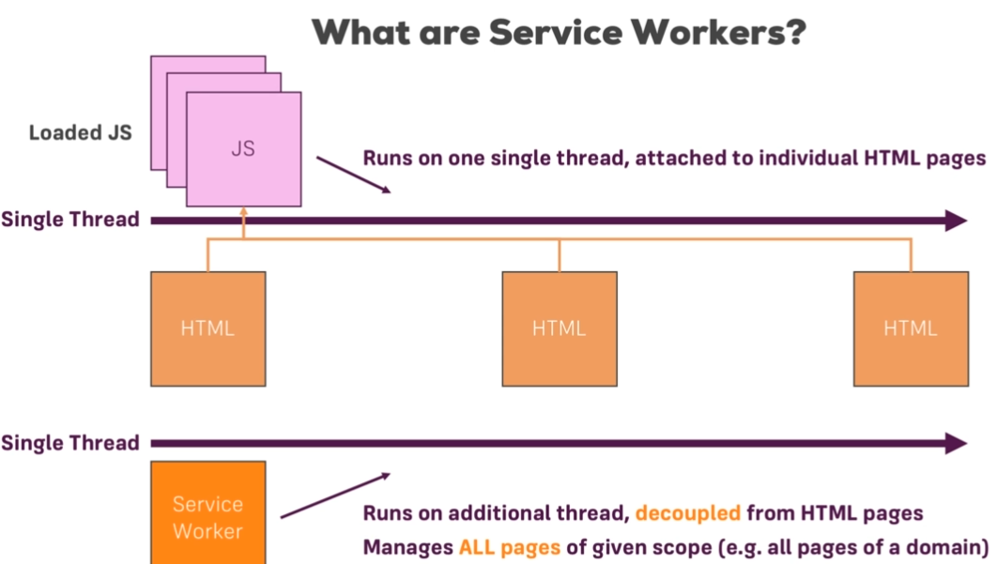

How to add the service:

, this will configure your active project to use Angular Service Worker package and start with a preconfigured service worker.

To See the service worker in action you need to build for prod the project and start it in a server

* **Caching Assets for offline use**

With this our **hardcoded** content will be cached and able to see them even if we are offline, but if you get all the data from the **Api** it will not work. To fix this we need to change the service worker config in **the nsw-config.json** file.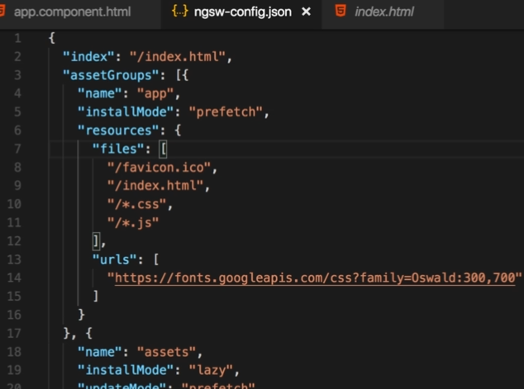

First of all we have the **index** page that indicates what is the root page of our app where we want to cache. Then we get an **assetGroup**, assetGroups are configurations that define which static assets should be cached and how they should be cached( dynamic assets for example would be the data from the API).

In this assetGroup we can have :

- **name**: a whichever name you like

- **installMode**: in our case we have prefetch which means that when our page loads, the service worker will go ahead and already prefetch all the presets specified in this assetGroup. That means that it is put in the cache even if we don’t need them yet

**-updateMode**: this is important if you are pushing a new version of your angular app to the server and the user is already browsing on that server. It will get informed about the new service worker and now the service worker can already prefetch the updated assets or load them lazily when they are required.

**-resources** : the assets which should be loaded

-**Font urls** : this is where we put font urls that reach out to a server to fetch them

* **Caching dynamic Assets URLs**

For this we’ll add a new configuration, **dataGroups**, which is used for dynamic data.

In this dataGroup we can have:

**-name**

- **urls**: this is an array where we put the urls we want to handle

- **version**: if you have an API which might have a different version and the version changed, so we could lock the version here

**-cacheConfig**: here we can configure in detail how the data should be cached

**-maxsize**: this is a number and defines how many entries you want to cash in.(how many responses)

**-maxAge**: how old the data in the cache should be before we get rid of it and fetch new data

**-timeout**: if you are waiting for example for more that 10s for a response fall back to the cache

**-strategy**: -freshness (first and only use the cash if you’re offline)

-performance( get something onto the screen as soon as possible)

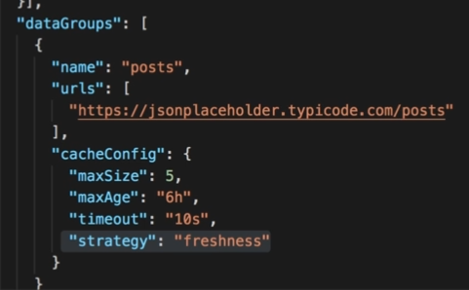

1. **Unit Testing**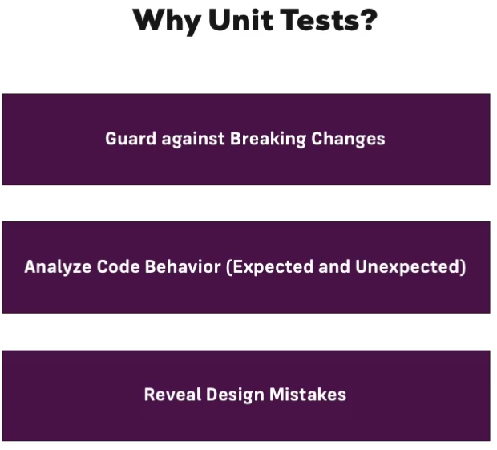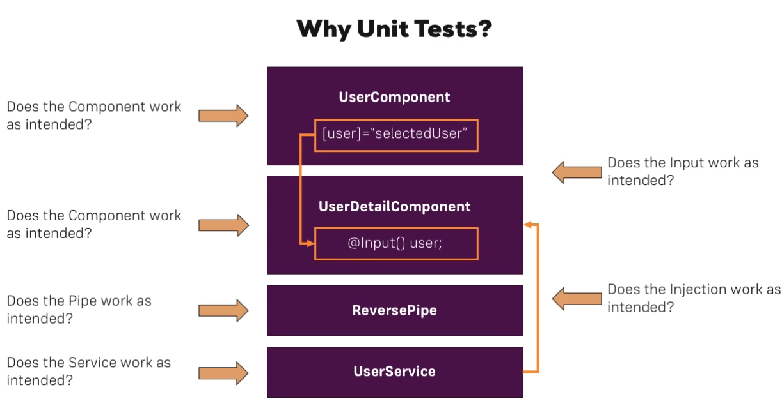

* **Testing Setup**

To start of in a .spec.ts file at the top we import 2 things from angular core testing : **TestBed** and **async**.

Then we **describe** our to be tested unit in this case which is our app, we then have a function which is executed here by the task runner. In this function we implement a **BeforeEach** function that gets executed before each test and here we configure a testing module as this method on the TestBed. TestBed is the main Angular tasking utility object, so this allows us to configure the modules for our testing. This allows us to declare which components we want to have in our testing, in our case the Appcomponent.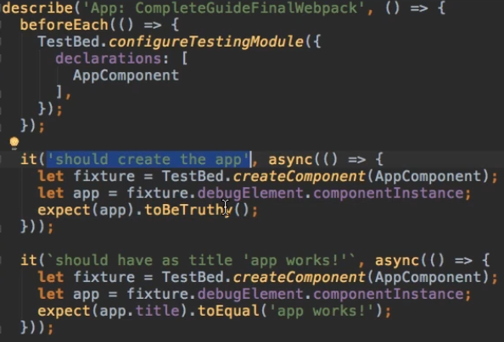

We always need to create the component in each block since each block is contained in itself. We do this by using create component on the TestBed and then we store this new component in this fixture.

Then we can get our app by using this fixture which holds our created component, and use some property debugElement with which we can check the instance of the component.

Finally we check for example if the title we get is the same as the expected one.

* **Running Tests**

We run the **ng test** command in the terminal, this will run each test block and show us which one failed so we can debug the problem.

* **Testing Dependencies and Services**

By creating a userService variable and using fixture.debulElement.injector.get(UserService) which we also need to add as an import to the top in the beforeEach. What this does is it uses the 2 injector which exist and is part of this component we now created and tells it to get an instance of this userService.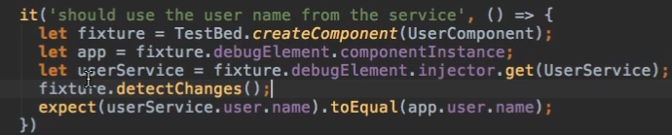

Next we need to run detectChanges to update our properties after injecting the service, now we can check if the userService user name is equal with what we have in the app.

* **Simulating Async tasks**

To get access to a method which happens asynchronously ( and of course we don’t want to execute the real method because this method might reach out to a server in a real application, so we want to fake it ) we’ll create a new variable spy where we’ll use **spyOn** and here as the first argument the service, and as the second argument the method passed as a string.

Now with this setup we can chain it by using .and. And return the value . ( wo if we spy on that, means that we get informed every time when getDetails gets executed and after we’ll return a value on our own )

Here we return the promise resolve data which behind the scenes it will execute the code as the asynchronous code but it will eventually give us back our own data and not what the asynch task does.

Next we want to run the change detection to update the component after it got this state above and then check if the data field is undefined in our case.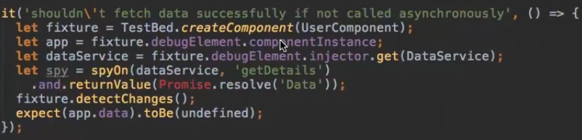

* **Isolated and non-isolated tests**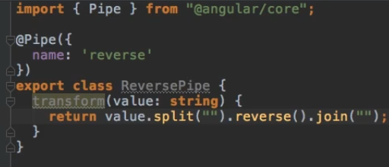

To demonstrate an solated test (doesn’t depend on any other piece in the Angular app) we need to make a new pipe.

Next all we need is to make a new spec file for this pipe and create a reverse pipe which is a new ReversePipe(the pipe we just created). Then a simple expect to finish this off.

